The First Six Months Decide: A Data-Driven Retention Strategy for a Texas auto insurer

Final Stage 1 — Data Analytics Competition

Team DataWizards
Member One
Member Two
Member Three
Example University
2026

Executive Summary
A Texas auto insurer loses 11.7% of its customers to non-renewal or cancellation, which puts about USD 17.8M of annual premium (11.8% of the premium base) at risk. Using records of 160,000 policyholders, we combined statistical driver analysis, survival analysis, interpretable regression, a cross-validated machine-learning ensemble and doubly robust causal inference to answer three questions: who leaves, when they leave, and which actions are worth funding.
Churn is most strongly associated with tenure band, age band and length of residence; customers in the riskiest group of tenure band ('0-6m') churn at 48.8%, 4.2 times the average. Risk is concentrated in time: the churn hazard peaks in tenure interval [90, 180) days (1.16% per 30 days, about 11.8 times the average). The final model reaches an out-of-fold ROC-AUC 0.702 (95% CI 0.698–0.707); the top 20% of scored customers contain 51% of all churners (2.6× random targeting). A retention campaign aimed at the top 10% of customers by expected loss is estimated to return USD 590.8K net (ROI 1.5×), whereas random targeting of the same size yields USD -35K.
We recommend (1) First-year onboarding programme; (2) Life-stage tailored engagement; (3) Household-based cross-sell and life-event triggers. Each action should start as a randomised pilot; detecting a reduction of 3.5 pp requires about 2,481 customers per arm.

1. Introduction
A personal auto insurer in Texas has seen roughly one in nine policyholders leave and wants to understand who leaves, when, and which retention actions are worth funding. The dataset (public Kaggle auto-insurance churn data) contains policy, demographic and household attributes for 200,000 customers.
For an individual insurer, churn (non-renewal or cancellation) affects several parts of the business at once. It erodes the renewal premium base, leaves acquisition costs unrecovered when policies exit early, distorts the persistency assumptions used in pricing (Eling & Kochanski, 2013) and is often a signal of unmet needs or poor service (Brockett et al., 2008). The economics of retention are well documented: Reichheld and Sasser (1990) reported that reducing defections by 5% raised profits by 25% to 85% across several service businesses. Not every exit is equally avoidable, however: Gottlieb and Smetters (2021) found that forgetting to pay explained 37.8% of recent life-insurance lapses, so part of churn can be addressed through process design rather than price.
Prior research links lapse and churn to income shocks, contract age, product type and payment frequency (Eling & Kiesenbauer, 2014; Hein et al., 2020) and to renewal pricing and the service experience (Brockett et al., 2008). Methodologically, churn models should be judged by the profit of the campaigns they enable (Verbraken et al., 2013), and risk should be distinguished from responsiveness to an intervention (Ascarza, 2018). Appendix B reviews the methods literature in more detail.
This study answers 4 research questions (RQ):
- RQ1. Which customer, policy and service factors are associated with churn, and how strongly after controlling for the others?
- RQ2. When during the customer lifecycle is churn risk highest, and which segments carry the highest risk?
- RQ3. How accurately can churn be predicted, and which customers should be prioritised?
- RQ4. Which interventions are most likely to reduce churn, for whom, and what is their expected economic value?

2. Data and Methodology

2.1 Data and preparation
The training data contain 160,000 customers (plus 40,000 customers to be scored) and 20 original variables. The target is 'Churn', defined as an account that was suspended (policy cancelled or not renewed) (churn = 1); the churn rate is 11.7%, so models are evaluated with ROC-AUC, precision–recall and profit rather than accuracy.
Preparation was automated and audited: 5 type corrections and harmonisations were applied (for example numbers or ranges stored as text, date parsing and inconsistent category labels), 0 duplicate records were removed and impossible values were set to missing. Most importantly, acct suspd date year, acct suspd date month, acct suspd date (days since) and acct suspd date are recorded only around or after the churn event; such post-event variables leak the outcome, so they and all derived features were removed before any analysis (single-feature and missingness tests flagged them automatically). We engineered 12 insurance-specific features, such as tenure (years), tenure band, new customer (<12 months), age band and premium-to-income ratio.

2.2 Analytical framework
The analysis follows five layers (Figure B.1). (1) Univariate tests (χ² and Mann–Whitney U) with effect sizes, Information Value and Benjamini–Hochberg correction screen candidate drivers (Benjamini & Hochberg, 1995). (2) Because churn is a time-to-event outcome with censored observations, Kaplan–Meier curves, log-rank tests, a Cox model, an accelerated failure time model and restricted mean survival time describe when customers leave (Kaplan & Meier, 1958; Cox, 1972). (3) A logistic regression gives adjusted odds ratios that managers can read directly. (4) 7 algorithms — CatBoost, Explainable boosting machine (EBM), Hist. gradient boosting, LightGBM, Logistic regression, Neural network (MLP) and XGBoost — were trained with stratified 5-fold cross-validation, tuned with Bayesian optimisation and combined by ensemble selection; tree ensembles remain the strongest family on tabular data (Grinsztajn et al., 2022), and SHAP values explain each prediction (Lundberg & Lee, 2017). (5) Doubly robust estimators (AIPW and the DR-learner) estimate the average and heterogeneous effects of controllable levers (Chernozhukov et al., 2018; Kennedy, 2023). Results are translated into money with customer lifetime value, the expected maximum profit measure (Verbraken et al., 2013) and a campaign simulation.

2.3 Validation
All reported performance figures are out-of-fold estimates; target-dependent encodings and hyperparameter search were fitted inside training folds only. Models are compared with DeLong tests for correlated AUCs (DeLong et al., 1988) with Holm correction, uncertainty is reported with bootstrap and DeLong confidence intervals, and calibration is checked with the Brier score and expected calibration error. Sanity checks support the validity of the pipeline: a model trained on shuffled labels scores an AUC of 0.503, and an adversarial classifier separates training from scoring data with AUC 0.50. Appendix B documents the full validation design.

3. Findings

3.1 Who churns? (RQ1)
The strongest correlates of churn are tenure band (IV 0.89): '0-6m' churns at 48.8%, 4.2× the average; age band (IV 0.04): '25-34' churns at 14.6%, 1.2× the average; length of residence (IV 0.01): '0–1' churns at 13.5%, 1.2× the average (Table 1). Several variables — length of residence, has children, college degree and curr ann amt — are statistically detectable but practically negligible (IV < 0.02), a reminder that with 160,000 records significance alone is not evidence of importance.
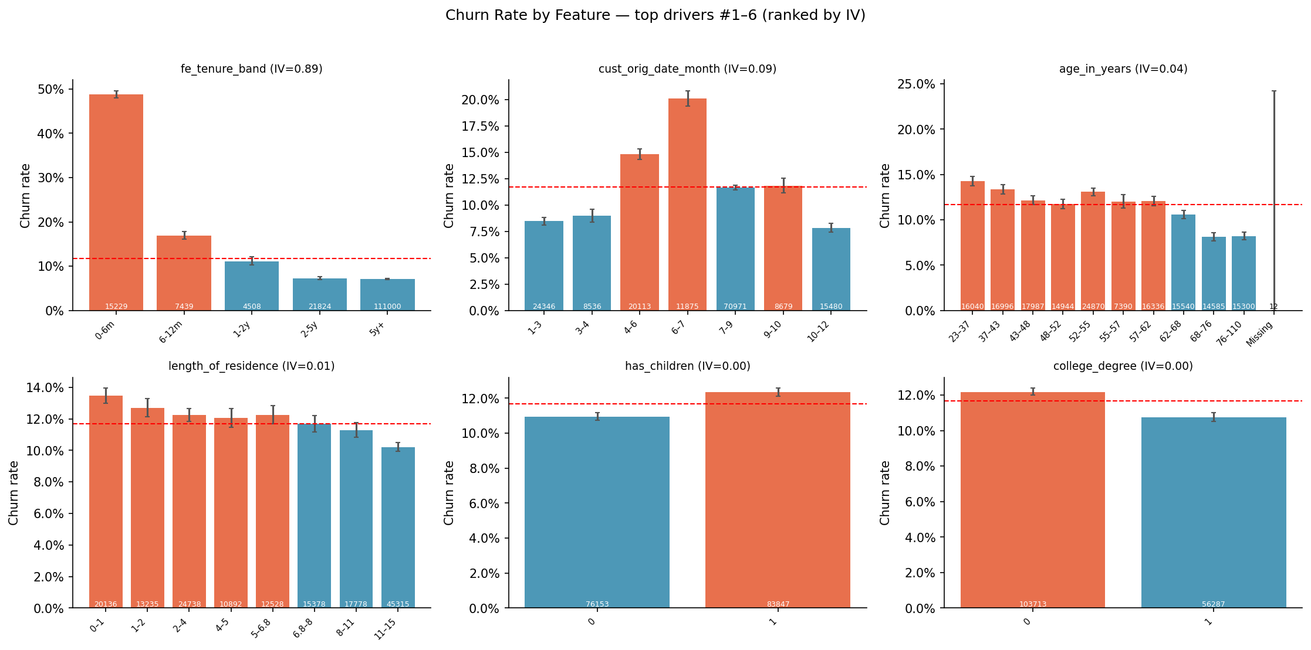
Figure 1. Churn rate by the strongest drivers (bars: churn rate with 95% Wilson CI; dashed line: overall churn rate).
Table 1. Evidence for churn drivers across methods (overall churn rate 11.7%; 'methods agreeing' counts significant univariate test, logistic regression, Cox model and top-10 SHAP).
Driver | Riskiest group | Churn rate | Lift | IV | Odds ratio | Hazard ratio | SHAP rank | Methods agreeing
tenure band | 0-6m | 48.8% | 4.18× | 0.89 | 12.20 | — | 10 | 3/4
age band | 25-34 | 14.6% | 1.25× | 0.04 | 0.92 | 0.48 | 16 | 3/4
length of residence | 0–1 | 13.5% | 1.15× | 0.01 | — | — | 4 | 2/4
college degree | No | 12.2% | 1.04× | 0.00 | — | — | 5 | 2/4
has children | Yes | 12.3% | 1.06× | 0.00 | — | — | 6 | 2/4
latitude | Missing | 12.4% | 1.07× | 0.00 | — | — | 8 | 1/4
premium-to-income ratio | 0.0182–0.0232 | 12.4% | 1.06× | 0.00 | — | — | 11 | 1/4

The multivariate logistic regression confirms that these effects are not artefacts of each other: holding the other variables constant, the largest adjusted effects are tenure band = 0-6m (vs '5y+': OR 12.20, 95% CI 11.72–12.71), tenure band = 6-12m (vs '5y+': OR 2.74, 95% CI 2.56–2.94) and tenure band = 1-2y (vs '5y+': OR 1.63, 95% CI 1.47–1.79) (full model in Appendix D).

3.2 When do customers churn? (RQ2)
Survival analysis treats active customers as censored observations. The Kaplan–Meier estimates show 98.6% after 90 days; 95.3% after 180 days; 94.4% after 365 days. The churn hazard peaks in tenure interval [90, 180) days at 1.16% per 30 days, against an average of 0.10% (Figure 2).
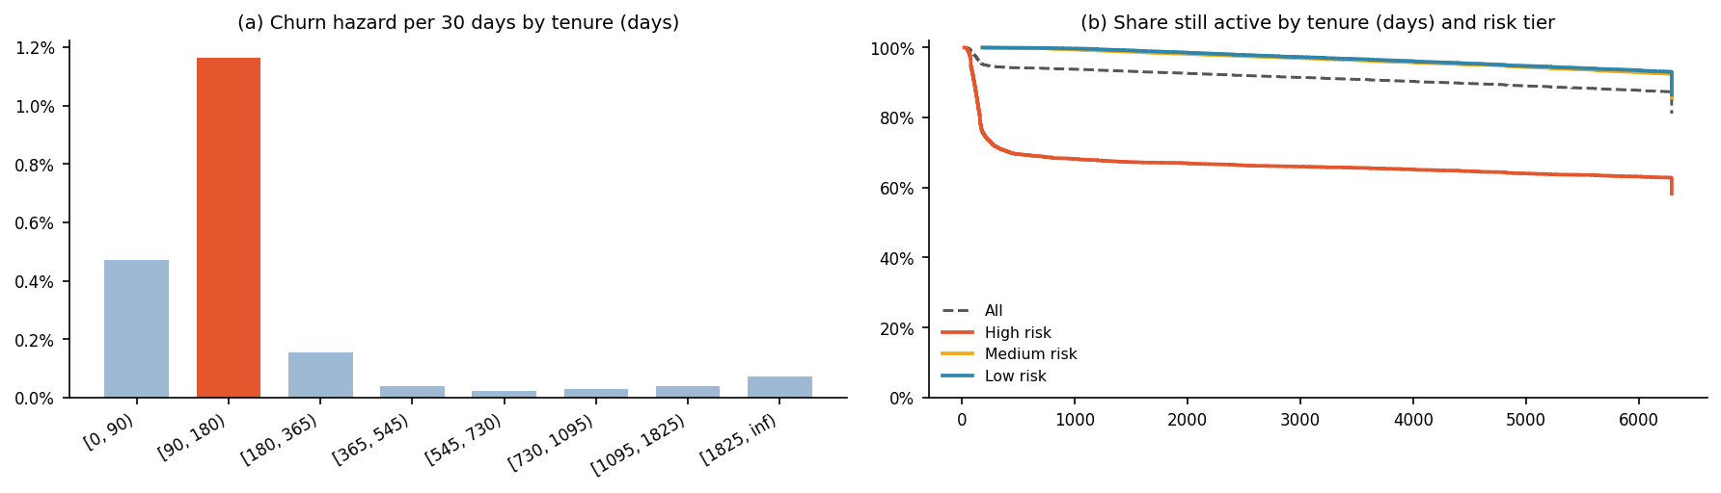
Figure 2. (a) Churn hazard per 30 days by tenure interval; (b) Kaplan–Meier survival by predicted risk tier (out-of-sample validation of the score over time).
Restricted mean survival time translates this into time lost: within the first 730 days, customers with age band = '<25' stay on average 57.9 days less than those in '65+'.

3.3 Who is most at risk? Interpretable segments
A shallow decision tree turns the drivers into segments operations teams can act on (Table F.1). The riskiest segment — tenure band = 0-6m AND cust orig date month ≥ 7 AND age in years ≤ 45 — has 5,105 customers (3.2% of the base) churning at 50.9% (4.4×) and contains 13.9% of all churners, whereas the most loyal segment churns at only 6.9%.

3.4 How well can churn be predicted? (RQ3)
Table 2. Out-of-fold performance (5-fold stratified CV; random baseline ROC-AUC 0.500, PR-AUC 0.117). EMPC = expected maximum profit per customer (Verbraken et al., 2013); p-values Holm-corrected.
Model | ROC-AUC (95% CI) | PR-AUC | Brier | EMPC (USD) | DeLong p vs final
Final ensemble: hill_climb | 0.702 (0.697–0.707) | 0.329 | 0.088 | 4.31 | —
LightGBM | 0.700 (0.696–0.705) | 0.325 | 0.088 | 4.31 | 0.210
XGBoost | 0.700 (0.695–0.704) | 0.328 | 0.090 | 4.23 | 0.149
xgb_multiseed | 0.700 (0.695–0.704) | 0.326 | 0.092 | 4.22 | 0.135
lgbm_tuned | 0.699 (0.694–0.703) | 0.326 | 0.090 | 4.25 | 0.141

The final model reaches an out-of-fold ROC-AUC 0.702 (95% CI 0.698–0.707) and a PR-AUC of 0.329, 2.8 times the random baseline (Table 2). The interpretable logistic regression reaches 0.696; the ensemble is significantly better (ΔAUC +0.006, DeLong p 0.013), so the added complexity buys real accuracy. A glass-box Explainable Boosting Machine reaches 0.693. Ranking by expected maximum profit differs from ranking by AUC (most profitable: Hist. gradient boosting). Concentration is strong: the highest-risk decile churns at 49.4% and the top 20% contain 51% of churners.
Model development was systematic: 30 logged experiments covered the model zoo, tuning, multi-seed averaging, feature selection, ablation and ensembling (Appendix F). An ablation study shows that removing tenure costs 0.023 AUC (DeLong p <0.001), the largest contribution of any feature group.

3.5 Why is a customer at risk? Explaining the model
SHAP values attribute each prediction to the features (Lundberg & Lee, 2017). The model relies mostly on days tenure (52%), tenure (years) (15%) and cust orig date (days since) (7%) of total attribution (Figure G.4), consistent with the statistical evidence, so the model behaves in a way managers can audit.

4. Business Impact (RQ4)

4.1 Value at risk and prioritisation
Weighting each customer's churn probability by annual premium, about USD 17.8M of annual premium (11.8% of the premium base) is expected to be lost. Crossing risk with value (Figure 3b) isolates a 'Priority Save' group — 11.4% of customers with high risk and above-median premium — that holds 35% of the value at risk and warrants personal contact; high-risk, low-value customers can be served through automated digital touchpoints.

4.2 Retention campaign economics
We simulated a retention campaign on the out-of-fold predictions, assuming: a contact-and-incentive cost of USD 25 per customer, that 25% of contacted would-be churners are retained and a 15% margin over a 5-year horizon (discount rate 10%). Contacting the top 10% by expected loss maximises net benefit at USD 590.8K (ROI 1.5×; Figure 3a). The conclusion is robust: the campaign stays profitable in 8 of 9 combinations of success rate (±50%) and cost (×0.5–×2) in the sensitivity analysis.
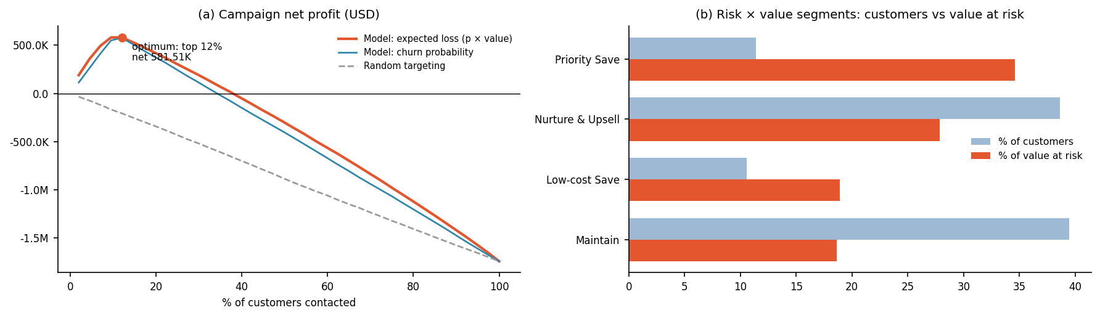
Figure 3. (a) Net profit of a retention campaign by share of customers contacted under three targeting rules; (b) share of customers vs share of value at risk by risk × value segment.

4.3 Churn personas
Clustering the SHAP explanations of at-risk customers yields 2 personas with different reasons for risk: P2 (79% of at-risk customers, actual churn 8.5%) with moderate, diffuse risk and no dominant driver; P1 (21% of at-risk customers, actual churn 51.9%) driven mainly by days tenure. Each persona receives a different intervention in the recommendations.

5. Recommendations and Implementation
Table 3. Recommended retention actions, ranked by evidence and expected value.
# | Action | Key evidence | Expected impact | KPI | When
1 | First-year onboarding programme | '0-6m' churns at 48.8% (4.2x avg); IV 0.89 | measured in pilot | 13th-month persistency ratio | Medium term
2 | Life-stage tailored engagement | '25-34' churns at 14.6% (1.2x avg); IV 0.04 | measured in pilot | Churn rate by age band | Medium term
3 | Household-based cross-sell and life-event triggers | '0–1' churns at 13.5% (1.2x avg); IV 0.01 | measured in pilot | Products per household | Long term
4 | Deploy a churn early-warning system | Model ROC-AUC 0.702; top-20% captures 51% of churners | optimal campaign: target top 10% → net 590.81K | Precision/recall of alerts | Quick win
5 | Validate with controlled pilots (A/B tests) | What-if results are associational | measured in pilot | Uplift in retention rate (treated − control) | Quick win

1. First-year onboarding programme. Welcome call, policy walkthrough, app activation and 90-day check-in for new customers; first renewal treated as a critical moment. Timing matters: because the churn hazard peaks in tenure interval [90, 180) days, the key touchpoints (welcome call, coverage check, renewal-readiness contact) should be completed before that window opens.
2. Life-stage tailored engagement. Tailor products, pricing communication and service channels to the highest-risk age groups (e.g. digital-first onboarding and flexible payment for younger customers; loyalty recognition for long-standing older customers).
Implementation follows a pilot → measure → scale logic (Figure J.4). Every action keeps a randomised control group: with a baseline churn of 28.0% in the High-risk tier, detecting a 3.5 pp reduction requires 2,481 customers per arm (α = 0.05, power 80%). Pilot results then train uplift models so that future campaigns target customers by expected response × value rather than by risk alone (Ascarza, 2018). The model is deployed as a monthly early-warning score with drift and calibration monitoring and quarterly retraining (Appendix J).

6. Discussion and Conclusion
In answer to the research questions — RQ1: churn is driven mainly by tenure band, age band and length of residence; RQ2: risk peaks in tenure interval [90, 180) days; RQ3: churn can be predicted with ROC-AUC 0.702 (95% CI 0.698–0.707), concentrating 51% of churners in the top 20%; RQ4: a value-targeted campaign returns about USD 590.8K net, while the data contain no controllable levers whose effect can be estimated, so interventions must be tested in pilots. The concentration of exits early in the relationship is consistent with evidence that lapse declines with contract age (Eling & Kiesenbauer, 2014); because acquisition costs are front-loaded, early-tenure retention has the highest value per retained policy.
Two features distinguish this analysis from a standard churn model. First, every claim is supported by converging evidence — univariate tests, multivariate regression, survival models and SHAP — with uncertainty reported as confidence intervals. Second, recommendations are prioritised by money and by causal plausibility, and are designed to be tested. On governance, the score is audited for calibration and selection differences across customer groups and documented in a model card; it is intended for retention outreach only, not for pricing or underwriting (Appendix J).
Limitations. The data are a single snapshot from one insurer, so results may not generalise and may shift with economic conditions. Drivers identified by statistical tests, regression and SHAP are associations; the causal estimates rely on the assumption of no unmeasured confounding, which we probe with E-values but cannot rule out. The campaign economics depend on assumed costs and acceptance rates, which we vary in sensitivity analysis. Variables such as competitor prices, service interactions and household income shocks are not observed. A randomised pilot of the recommended actions is the next step to measure their true effect.

References
Ascarza, E. (2018). Retention futility: Targeting high-risk customers might be ineffective. Journal of Marketing Research, 55(1), 80–98. https://doi.org/10.1509/jmr.16.0163
Benjamini, Y., & Hochberg, Y. (1995). Controlling the false discovery rate: A practical and powerful approach to multiple testing. Journal of the Royal Statistical Society: Series B (Methodological), 57(1), 289–300. https://doi.org/10.1111/j.2517-6161.1995.tb02031.x
Brockett, P. L., Golden, L. L., Guillén, M., Nielsen, J. P., Parner, J., & Pérez-Marín, A. M. (2008). Survival analysis of a household portfolio of insurance policies: How much time do you have to stop total customer defection? Journal of Risk and Insurance, 75(3), 713–737. https://doi.org/10.1111/j.1539-6975.2008.00281.x
Chernozhukov, V., Chetverikov, D., Demirer, M., Duflo, E., Hansen, C., Newey, W., & Robins, J. (2018). Double/debiased machine learning for treatment and structural parameters. The Econometrics Journal, 21(1), C1–C68. https://doi.org/10.1111/ectj.12097
Cox, D. R. (1972). Regression models and life-tables. Journal of the Royal Statistical Society: Series B (Methodological), 34(2), 187–202. https://doi.org/10.1111/j.2517-6161.1972.tb00899.x
DeLong, E. R., DeLong, D. M., & Clarke-Pearson, D. L. (1988). Comparing the areas under two or more correlated receiver operating characteristic curves: A nonparametric approach. Biometrics, 44(3), 837–845. https://doi.org/10.2307/2531595
Eling, M., & Kiesenbauer, D. (2014). What policy features determine life insurance lapse? An analysis of the German market. Journal of Risk and Insurance, 81(2), 241–269. https://doi.org/10.1111/j.1539-6975.2012.01504.x
Eling, M., & Kochanski, M. (2013). Research on lapse in life insurance: What has been done and what needs to be done? The Journal of Risk Finance, 14(4), 392–413. https://doi.org/10.1108/JRF-12-2012-0088
Gottlieb, D., & Smetters, K. (2021). Lapse-based insurance. American Economic Review, 111(8), 2377–2416. https://doi.org/10.1257/aer.20160868
Grinsztajn, L., Oyallon, E., & Varoquaux, G. (2022). Why do tree-based models still outperform deep learning on typical tabular data? In Advances in Neural Information Processing Systems 35 (pp. 507–520). https://doi.org/10.52202/068431-0037
Hein, K. Z. P. W., Keovilay, J., Adinegoro, W., & Ko, B. (2020). Analisis empiris perilaku lapse pada nasabah asuransi jiwa di Indonesia. Jurnal Statistika dan Aplikasinya, 4(2), 73–81. https://doi.org/10.21009/JSA.04202
Kaplan, E. L., & Meier, P. (1958). Nonparametric estimation from incomplete observations. Journal of the American Statistical Association, 53(282), 457–481. https://doi.org/10.1080/01621459.1958.10501452
Kennedy, E. H. (2023). Towards optimal doubly robust estimation of heterogeneous causal effects. Electronic Journal of Statistics, 17(2), 3008–3049. https://doi.org/10.1214/23-EJS2157
Lundberg, S. M., & Lee, S.-I. (2017). A unified approach to interpreting model predictions. In Advances in Neural Information Processing Systems 30. https://papers.nips.cc/paper_files/paper/2017/hash/8a20a8621978632d76c43dfd28b67767-Abstract.html
Reichheld, F. F., & Sasser, W. E., Jr. (1990). Zero defections: Quality comes to services. Harvard Business Review, 68(5), 105–111.
Verbraken, T., Verbeke, W., & Baesens, B. (2013). A novel profit maximizing metric for measuring classification performance of customer churn prediction models. IEEE Transactions on Knowledge and Data Engineering, 25(5), 961–973. https://doi.org/10.1109/TKDE.2012.50

Appendices
The appendices are not counted in the page limit. They document every analysis step so that each result in the main text can be traced and reproduced; all figures and tables were generated by the accompanying notebook.

Appendix A. Data Overview and Quality
This appendix documents the raw data, data quality checks and the transformations applied before analysis.
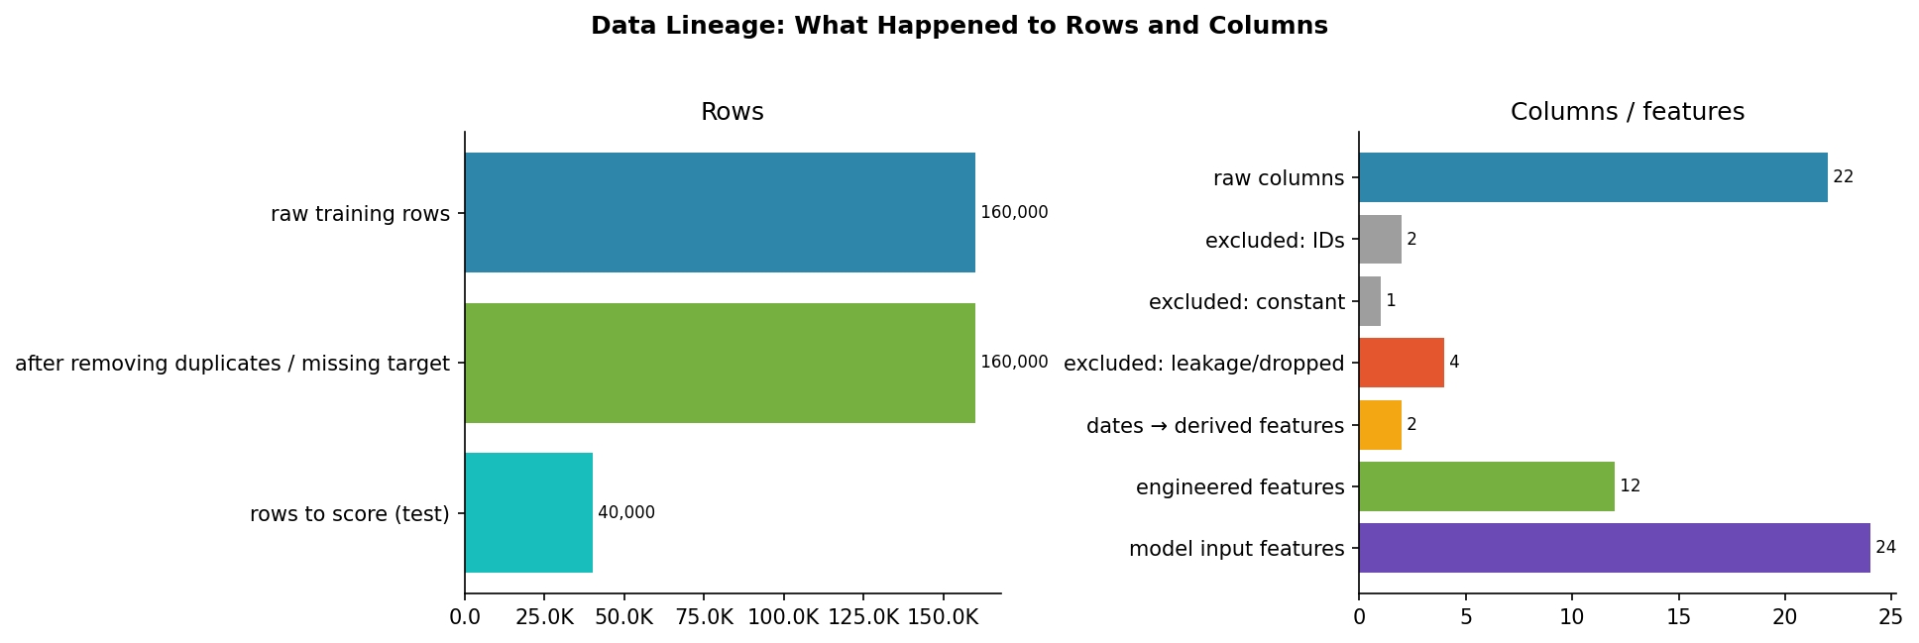
Figure A.1. Data Lineage: What Happened to Rows and Columns
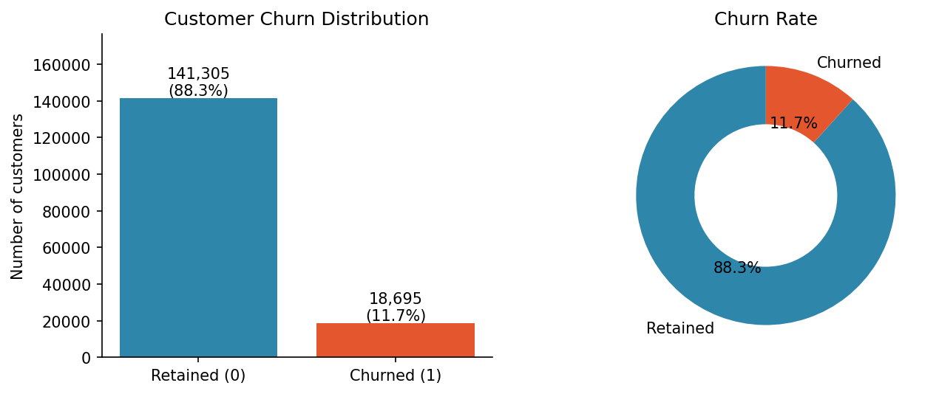
Figure A.2. Customer Churn Distribution
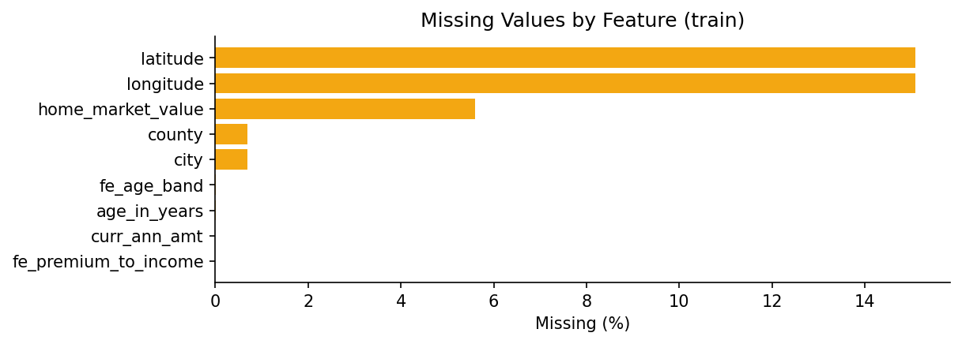
Figure A.3. Missing Values by Feature (train)
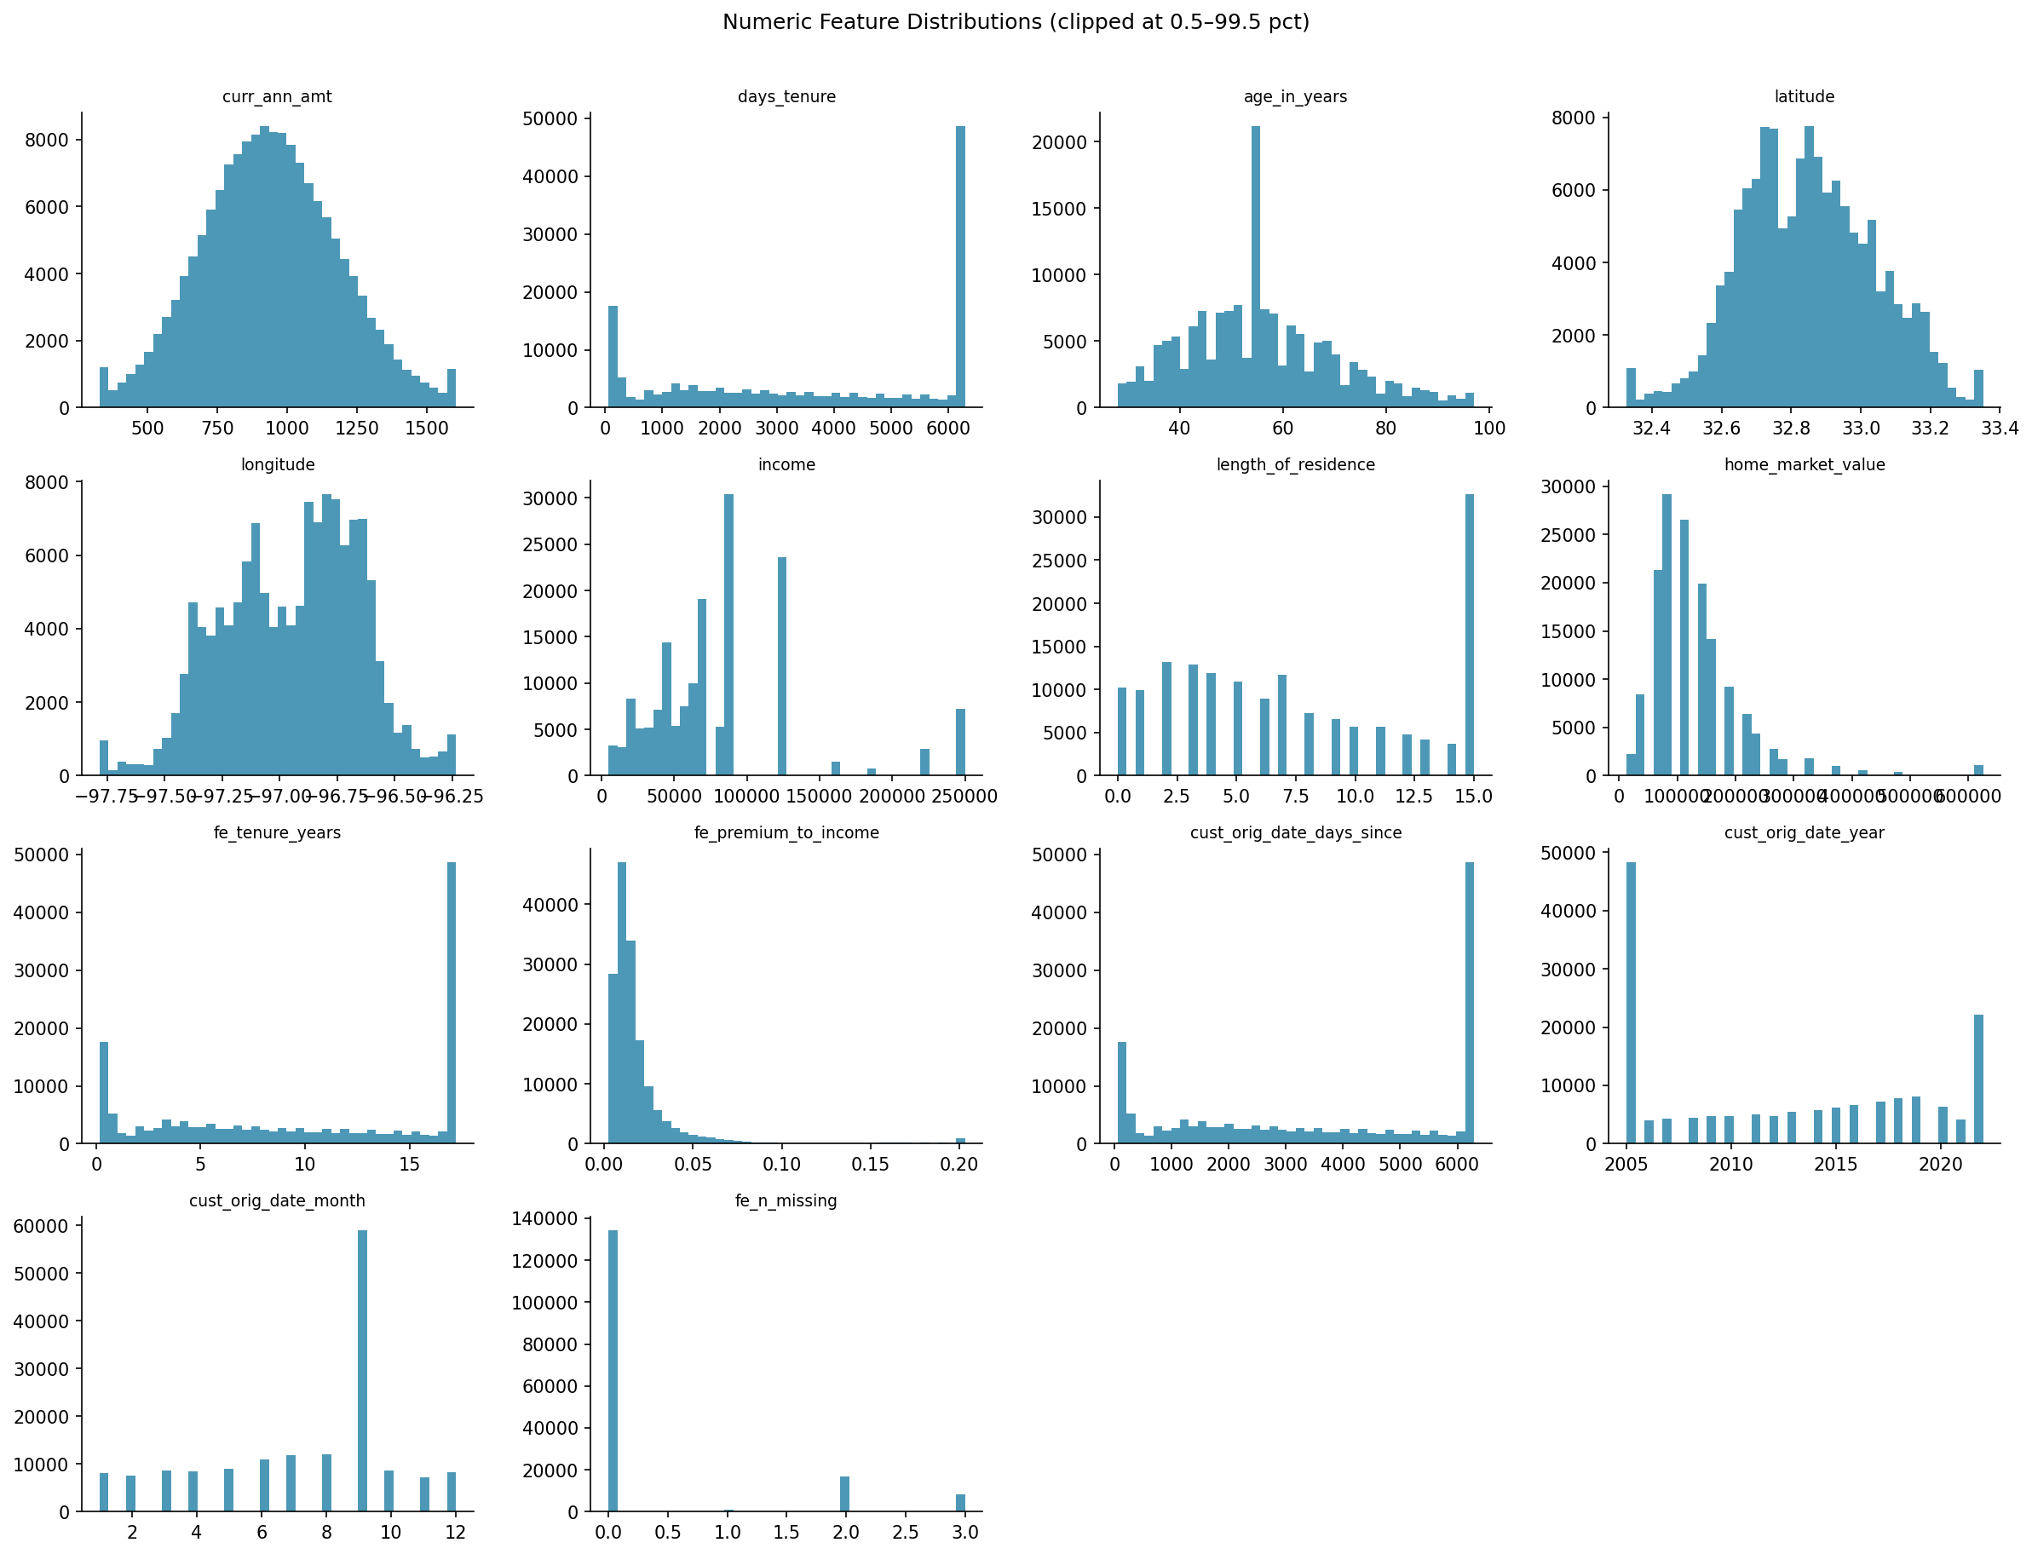
Figure A.4. Numeric Feature Distributions (clipped at 0.5–99.5 pct)
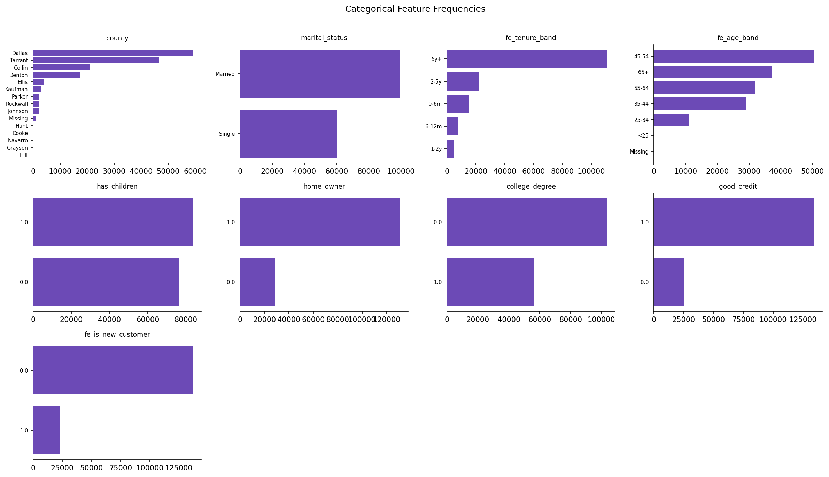
Figure A.5. Categorical Feature Frequencies
Table A.1. Data dictionary and quality report (inferred type, missing values, cardinality).
Column | Inferred type | Role | Missing % | N unique | Top value | Top freq %
individual id | id |  | 0 | 160,000 | 221.30B | 0
address id | id |  | 0 | 148,110 | 521.30B | 0.020
curr ann amt | numeric | premium | 0 | 159,979 | 899.1 | 0
days tenure | numeric | tenure | 0 | 5,048 | 6,291 | 29.5
cust orig date | date |  | 0 | 5,048 | 2005-09-11 00:00:00 | 29.5
age in years | numeric | age | 0.010 | 88 | 55.0 | 10.8
date of birth | date |  | 0 | 1,028 | 1967-07-07 00:00:00 | 8.400
latitude | numeric |  | 15.1 | 124,363 | 33.0 | 0.010
longitude | numeric |  | 15.1 | 124,980 | -96.7 | 0.010
city | high_card | region | 0.690 | 95 | Dallas | 18.3
state | constant |  | 0 | 1 | TX | 100.0
county | categorical |  | 0.690 | 14 | Dallas | 37.3
income | numeric | income | 0 | 20 | 87,500 | 19.0
has children | binary | dependents | 0 | 2 | 1.000 | 52.4
length of residence | numeric |  | 0 | 17 | 15.0 | 20.4
marital status | binary_cat |  | 0 | 2 | Married | 62.3
home market value | numeric |  | 5.590 | 18 | 87,500 | 19.3
home owner | binary |  | 0 | 2 | 1.000 | 82.0
college degree | binary |  | 0 | 2 | 0 | 64.8
good credit | binary |  | 0 | 2 | 1.000 | 84.0
acct suspd date | date |  | 88.3 | 300 | 2022-02-10 00:00:00 | 0.450

Table A.2. Leakage screen: name-based, missingness-based and single-feature AUC checks.
Feature | Name keyword | Missingness auc | Single feature auc | Statistical evidence | Flagged
acct suspd date year | yes | 1.000 | 1.000 | yes | yes
tenure (years) | no |  | 0.696 | no | no
days tenure | no |  | 0.696 | no | no
cust orig date (days since) | no |  | 0.696 | no | no
tenure band | no |  | 0.693 | no | no
cust orig date year | no |  | 0.689 | no | no
new customer (<12 months) | no |  | 0.680 | no | no
age in years | no | 0.500 | 0.547 | no | no
age band | no | 0.500 | 0.546 | no | no
acct suspd date month | yes | 1.000 | 0.539 | yes | yes
length of residence | no |  | 0.530 | no | no
cust orig date month | no |  | 0.519 | no | no
curr ann amt | no | 0.500 | 0.515 | no | no
has children | no |  | 0.515 | no | no
college degree | no |  | 0.514 | no | no

Automated cleaning log: address_id: kolom ID numerik (nama ID & 183,698 nilai unik) → tidak dipakai sebagai fitur; cust_orig_date: parsed sebagai tanggal (100.0%); date_of_birth: parsed sebagai tanggal (100.0%); home_market_value: string rentang (misal '50000 - 74999') → numeric titik tengah; acct_suspd_date: parsed sebagai tanggal (100.0%)

Appendix B. Methodology and Validation Design
Architecture of the analytics pipeline, the cross-validation design and the predictive model, plus tuning results.
Statistical screening. For categorical variables we use Pearson's χ² test with Cramér's V; for numeric variables the Mann–Whitney U test with the rank-biserial correlation, so that every p-value is paired with an effect size. Because dozens of variables are tested, p-values are converted to Benjamini–Hochberg q-values. Weight of evidence and Information Value, standard in credit and insurance scoring, summarise each binned variable's predictive strength (Siddiqi, 2006); proportions are reported with Wilson 95% intervals.
Survival layer. Tenure is the time axis and active customers are right-censored. Kaplan–Meier curves and log-rank tests describe retention; discrete hazards per tenure interval locate the critical window; the Cox model gives adjusted hazard ratios, its proportional-hazards assumption is checked with Schoenfeld residuals (Schoenfeld, 1982), and a Weibull accelerated failure time model provides time ratios that remain interpretable when the assumption fails (Wei, 1992). Restricted mean survival time expresses differences in months or days retained (Royston & Parmar, 2013).
Predictive layer. Logistic regression, random forest, extra trees, histogram gradient boosting, LightGBM, XGBoost and CatBoost (Ke et al., 2017; Chen & Guestrin, 2016; Prokhorenkova et al., 2018), a glass-box Explainable Boosting Machine (Lou et al., 2013) and a neural network are trained on identical folds. Hyperparameters are tuned with the TPE sampler and median pruning (Akiba et al., 2019) on inner folds; the best families are re-trained with several seeds; features with non-positive permutation importance are tested for removal; and six ensembling strategies, including greedy ensemble selection (Caruana et al., 2004) and stacking, are compared, the simplest within 0.0005 of the best being preferred. Probabilities are calibrated by isotonic or Platt scaling when this lowers cross-validated log-loss, and calibration is summarised by the Brier score and expected calibration error (Guo et al., 2017).
Model comparison. Correlated AUCs are compared with the DeLong test (DeLong et al., 1988) using the fast algorithm, with Holm correction across comparisons; bootstrap intervals complement the analytic ones. Because AUC is not aligned with campaign profit (Verbeke et al., 2012; Höppner et al., 2020), models are also ranked by the expected maximum profit measure for churn, which integrates campaign profit over a Beta-distributed acceptance rate (Verbraken et al., 2013). The risk score is further validated on time-to-churn with Harrell's C-index (Harrell et al., 1982).
Why not only an interpretable model? Interpretable models should be preferred when they perform comparably (Rudin, 2019); we therefore report the logistic regression and the EBM next to the ensemble and test whether the accuracy gain is significant.
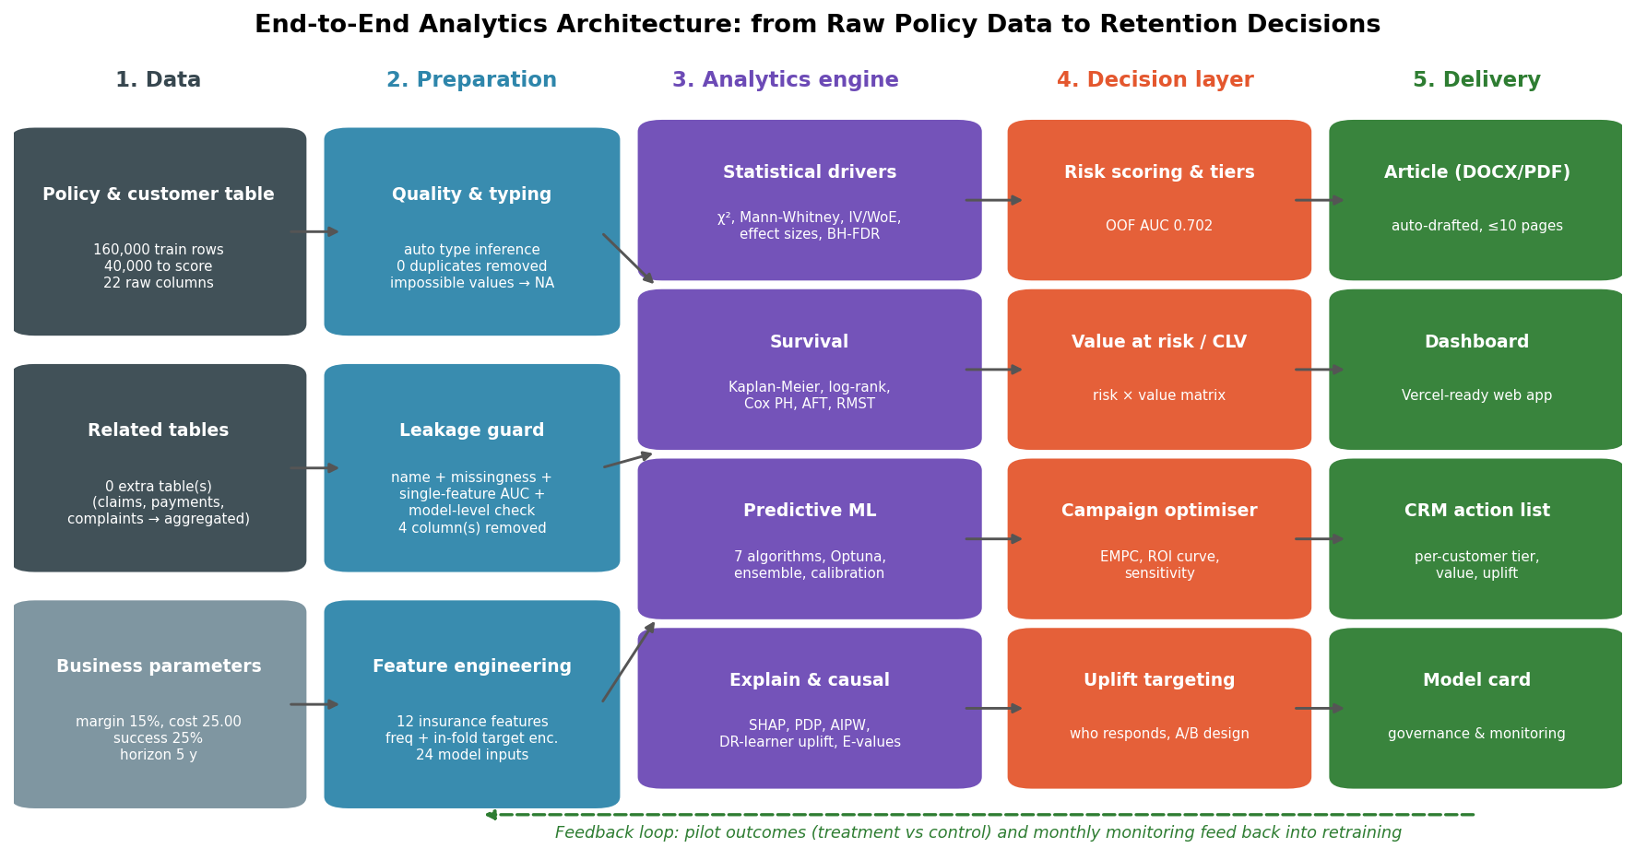
Figure B.1. End-to-end analytics architecture: from raw policy data to retention decisions, with a feedback loop from pilots.
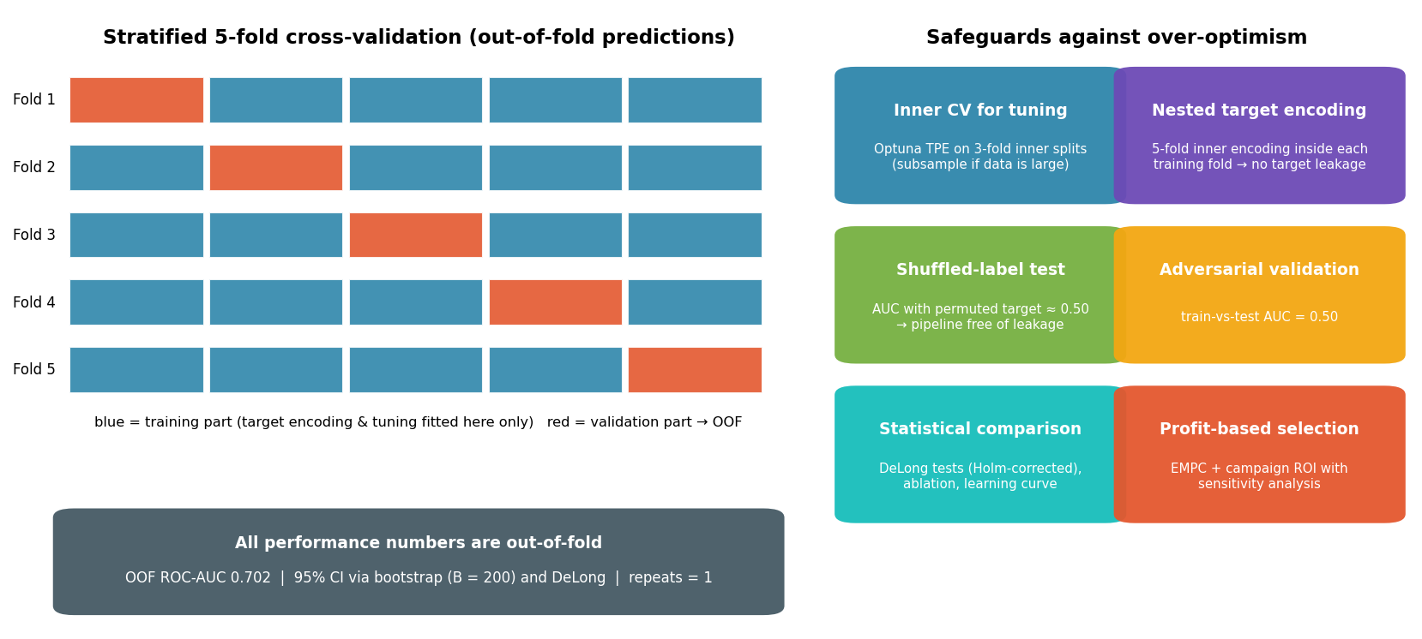
Figure B.2. validation_design
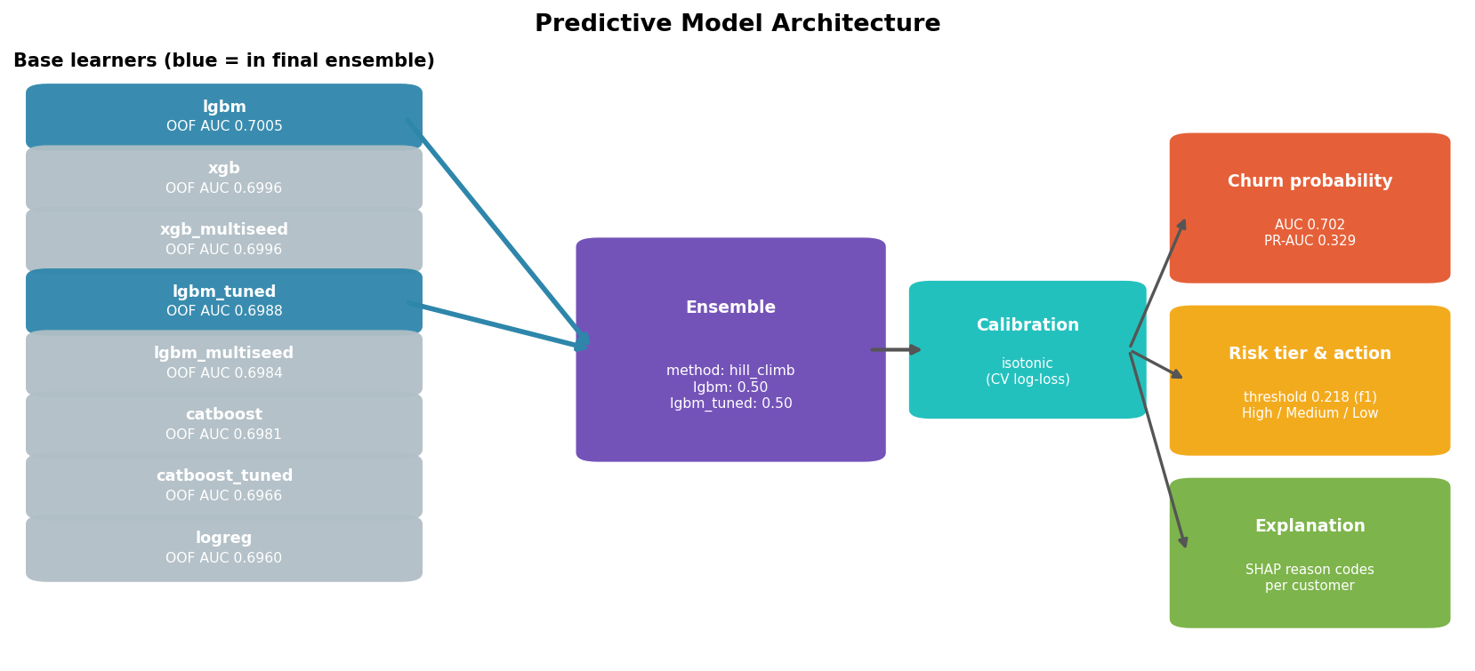
Figure B.3. Predictive Model Architecture
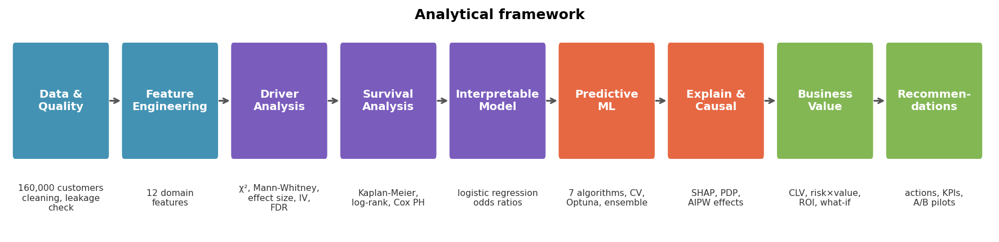
Figure B.4. Analytical framework
Table B.1. Key analysis settings (reproducibility).
Setting | Value
RUN_MODE | full
SEED | 42
N_FOLDS | 5
N_REPEATS | 1
METRIC | roc_auc
MODELS | ['logreg', 'hgb', 'lgbm', 'xgb', 'catboost', 'ebm', 'mlp']
USE_OPTUNA | True
OPTUNA_TRIALS | 15
FINAL_SEEDS | [42, 7]
CALIBRATION | auto
PROFIT_MARGIN | 0.15
RETENTION_COST | 25
RETENTION_SUCCESS_RATE | 0.25
DISCOUNT_RATE | 0.1
CLV_HORIZON_YEARS | 5
RISK_TIER_CUTS | (0.5, 0.8)
WHAT_IF_ADOPTION | 0.3
PILOT_POWER | 0.8
PILOT_ALPHA | 0.05

Table B.2. Bayesian hyperparameter optimisation (Optuna) results.
Model | Trials completed | Best tuning score | Default cv auc | Best params | Tuned cv auc | Gain auc
lgbm | 11 | 0.703 | 0.700 | {"learning_rate": 0.07696668733291795, "num_leaves": 130, "min_child_samples": 11, "subsample": 0.512121241850058, "colsample_bytree": 0.6036841581615148, "reg_alpha": 0.0195536152465732, "reg_lambda": 6.703489882056627e-06, "min_split_gain": 0.03358588493447223, "cat_smooth": 36.61527549847105} | 0.699 | -0.002
catboost | 6 | 0.699 | 0.698 | {"learning_rate": 0.09729870597990298, "depth": 4, "l2_leaf_reg": 5.748924681991978, "random_strength": 1.7772437065861273, "bagging_temperature": 0.046450412719997725} | 0.697 | -0.001
xgb | 11 | 0.702 | 0.700 | {"learning_rate": 0.08813259224734658, "max_depth": 5, "min_child_weight": 4.231156845697541, "subsample": 0.5089809378074099, "colsample_bytree": 0.6110461787176937, "reg_alpha": 0.0015027010896820222, "reg_lambda": 4.3444691085504035, "gamma": 3.3828618987138985} | 0.696 | -0.004

Appendix C. Driver Analysis (Detailed)
Churn rates for every analysed variable with 95% confidence intervals, predictive strength (Information Value), correlations and interactions.
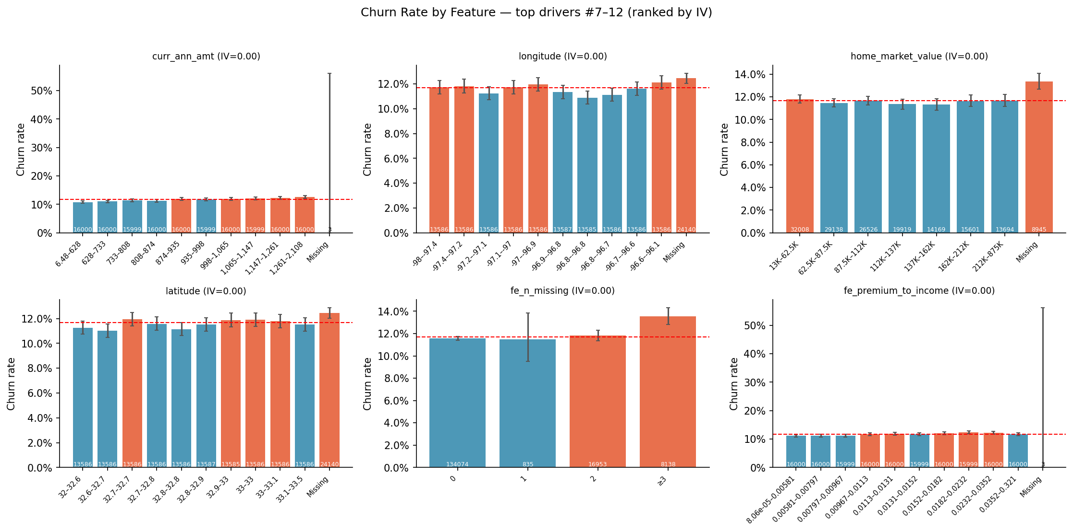
Figure C.1. Churn Rate by Feature — top drivers #7–12 (ranked by IV)
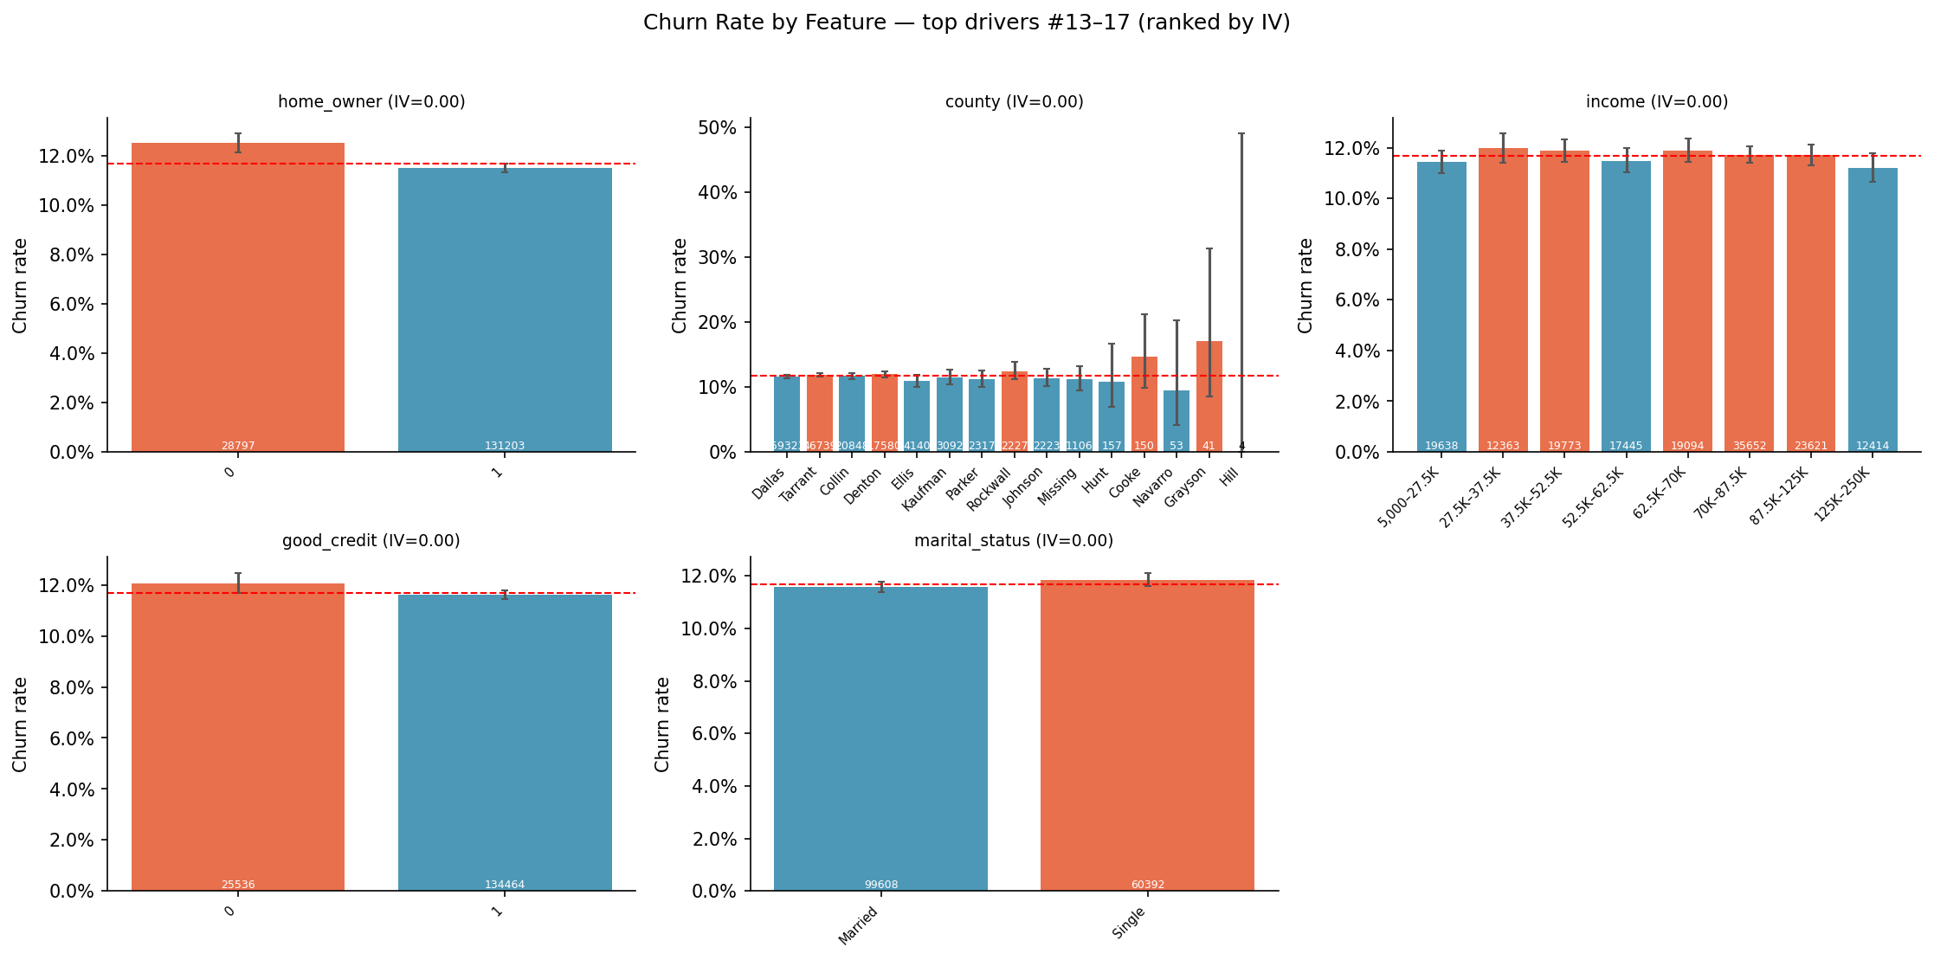
Figure C.2. Churn Rate by Feature — top drivers #13–17 (ranked by IV)
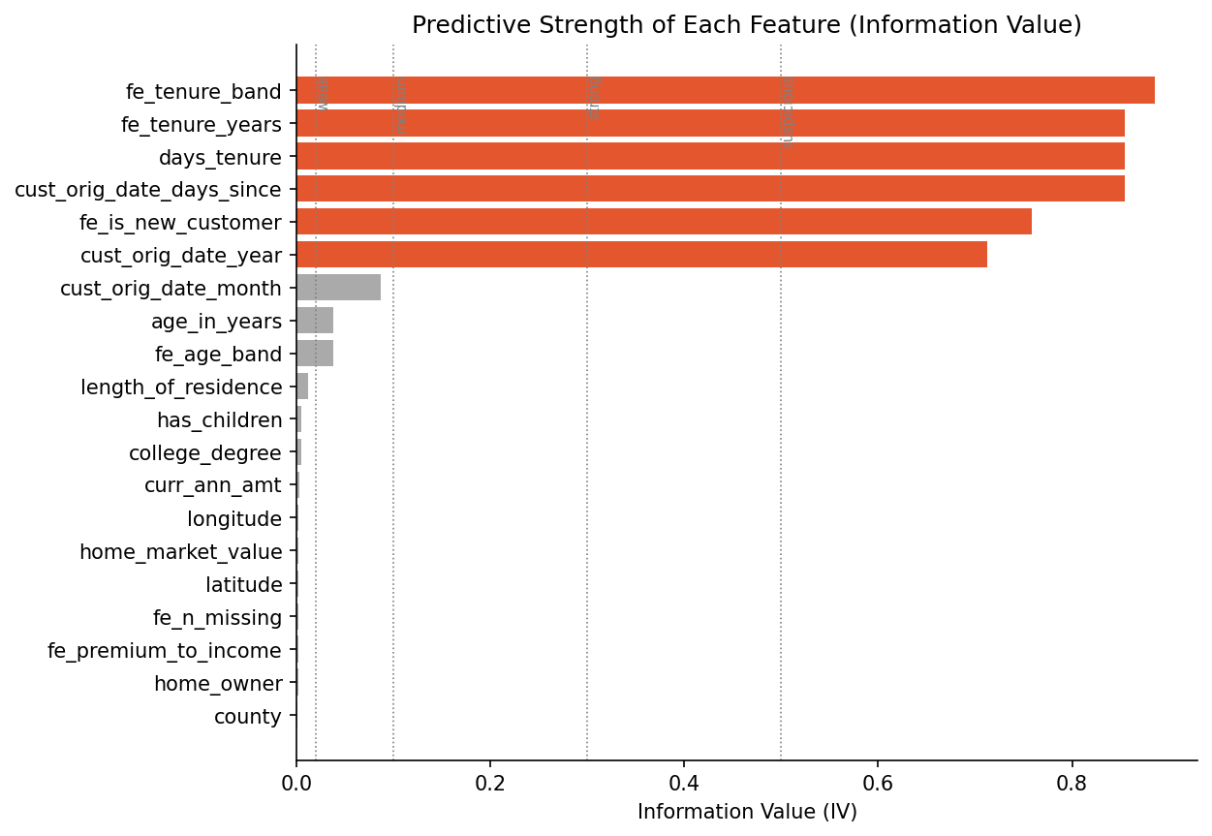
Figure C.3. Predictive Strength of Each Feature (Information Value)
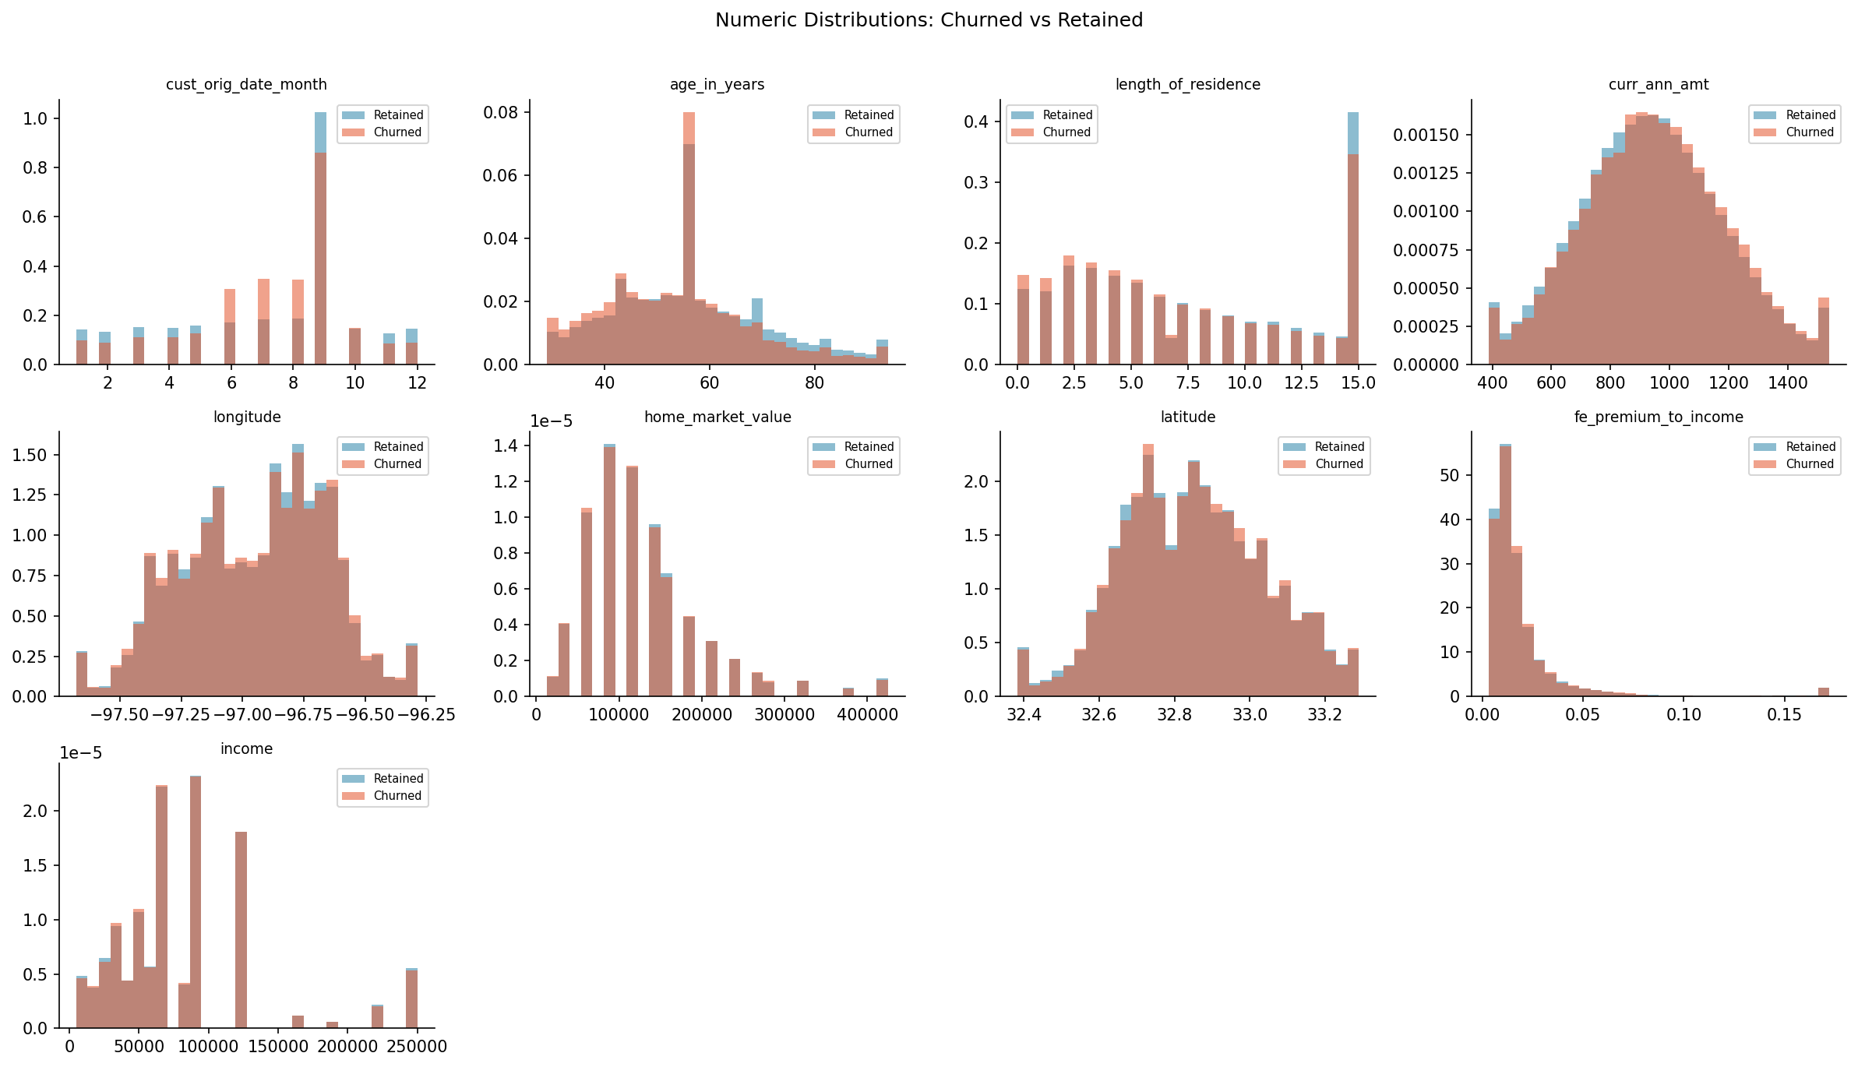
Figure C.4. Numeric Distributions: Churned vs Retained
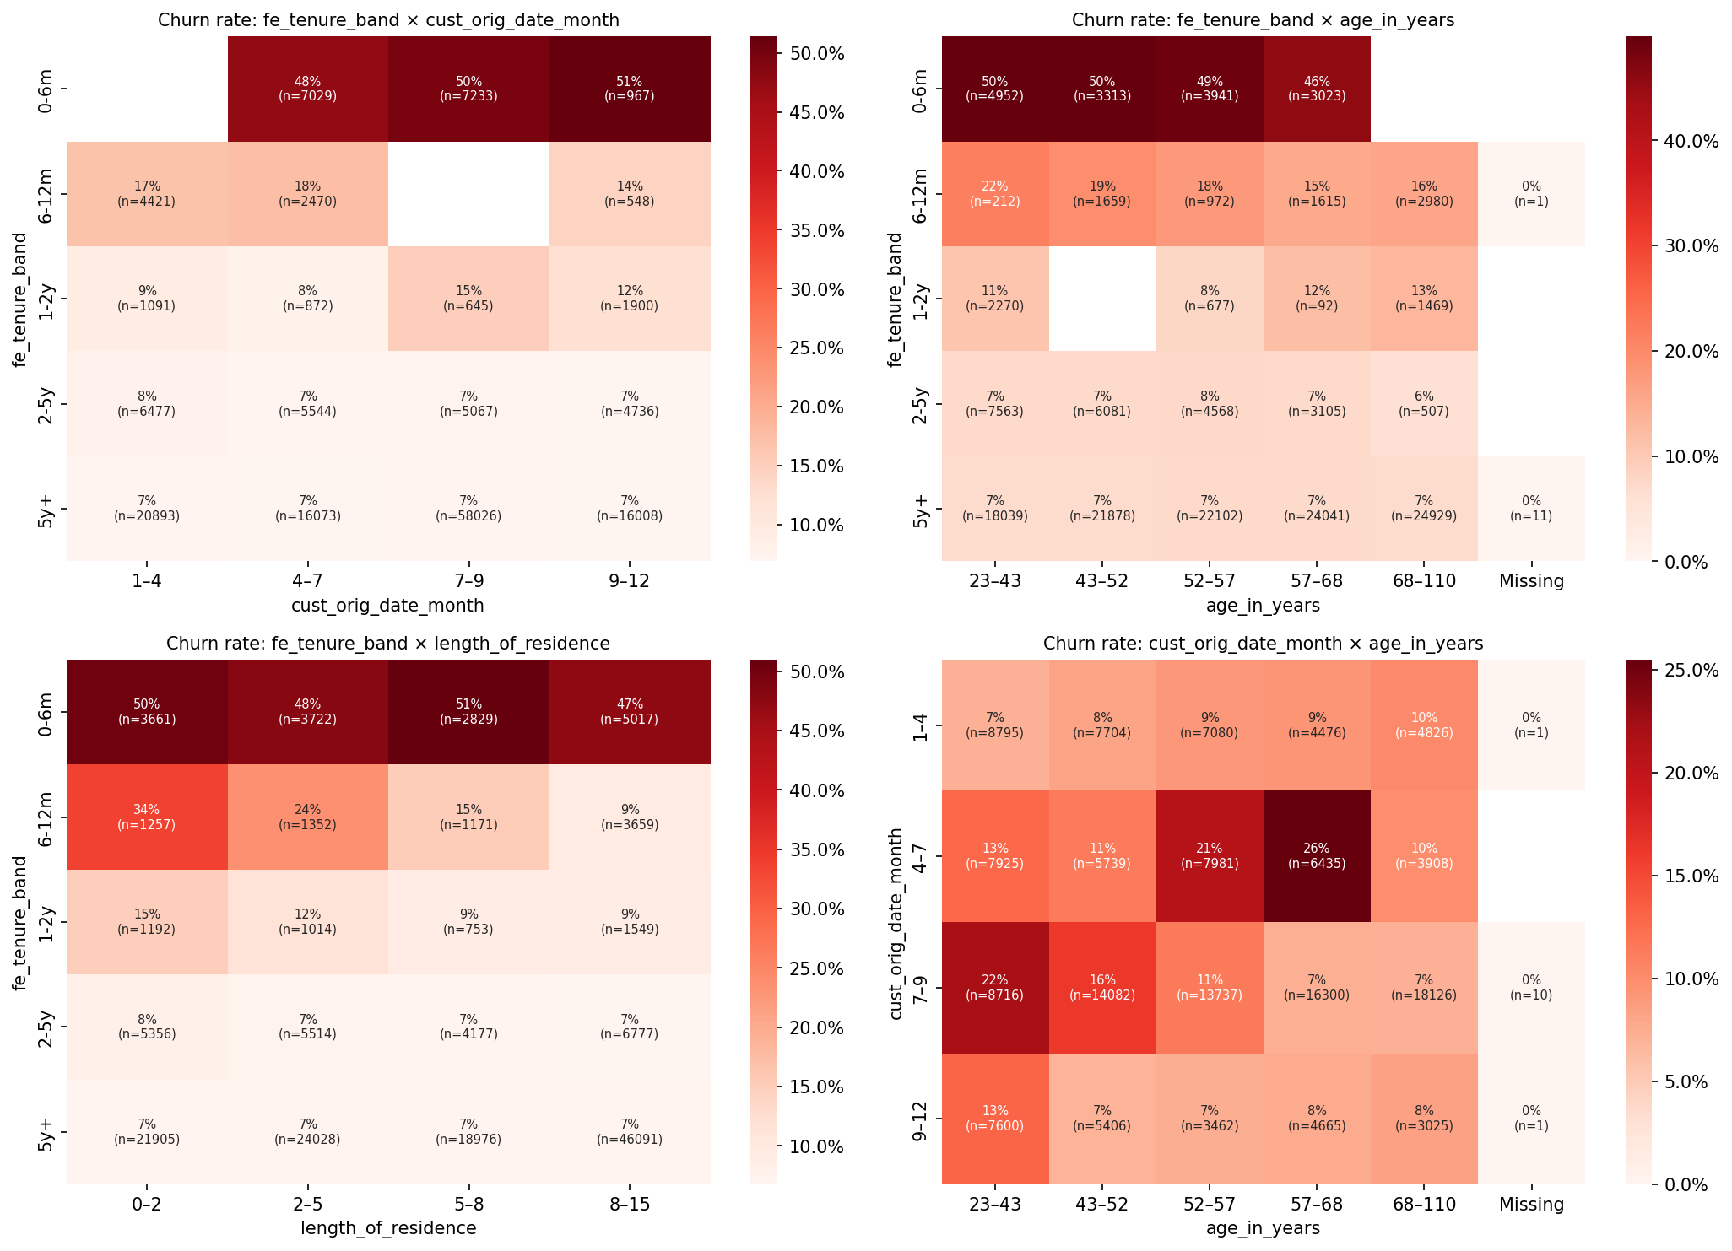
Figure C.5. Churn rate: tenure band × cust orig date month
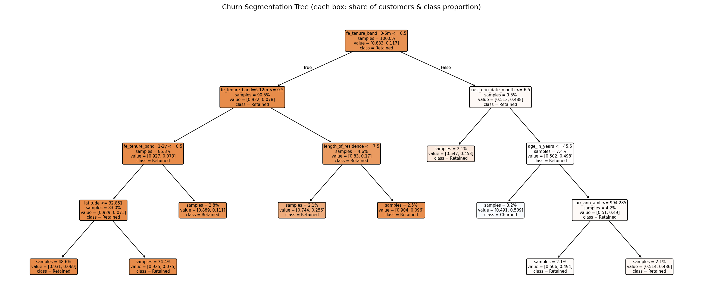
Figure C.6. Churn Segmentation Tree (each box: share of customers & class proportion)
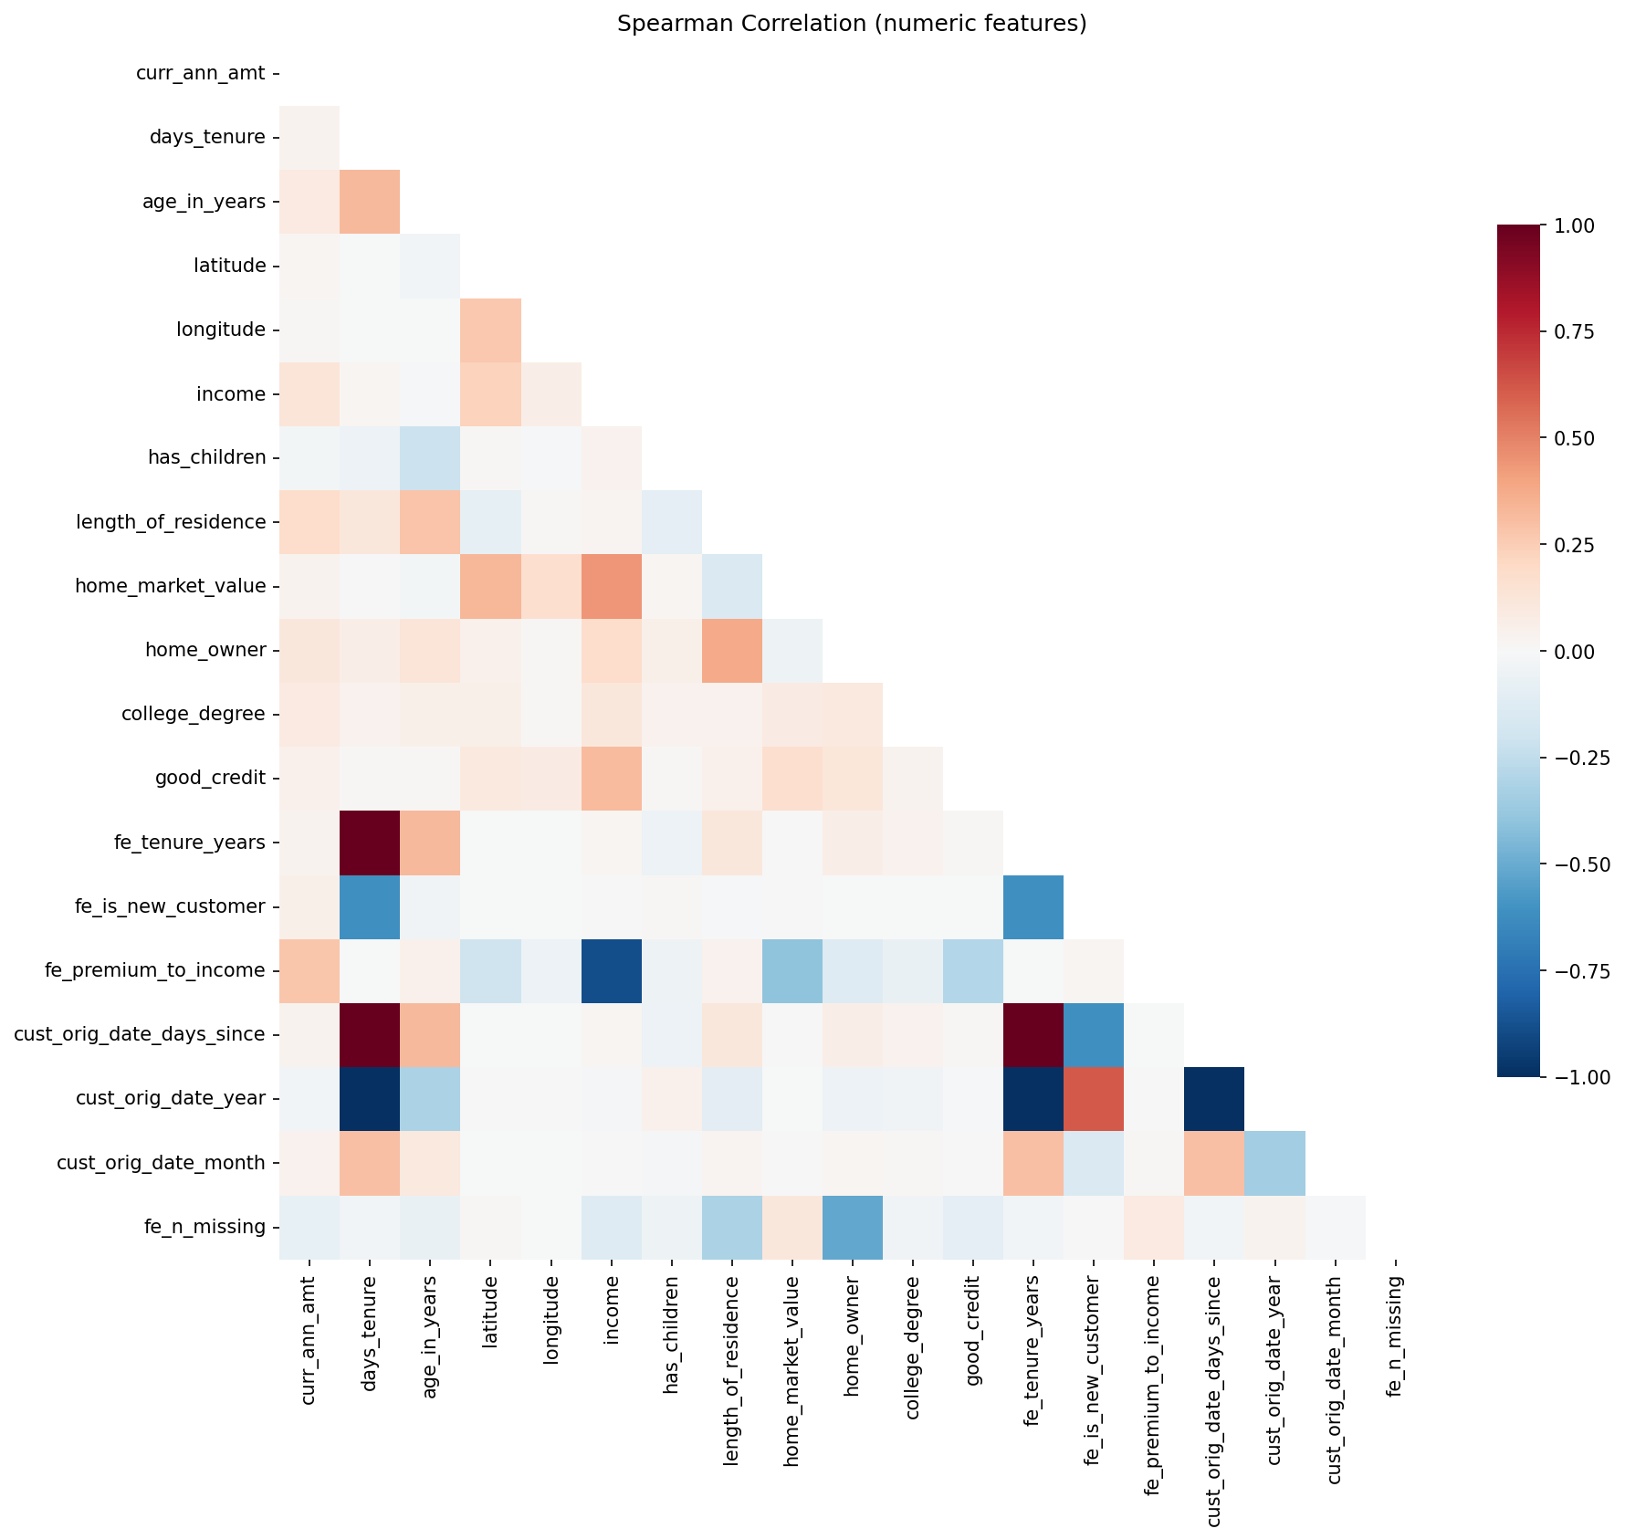
Figure C.7. Spearman Correlation (numeric features)
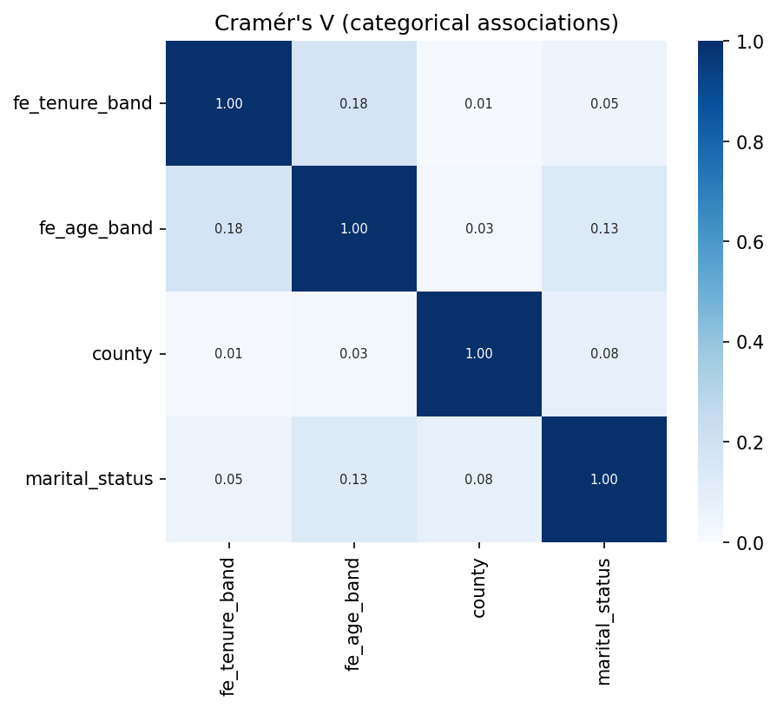
Figure C.8. Cramér's V (categorical associations)
Table C.1. Univariate driver statistics (top 25 by Information Value; q-values Benjamini–Hochberg).
Feature | Type | Iv | Iv strength | Effect metric | Effect size | Q value BH | Univariate auc | Highest risk level | Highest risk rate
tenure band | categorical | 0.885 | suspicious(>0.5) | Cramér's V | 0.381 | 0 | 0.693 | 0-6m | 0.488
tenure (years) | numeric | 0.855 | suspicious(>0.5) | rank-biserial r | -0.391 | 0 | 0.696 | 0.0548–0.523 | 0.473
days tenure | numeric | 0.855 | suspicious(>0.5) | rank-biserial r | -0.391 | 0 | 0.696 | 20–191 | 0.473
cust orig date (days since) | numeric | 0.855 | suspicious(>0.5) | rank-biserial r | -0.391 | 0 | 0.696 | 20–191 | 0.473
new customer (<12 months) | categorical | 0.759 | suspicious(>0.5) | Cramér's V | 0.338 | 0 | 0.680 | 1 | 0.384
cust orig date year | numeric | 0.713 | suspicious(>0.5) | rank-biserial r | 0.378 | 0 | 0.689 | 2,020–2,022 | 0.348
cust orig date month | numeric | 0.086 | weak | rank-biserial r | -0.039 | 1.2e-18 | 0.519 | 6–7 | 0.201
age in years | numeric | 0.038 | weak | rank-biserial r | -0.094 | 3.8e-96 | 0.547 | 23–37 | 0.143
age band | categorical | 0.038 | weak | Cramér's V | 0.060 | 3.1e-120 | 0.546 | 25-34 | 0.146
length of residence | numeric | 0.011 | useless | rank-biserial r | -0.061 | 1.9e-41 | 0.530 | 0–1 | 0.135
has children | categorical | 0.005 | useless | Cramér's V | 0.022 | 1.2e-17 | 0.515 | 1 | 0.123
college degree | categorical | 0.004 | useless | Cramér's V | 0.021 | 5.4e-17 | 0.514 | 0 | 0.122
curr ann amt | numeric | 0.003 | useless | rank-biserial r | 0.030 | 3.8e-11 | 0.515 | 1,261–2,108 | 0.126
longitude | numeric | 0.002 | useless | rank-biserial r | -0.001 | 0.772 | 0.501 | Missing | 0.124
home market value | numeric | 0.002 | useless | rank-biserial r | -0.004 | 0.433 | 0.502 | Missing | 0.134
latitude | numeric | 0.002 | useless | rank-biserial r | 0.009 | 0.082 | 0.505 | Missing | 0.124
number of missing fields | numeric | 0.002 | useless | rank-biserial r | 0.011 | 1.0e-04 | 0.506 | ≥3 | 0.136
premium-to-income ratio | numeric | 0.002 | useless | rank-biserial r | 0.017 | 1.7e-04 | 0.509 | 0.0182–0.0232 | 0.124
home owner | categorical | 0.001 | useless | Cramér's V | 0.012 | 3.4e-06 | 0.504 | 0 | 0.125
county | categorical | 6.3e-04 | useless | Cramér's V | 0.008 | 0.724 | 0.500 | Rockwall | 0.124
income | numeric | 4.3e-04 | useless | rank-biserial r | -0.003 | 0.624 | 0.501 | 27.5K–37.5K | 0.120
good credit | categorical | 2.6e-04 | useless | Cramér's V | 0.005 | 0.052 | 0.502 | 0 | 0.121
marital status | categorical | 1.7e-04 | useless | Cramér's V | 0.004 | 0.113 | 0.502 | Single | 0.119

Table C.2. All decision-tree segments.
Segment rule | N customers | Share % | Churn rate | Lift | Churners captured %
tenure band = 0-6m AND cust orig date month > 6.50 AND age in years ≤ 45.50 | 5,105 | 3.191 | 0.509 | 4.359 | 13.9
tenure band = 0-6m AND cust orig date month > 6.50 AND age in years > 45.50 AND curr ann amt ≤ 994.28 | 3,404 | 2.127 | 0.494 | 4.226 | 8.992
tenure band = 0-6m AND cust orig date month > 6.50 AND age in years > 45.50 AND curr ann amt > 994.28 | 3,367 | 2.104 | 0.486 | 4.161 | 8.756
tenure band = 0-6m AND cust orig date month ≤ 6.50 | 3,353 | 2.096 | 0.453 | 3.880 | 8.131
tenure band ≠ 0-6m AND tenure band = 6-12m AND length of residence ≤ 7.50 | 3,425 | 2.141 | 0.256 | 2.191 | 4.691
tenure band ≠ 0-6m AND tenure band ≠ 6-12m AND tenure band = 1-2y | 4,508 | 2.817 | 0.111 | 0.953 | 2.685
tenure band ≠ 0-6m AND tenure band = 6-12m AND length of residence > 7.50 | 4,014 | 2.509 | 0.096 | 0.819 | 2.054
tenure band ≠ 0-6m AND tenure band ≠ 6-12m AND tenure band ≠ 1-2y AND latitude > 32.85 | 55,107 | 34.4 | 0.075 | 0.639 | 22.0
tenure band ≠ 0-6m AND tenure band ≠ 6-12m AND tenure band ≠ 1-2y AND latitude ≤ 32.85 | 77,717 | 48.6 | 0.069 | 0.593 | 28.8

Table C.3. Variance inflation factors (numeric features).
Feature | VIF
days tenure | 1,000,799.92B
tenure (years) | 1,000,799.92B
cust orig date (days since) | 1,000,799.92B
cust orig date year | 103,605
cust orig date month | 147.2
new customer (<12 months) | 1.621
home owner | 1.564
income | 1.517
premium-to-income ratio | 1.489
number of missing fields | 1.469
length of residence | 1.329
age in years | 1.271
good credit | 1.188
home market value | 1.175
curr ann amt | 1.112
latitude | 1.109
has children | 1.065
longitude | 1.057
college degree | 1.034

Appendix D. Interpretable Logistic Regression
Adjusted odds ratios with 95% confidence intervals; numeric variables are standardised (per 1 SD), categories are compared with the most common level.
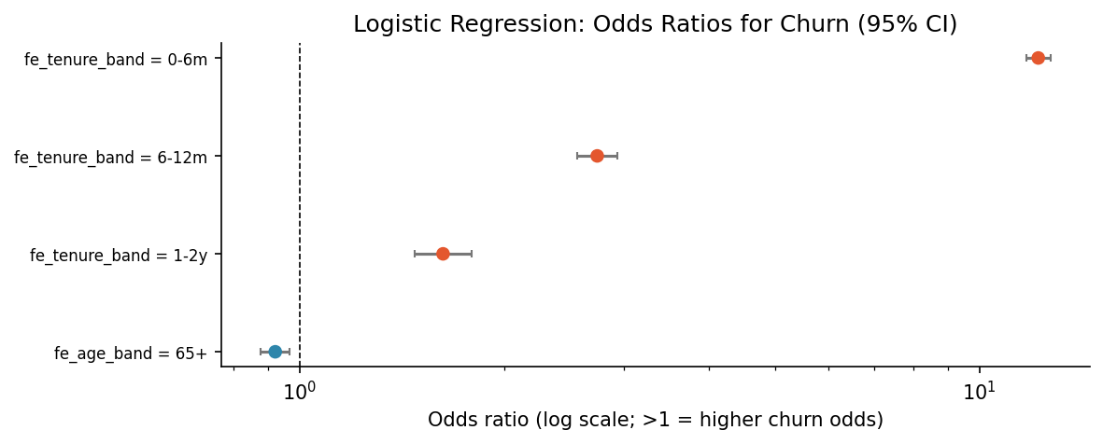
Figure D.1. Logistic Regression: Odds Ratios for Churn (95% CI)
Table D.1. Logistic regression: odds ratios, 95% CI, p-values and average marginal effects.
Term | Coef | Odds ratio | Or ci low | Or ci high | P value | Scale | Avg marginal effect pp | Interpretation
age band = Missing | -16.8 | 5.2e-08 | 0 | infB | 0.997 | vs '45-54' | -148.0 | -100% odds of churn (vs '45-54')
tenure band = 0-6m | 2.502 | 12.2 | 11.7 | 12.7 | 0 | vs '5y+' | 22.1 | +1120% odds of churn (vs '5y+')
tenure band = 6-12m | 1.008 | 2.740 | 2.558 | 2.936 | 1.5e-180 | vs '5y+' | 8.892 | +174% odds of churn (vs '5y+')
tenure band = 1-2y | 0.486 | 1.626 | 1.475 | 1.792 | 1.5e-22 | vs '5y+' | 4.287 | +63% odds of churn (vs '5y+')
age band = <25 | -0.301 | 0.740 | 0.441 | 1.242 | 0.255 | vs '45-54' | -2.653 | -26% odds of churn (vs '45-54')
age band = 65+ | -0.082 | 0.921 | 0.877 | 0.968 | 0.001 | vs '45-54' | -0.725 | -8% odds of churn (vs '45-54')
age band = 25-34 | 0.047 | 1.048 | 0.981 | 1.120 | 0.163 | vs '45-54' | 0.417 | +5% odds of churn (vs '45-54')
age band = 35-44 | -0.015 | 0.985 | 0.940 | 1.033 | 0.544 | vs '45-54' | -0.130 | -1% odds of churn (vs '45-54')
cust orig date month | 0.011 | 1.011 | 0.992 | 1.030 | 0.250 | per 1 SD (= 2.93) | 0.097 | +1% odds of churn (per 1 SD (= 2.93))
tenure band = 2-5y | 0.010 | 1.010 | 0.953 | 1.069 | 0.741 | vs '5y+' | 0.085 | +1% odds of churn (vs '5y+')
age band = 55-64 | 5.5e-04 | 1.001 | 0.955 | 1.048 | 0.982 | vs '45-54' | 0.005 | +0% odds of churn (vs '45-54')

Appendix E. Survival Analysis
Kaplan–Meier estimates, hazards by tenure, Cox and Weibull AFT models, proportional-hazards diagnostics and validation of risk tiers over time.
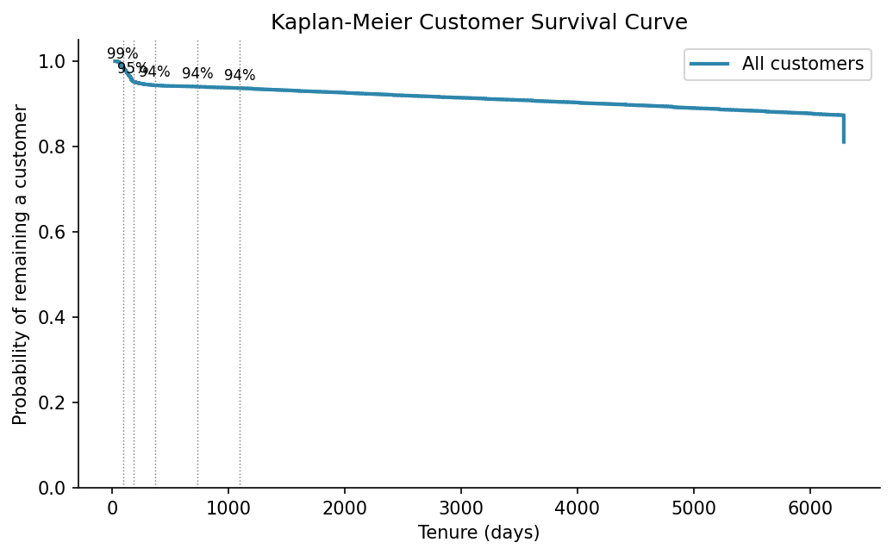
Figure E.1. Kaplan-Meier Customer Survival Curve
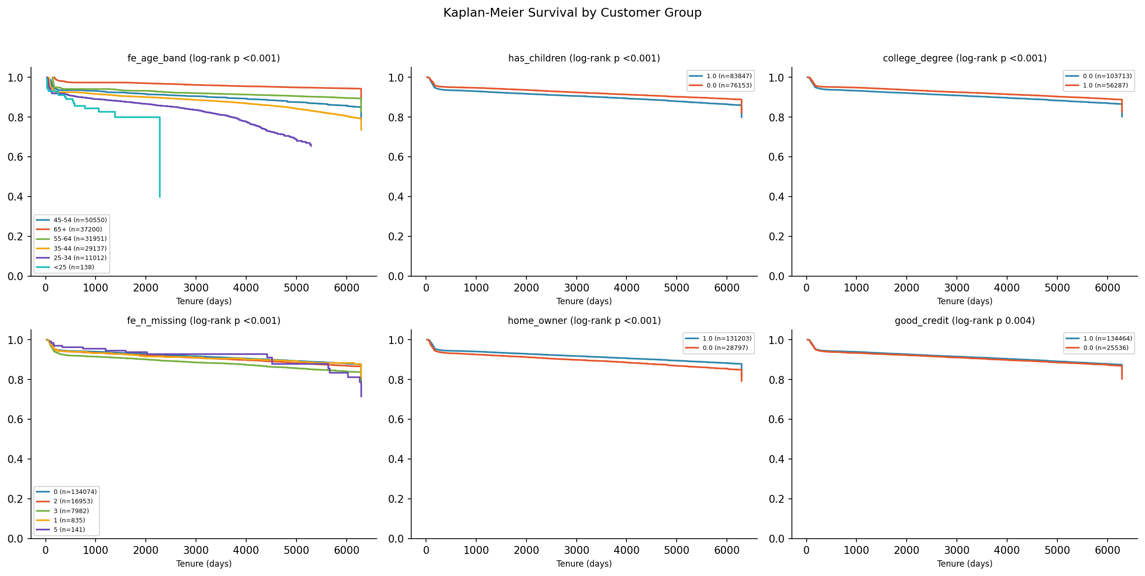
Figure E.2. Kaplan-Meier Survival by Customer Group
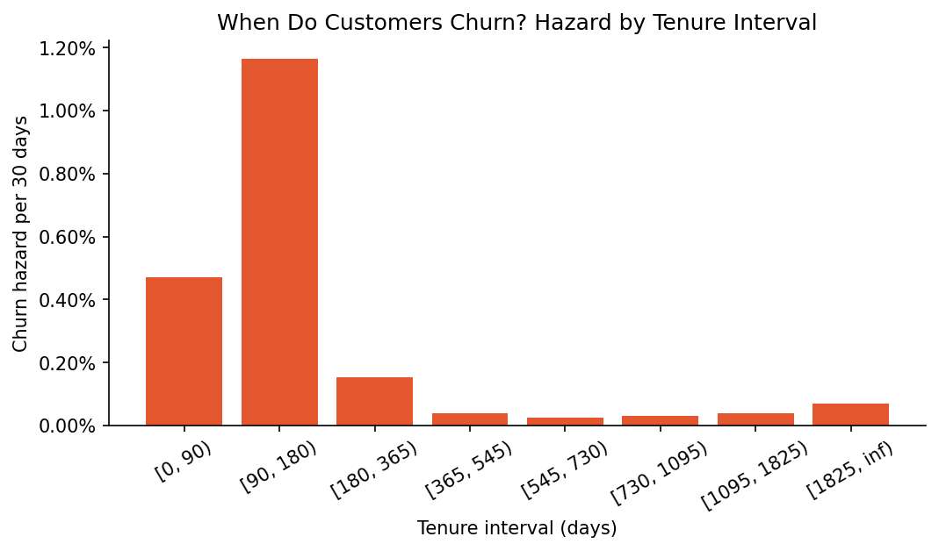
Figure E.3. When Do Customers Churn? Hazard by Tenure Interval
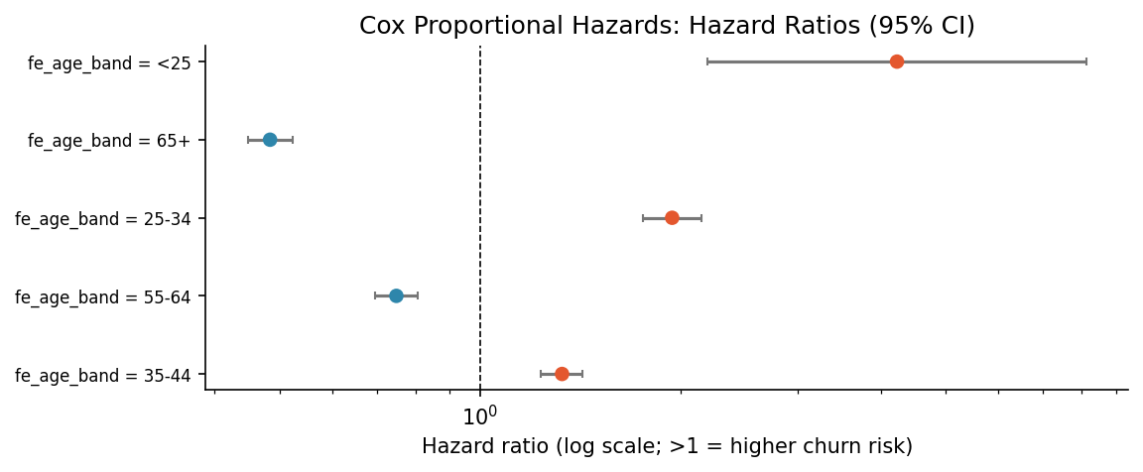
Figure E.4. Cox Proportional Hazards: Hazard Ratios (95% CI)
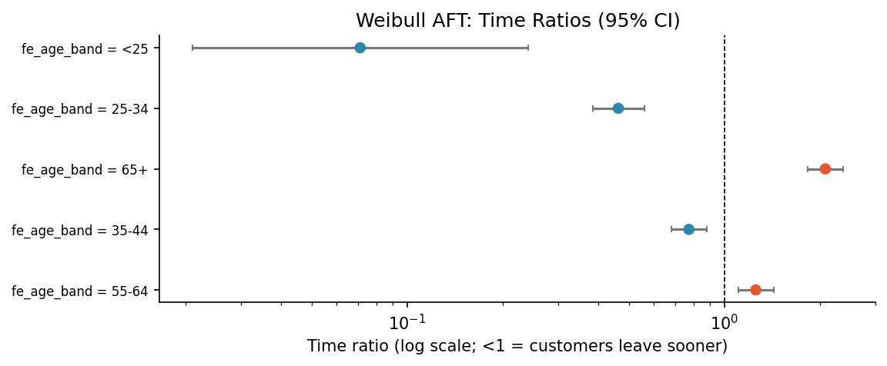
Figure E.5. Weibull AFT: Time Ratios (95% CI)
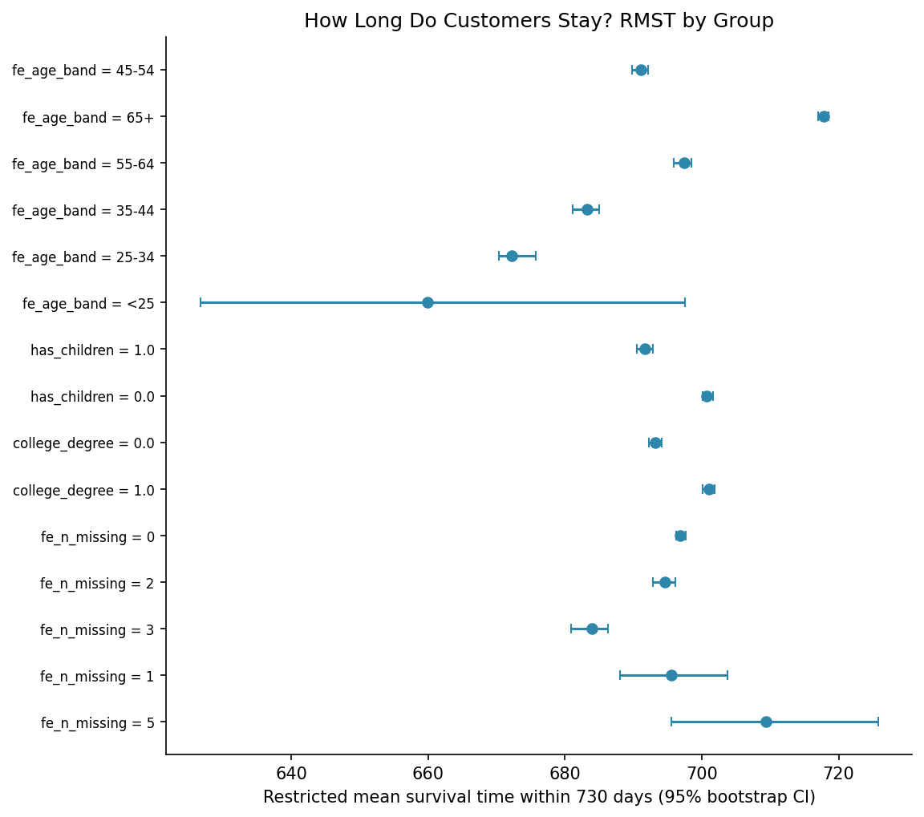
Figure E.6. How Long Do Customers Stay? RMST by Group
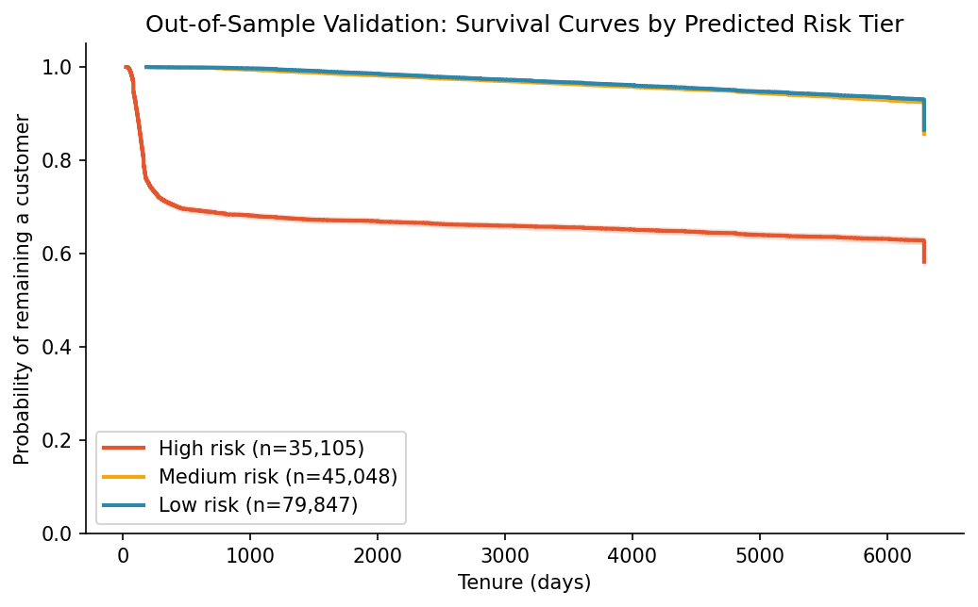
Figure E.7. Out-of-Sample Validation: Survival Curves by Predicted Risk Tier
Table E.1. Hazard by tenure interval.
Interval | At risk start | Churn events | Person time | Hazard
[0, 90) | 160,000 | 2,215 | 14.32M | 0.005
[90, 180) | 155,521 | 5,176 | 13.53M | 0.012
[180, 365) | 145,025 | 1,308 | 25.92M | 0.002
[365, 545) | 137,350 | 305 | 24.51M | 3.8e-04
[545, 730) | 135,208 | 196 | 24.85M | 2.4e-04
[730, 1095) | 132,836 | 475 | 47.41M | 3.0e-04
[1095, 1825) | 126,907 | 1,116 | 86.62M | 3.9e-04
[1825, inf) | 111,008 | 7,904 | 338.55M | 7.1e-04

Table E.2. Log-rank tests by group.
Feature | Logrank chi2 | P value
age band | 2,877 | 0
has children | 174.0 | 0
college degree | 132.6 | 0
number of missing fields | 76.0 | 1.2e-15
home owner | 101.2 | 0
good credit | 8.325 | 0.004

Table E.3. Cox proportional hazards model.
Term | Coef | Hazard ratio | Hr ci low | Hr ci high | P value | Scale | Interpretation
age band = Missing | -16.2 | 9.0e-08 | 0 | infB | 0.997 | vs '45-54' | -100% churn hazard (vs '45-54')
age band = <25 | 1.441 | 4.225 | 2.194 | 8.137 | 1.6e-05 | vs '45-54' | +323% churn hazard (vs '45-54')
age band = 65+ | -0.725 | 0.484 | 0.448 | 0.523 | 3.7e-76 | vs '45-54' | -52% churn hazard (vs '45-54')
age band = 25-34 | 0.664 | 1.943 | 1.756 | 2.149 | 5.9e-38 | vs '45-54' | +94% churn hazard (vs '45-54')
age band = 55-64 | -0.289 | 0.749 | 0.697 | 0.806 | 5.7e-15 | vs '45-54' | -25% churn hazard (vs '45-54')
age band = 35-44 | 0.284 | 1.328 | 1.236 | 1.427 | 1.2e-14 | vs '45-54' | +33% churn hazard (vs '45-54')

Table E.4. Schoenfeld test of the proportional-hazards assumption.
Term | Test statistic | P | Ph violated
age band = <25 | 0.826 | 0.363 | no
age band = 25-34 | 0.657 | 0.418 | no
age band = 35-44 | 9.621 | 0.002 | yes
age band = 55-64 | 5.314 | 0.021 | no
age band = 65+ | 80.4 | 3.1e-19 | yes
age band = Missing | 0.002 | 0.966 | no

Table E.5. Weibull accelerated failure time model (time ratios).
Term | Time ratio | Tr ci low | Tr ci high | P value | Scale
age band = <25 | 0.071 | 0.021 | 0.241 | 2.1e-05 | vs '45-54'
age band = Missing | 11.7 | 0.002 | 70,299 | 0.580 | vs '45-54'
age band = 25-34 | 0.463 | 0.384 | 0.559 | 7.9e-16 | vs '45-54'
age band = 65+ | 2.082 | 1.828 | 2.371 | 2.5e-28 | vs '45-54'
age band = 35-44 | 0.773 | 0.679 | 0.880 | 1.0e-04 | vs '45-54'
age band = 55-64 | 1.257 | 1.106 | 1.429 | 4.7e-04 | vs '45-54'

Table E.6. Restricted mean survival time by group.
Feature | Level | N | Rmst | Rmst ci low | Rmst ci high | Diff vs best | Reference level | Tau
age band | 45-54 | 50,550 | 691.0 | 689.8 | 692.2 | -26.8 | 65+ | 730.0
age band | 65+ | 37,200 | 717.9 | 717.0 | 718.5 | 0 | 65+ | 730.0
age band | 55-64 | 31,951 | 697.4 | 695.9 | 698.5 | -20.4 | 65+ | 730.0
age band | 35-44 | 29,137 | 683.2 | 681.1 | 685.0 | -34.6 | 65+ | 730.0
age band | 25-34 | 11,012 | 672.2 | 670.4 | 675.7 | -45.6 | 65+ | 730.0
age band | <25 | 138 | 659.9 | 626.7 | 697.6 | -57.9 | 65+ | 730.0
has children | 1.0 | 83,847 | 691.7 | 690.5 | 692.8 | -9.058 | 0.0 | 730.0
has children | 0.0 | 76,153 | 700.7 | 700.2 | 701.6 | 0 | 0.0 | 730.0
college degree | 0.0 | 103,713 | 693.2 | 692.3 | 694.1 | -7.844 | 1.0 | 730.0
college degree | 1.0 | 56,287 | 701.1 | 700.1 | 701.9 | 0 | 1.0 | 730.0
number of missing fields | 0 | 134,074 | 696.9 | 696.2 | 697.6 | -12.5 | 5 | 730.0
number of missing fields | 2 | 16,953 | 694.6 | 692.9 | 696.1 | -14.7 | 5 | 730.0
number of missing fields | 3 | 7,982 | 684.0 | 680.9 | 686.3 | -25.4 | 5 | 730.0
number of missing fields | 1 | 835 | 695.6 | 688.1 | 703.8 | -13.8 | 5 | 730.0
number of missing fields | 5 | 141 | 709.3 | 695.6 | 725.8 | 0 | 5 | 730.0

Table E.7. Survival probability by predicted risk tier.
Tier | N | S(90) | S(180) | S(365) | S(730) | S(1095)
High | 35,105 | 0.933 | 0.760 | 0.708 | 0.687 | 0.679
Medium | 45,048 | 1.000 | 1.000 | 0.999 | 0.998 | 0.993
Low | 79,847 | 1.000 | 1.000 | 0.999 | 0.999 | 0.997

Appendix F. Model Development, Comparison and Validation
All logged experiments (trial-and-error), statistical comparison of models, ablation study and diagnostic checks.
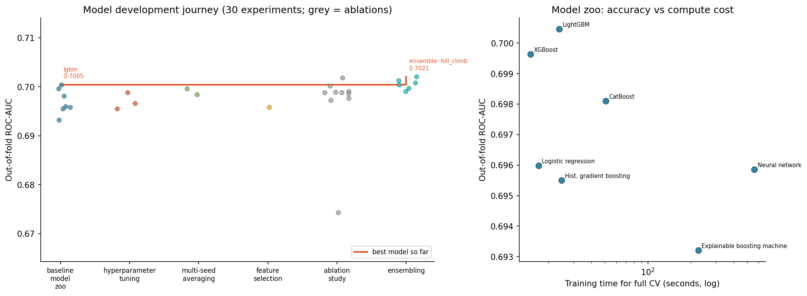
Figure F.1. Model development journey (30 experiments; grey = ablations)
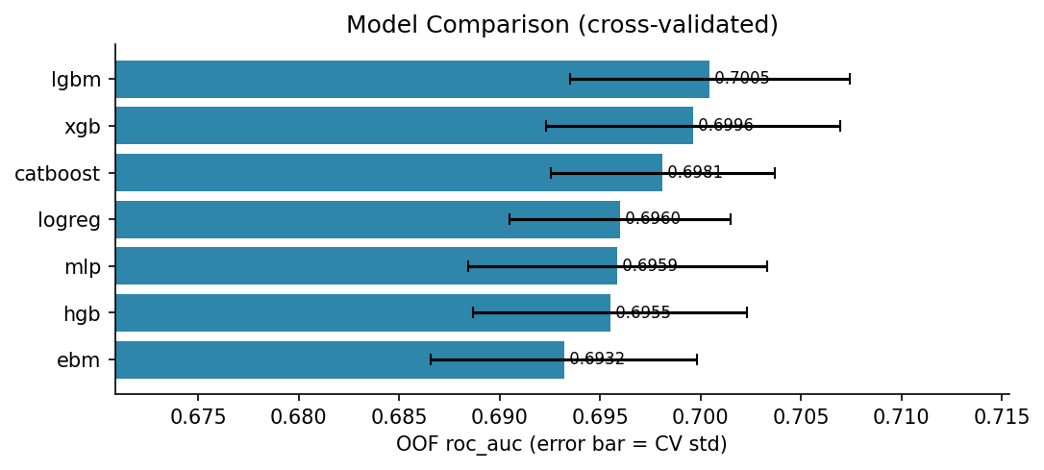
Figure F.2. Model Comparison (cross-validated)
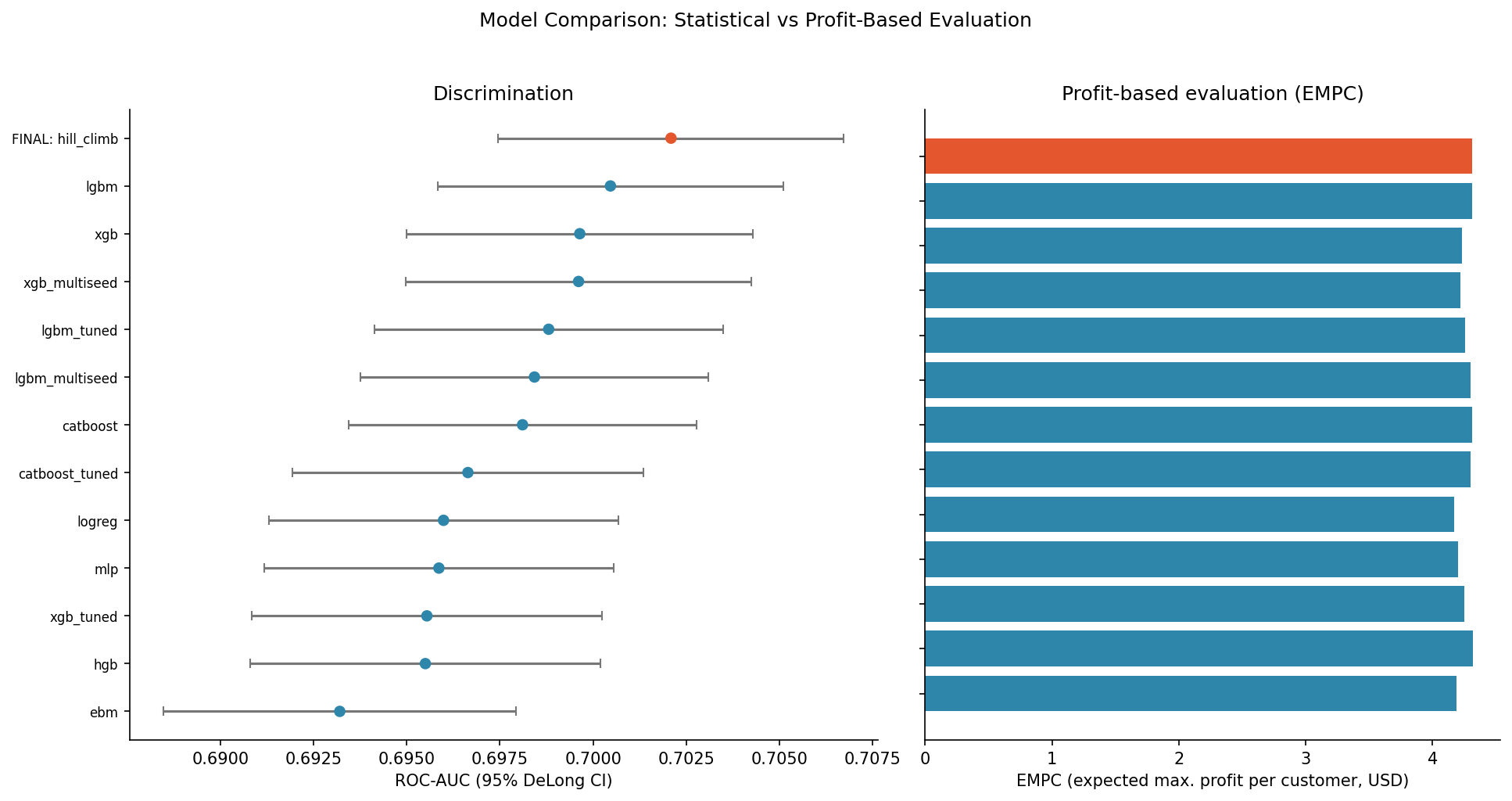
Figure F.3. Model Comparison: Statistical vs Profit-Based Evaluation
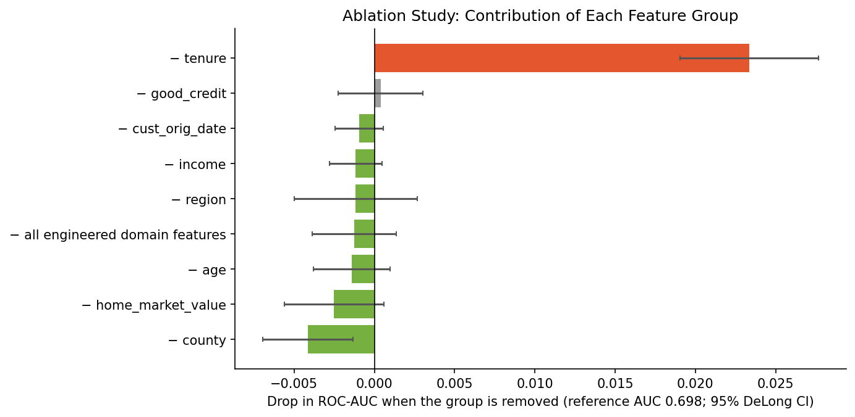
Figure F.4. Ablation Study: Contribution of Each Feature Group
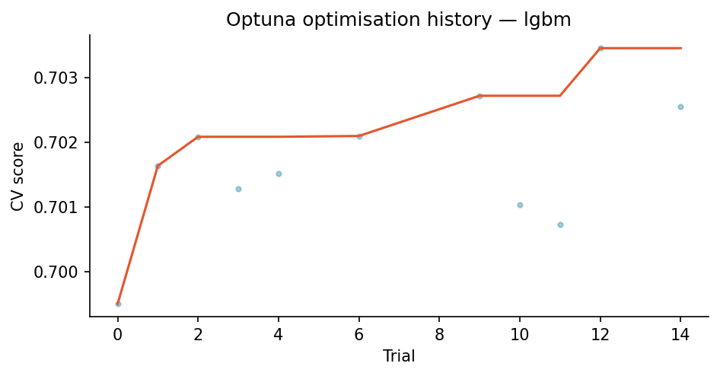
Figure F.5. Optuna optimisation history — lgbm
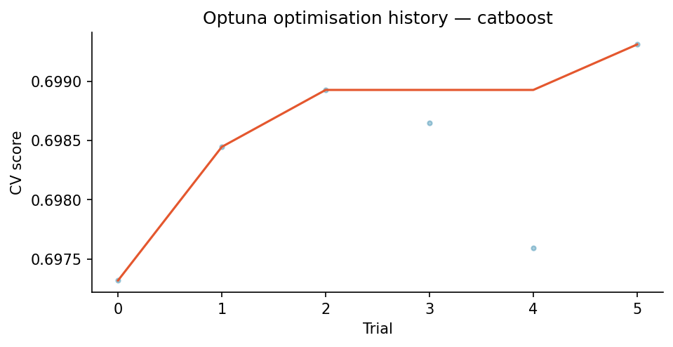
Figure F.6. Optuna optimisation history — catboost
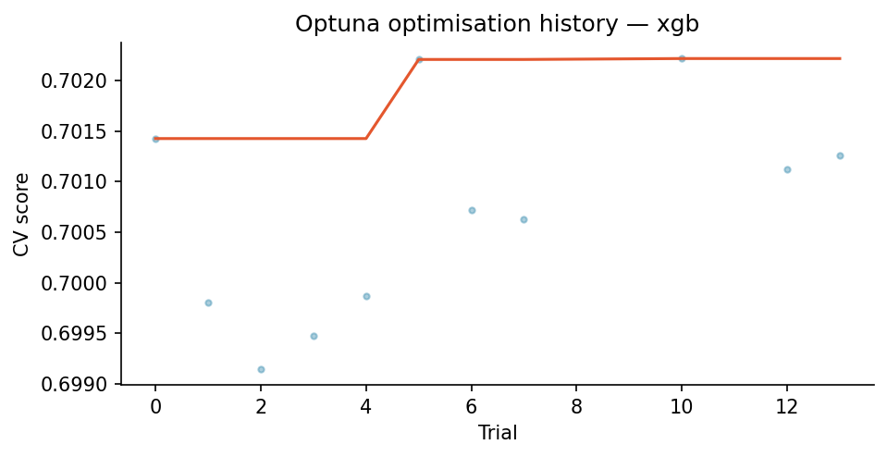
Figure F.7. Optuna optimisation history — xgb
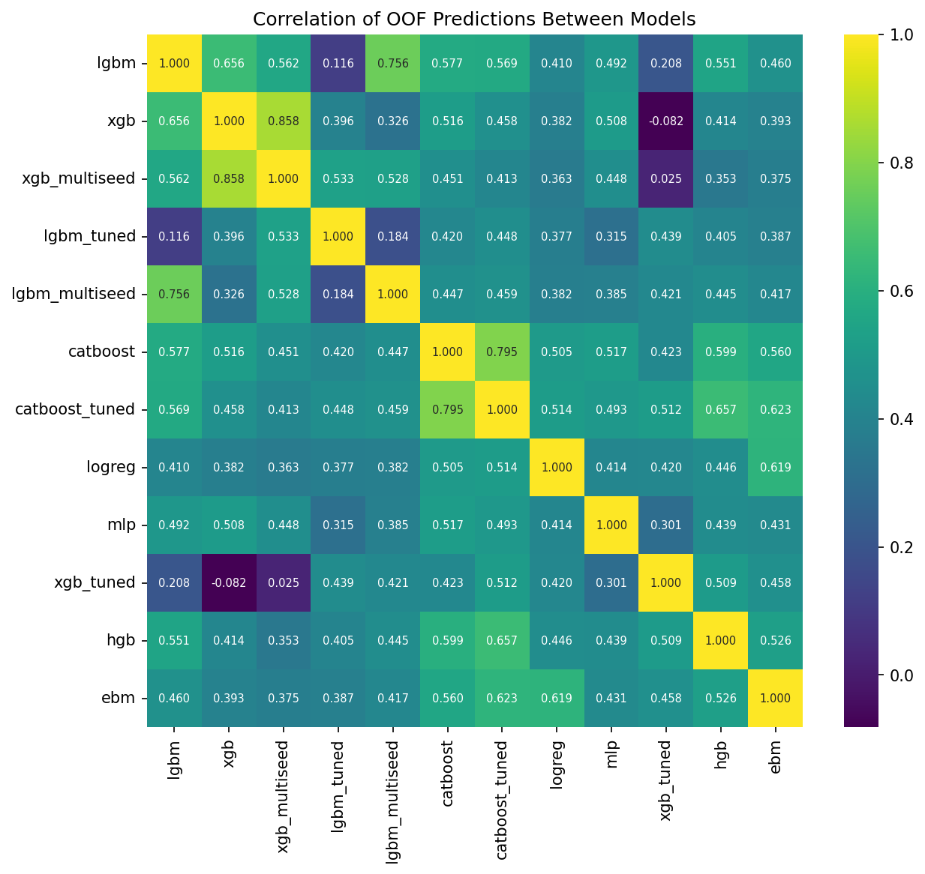
Figure F.8. Correlation of OOF Predictions Between Models
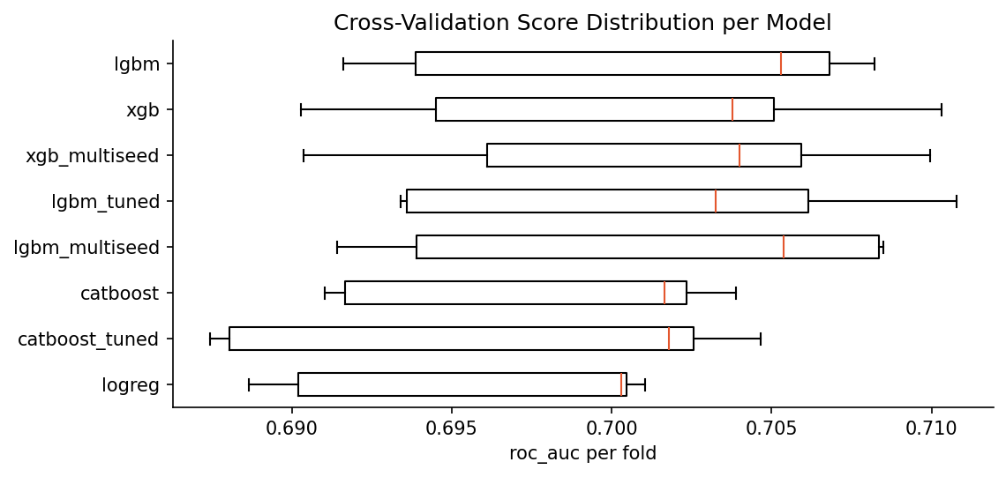
Figure F.9. Cross-Validation Score Distribution per Model
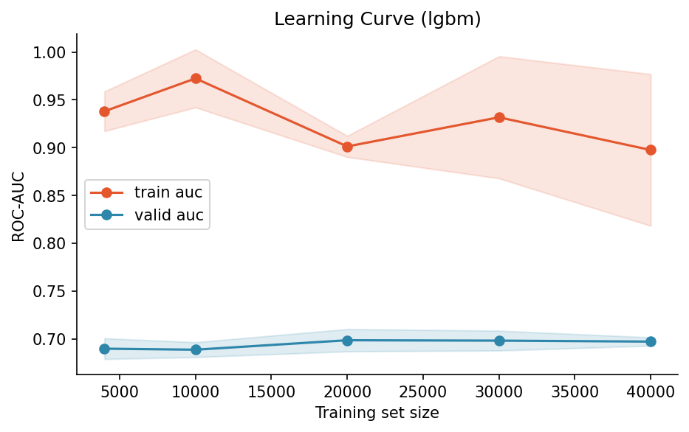
Figure F.10. Learning Curve (lgbm)
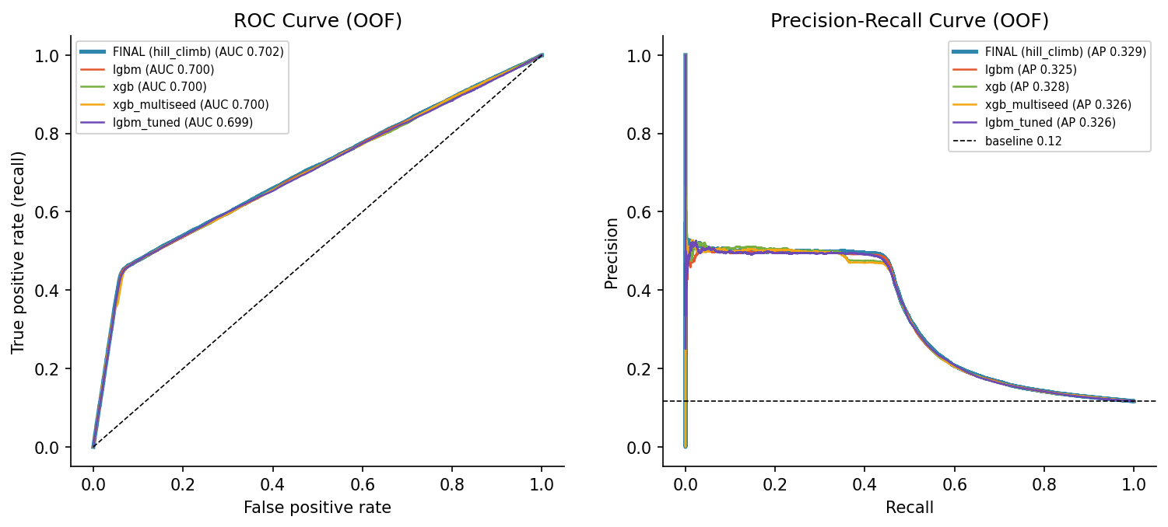
Figure F.11. ROC Curve (OOF)
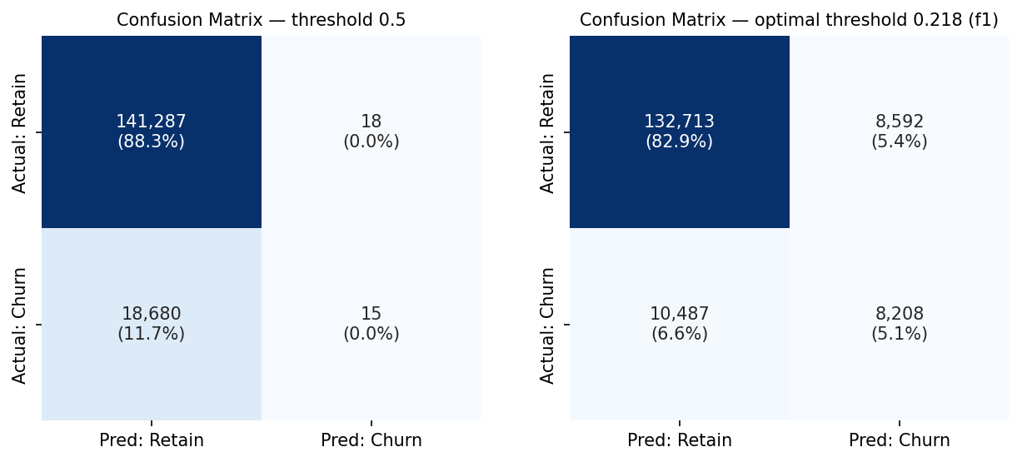
Figure F.12. Confusion Matrix — threshold 0.5
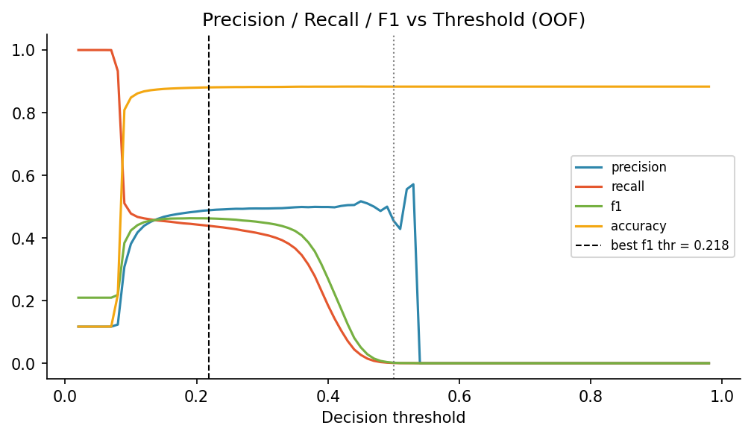
Figure F.13. Precision / Recall / F1 vs Threshold (OOF)
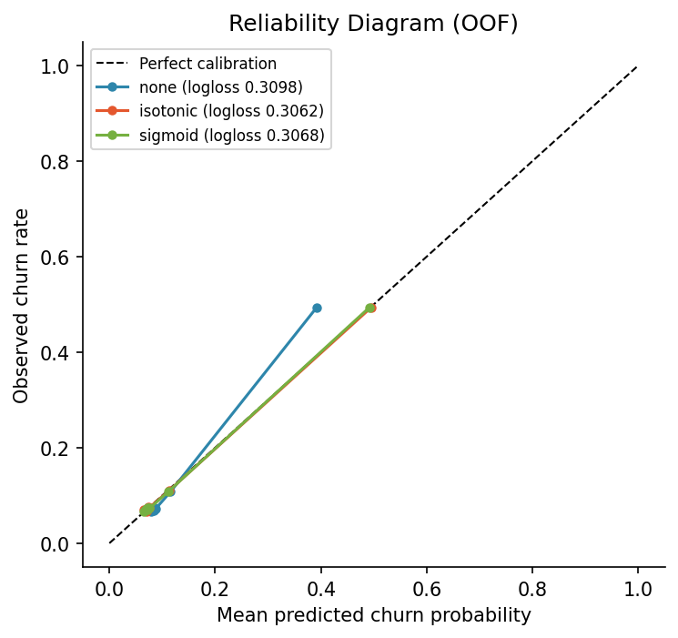
Figure F.14. Reliability Diagram (OOF)
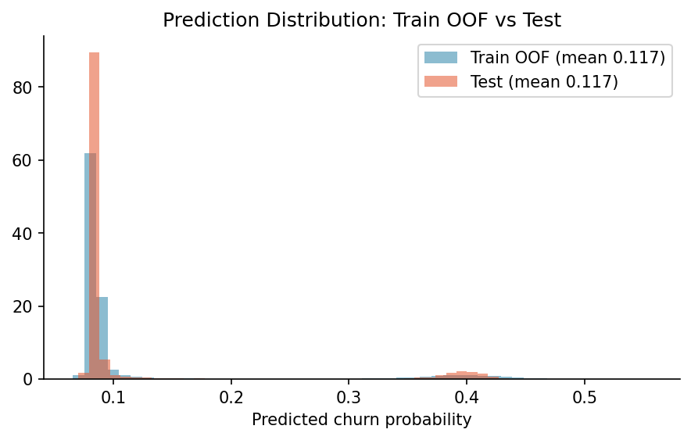
Figure F.15. Prediction Distribution: Train OOF vs Test
Table F.1. Highest-risk segments and the most loyal segment.
Segment (decision-tree rule) | Customers | Churn rate | Lift
tenure band = 0-6m AND cust orig date month ≥ 7 AND age in years ≤ 45 | 5,105 | 50.9% | 4.4×
tenure band = 0-6m AND cust orig date month ≥ 7 AND age in years ≥ 46 AND curr ann amt ≤ 994.28 | 3,404 | 49.4% | 4.2×
tenure band = 0-6m AND cust orig date month ≥ 7 AND age in years ≥ 46 AND curr ann amt > 994.28 | 3,367 | 48.6% | 4.2×
tenure band ≠ 0-6m AND tenure band ≠ 6-12m AND tenure band ≠ 1-2y AND latitude ≤ 32.85 | 77,717 | 6.9% | 0.6×

Table F.2. Full model comparison: AUC with DeLong CI, PR-AUC, Brier, ECE, KS and EMPC.
Model | Roc auc | Auc ci low | Auc ci high | Pr auc | Brier | Ece | Ks | Empc per customer | Delong p holm
FINAL: hill_climb | 0.702 | 0.697 | 0.707 | 0.329 | 0.088 | 0.021 | 0.386 | 4.312
lgbm | 0.700 | 0.696 | 0.705 | 0.325 | 0.088 | 0.013 | 0.386 | 4.309 | 0.210
xgb | 0.700 | 0.695 | 0.704 | 0.328 | 0.090 | 0.022 | 0.383 | 4.231 | 0.149
xgb_multiseed | 0.700 | 0.695 | 0.704 | 0.326 | 0.092 | 0.032 | 0.383 | 4.220 | 0.135
lgbm_tuned | 0.699 | 0.694 | 0.703 | 0.326 | 0.090 | 0.027 | 0.383 | 4.253 | 0.141
lgbm_multiseed | 0.698 | 0.694 | 0.703 | 0.322 | 0.090 | 0.025 | 0.386 | 4.298 | 0.077
catboost | 0.698 | 0.693 | 0.703 | 0.329 | 0.087 | 0.004 | 0.386 | 4.311 | 0.081
catboost_tuned | 0.697 | 0.692 | 0.701 | 0.327 | 0.087 | 0.004 | 0.386 | 4.299 | 0.012
logreg | 0.696 | 0.691 | 0.701 | 0.326 | 0.088 | 0.008 | 0.375 | 4.171 | 0.013
mlp | 0.696 | 0.691 | 0.701 | 0.323 | 0.088 | 0.013 | 0.379 | 4.200 | 0.008
xgb_tuned | 0.696 | 0.691 | 0.700 | 0.320 | 0.090 | 0.025 | 0.384 | 4.248 | 0.030
hgb | 0.696 | 0.691 | 0.700 | 0.324 | 0.087 | 0.005 | 0.386 | 4.319 | 0.003
ebm | 0.693 | 0.688 | 0.698 | 0.325 | 0.088 | 0.007 | 0.379 | 4.188 | 2.3e-05

Table F.3. Ablation study by feature group (DeLong tests, Holm-corrected) (first 10 columns; full table in report_tables.xlsx).
Ablation | N features removed | Features | Auc full | Auc without | Auc drop | Ci low | Ci high | Delong p | Holm p
− tenure | 6 | days tenure, tenure (years), new customer (<12 months), cust orig date (days since), cust orig date year, tenure band | 0.698 | 0.674 | 0.023 | 0.019 | 0.028 | 1.7e-26 | 1.5e-25
− good credit | 1 | good credit | 0.698 | 0.697 | 3.9e-04 | -0.002 | 0.003 | 0.773 | 1.000
− cust orig date | 1 | cust orig date month | 0.698 | 0.699 | -9.6e-04 | -0.002 | 5.4e-04 | 0.211 | 1.000
− income | 1 | income | 0.698 | 0.699 | -0.001 | -0.003 | 4.7e-04 | 0.163 | 0.976
− region | 1 | city | 0.698 | 0.699 | -0.001 | -0.005 | 0.003 | 0.550 | 1.000
− all engineered domain features | 9 | tenure (years), new customer (<12 months), premium-to-income ratio, cust orig date (days since), cust orig date year, cust orig date month, number of missing fields, tenure band | 0.698 | 0.699 | -0.001 | -0.004 | 0.001 | 0.346 | 1.000
− age | 2 | age in years, age band | 0.698 | 0.699 | -0.001 | -0.004 | 9.9e-04 | 0.251 | 1.000
− home market value | 1 | home market value | 0.698 | 0.700 | -0.003 | -0.006 | 5.9e-04 | 0.113 | 0.791
− county | 1 | county | 0.698 | 0.702 | -0.004 | -0.007 | -0.001 | 0.004 | 0.031

Table F.4. Ensemble methods compared.
Method | Oof roc auc | Oof auc | Weights
best_single | 0.700 | 0.700 | {'lgbm': 1.0}
mean_top3 | 0.701 | 0.701 | {'lgbm': 0.333, 'xgb': 0.333, 'xgb_multiseed': 0.333}
rank_mean_top3 | 0.701 | 0.701 | {'lgbm': 0.333, 'xgb': 0.333, 'xgb_multiseed': 0.333}
hill_climb | 0.702 | 0.702 | {'lgbm': 0.5, 'lgbm_tuned': 0.5}
optimized_weights | 0.699 | 0.699 | {'lgbm': 0.22, 'lgbm_tuned': 0.061, 'catboost': 0.207, 'catboost_tuned': 0.501, 'mlp': 0.011}
stacking_logreg | 0.700 | 0.700 | {'lgbm': 0.51, 'xgb': 0.249, 'xgb_multiseed': -0.167, 'lgbm_tuned': 0.238, 'lgbm_multiseed': -0.151, 'catboost': 0.6, 'catboost_tuned': -0.095, 'logreg': -0.191, 'mlp': 0.008, 'xgb_tuned': 0.16}

Table F.5. Bootstrap 95% confidence intervals for the final model.
Metric | Estimate | Ci low | Ci high
roc_auc | 0.702 | 0.698 | 0.707
pr_auc | 0.329 | 0.322 | 0.337
logloss | 0.310 | 0.307 | 0.313

Table F.6. Experiment log (all logged runs).
Exp id | Stage | Experiment | Note | Roc auc | Pr auc | Logloss | Time s
1 | 1 baseline model zoo | dummy | Baseline (prior), default hyperparameters | 0.500 | 0.117 | 0.361 | 2.589
2 | 1 baseline model zoo | logreg | Logistic regression, default hyperparameters | 0.696 | 0.326 | 0.310 | 17.1
3 | 1 baseline model zoo | hgb | Hist. gradient boosting, default hyperparameters | 0.696 | 0.324 | 0.307 | 24.8
4 | 1 baseline model zoo | lgbm | LightGBM, default hyperparameters | 0.700 | 0.325 | 0.310 | 23.9
5 | 1 baseline model zoo | xgb | XGBoost, default hyperparameters | 0.700 | 0.328 | 0.315 | 15.0
6 | 1 baseline model zoo | catboost | CatBoost, default hyperparameters | 0.698 | 0.329 | 0.307 | 50.5
7 | 1 baseline model zoo | ebm | Explainable boosting machine (EBM), default hyperparameters | 0.693 | 0.325 | 0.309 | 226.2
8 | 1 baseline model zoo | mlp | Neural network (MLP), default hyperparameters | 0.696 | 0.323 | 0.311 | 559.4
9 | 2 hyperparameter tuning | lgbm_tuned | Optuna TPE, 11 trials, 3-fold inner CV | 0.699 | 0.326 | 0.314 | 26.9
10 | 2 hyperparameter tuning | catboost_tuned | Optuna TPE, 6 trials, 3-fold inner CV | 0.697 | 0.327 | 0.307 | 34.0
11 | 2 hyperparameter tuning | xgb_tuned | Optuna TPE, 11 trials, 3-fold inner CV | 0.696 | 0.320 | 0.316 | 11.9
12 | 3 multi-seed averaging | lgbm_multiseed | average of 2 seeds (base: lgbm) | 0.698 | 0.322 | 0.315 | 40.6
13 | 3 multi-seed averaging | xgb_multiseed | average of 2 seeds (base: xgb) | 0.700 | 0.326 | 0.321 | 25.4
14 | 4 feature selection | lgbm_fs | drop 9 features with permutation importance ≤ 0 | 0.696 | 0.310 | 0.319 | 28.6
15 | 5 ablation study | ablation reference (all features) | reference for ablation (same folds & params) | 0.698 | 0.321 | 0.316 | 13.9
16 | 5 ablation study | ablation − tenure | drop 6 feature(s): days tenure, tenure (years), new customer (<12 months), cust orig date (days since)… | 0.674 | 0.255 | 0.334 | 18.9
17 | 5 ablation study | ablation − age | drop 2 feature(s): age in years, age band | 0.699 | 0.322 | 0.315 | 10.5
18 | 5 ablation study | ablation − county | drop 1 feature(s): county | 0.702 | 0.326 | 0.311 | 10.8
19 | 5 ablation study | ablation − income | drop 1 feature(s): income | 0.699 | 0.322 | 0.311 | 10.9
20 | 5 ablation study | ablation − home market value | drop 1 feature(s): home market value | 0.700 | 0.326 | 0.308 | 11.0
21 | 5 ablation study | ablation − cust orig date | drop 1 feature(s): cust orig date month | 0.699 | 0.318 | 0.315 | 11.4
22 | 5 ablation study | ablation − region | drop 1 feature(s): city | 0.699 | 0.325 | 0.315 | 9.099
23 | 5 ablation study | ablation − good credit | drop 1 feature(s): good credit | 0.697 | 0.321 | 0.311 | 12.5
24 | 5 ablation study | ablation − all engineered domain features | drop 9 feature(s): tenure (years), new customer (<12 months), premium-to-income ratio, cust orig date (days since)… | 0.699 | 0.322 | 0.313 | 14.2
25 | 6 ensembling | ensemble: best_single | lgbm 1.00 | 0.700 | 0.325 | 0.310
26 | 6 ensembling | ensemble: mean_top3 | lgbm 0.33, xgb 0.33, xgb_multiseed 0.33 | 0.701 | 0.329 | 0.313
27 | 6 ensembling | ensemble: rank_mean_top3 | lgbm 0.33, xgb 0.33, xgb_multiseed 0.33 | 0.701 | 0.329 | 0.798
28 | 6 ensembling | ensemble: hill_climb | lgbm 0.50, lgbm_tuned 0.50 | 0.702 | 0.329 | 0.310
29 | 6 ensembling | ensemble: optimized_weights | lgbm 0.22, lgbm_tuned 0.06, catboost 0.21, catboost_tuned 0.50, mlp 0.01 | 0.699 | 0.329 | 0.307
30 | 6 ensembling | ensemble: stacking_logreg | lgbm 0.51, xgb 0.25, xgb_multiseed -0.17, lgbm_tuned 0.24, lgbm_multiseed -0.15, catboost 0.60, catboost_tuned -0.10, logreg -0.19, mlp 0.01, xgb_tuned 0.16 | 0.700 | 0.328 | 0.306

Table F.7. Train–test drift (PSI, KS; top 15).
Feature | Psi | Ks stat | Ks p | N unseen levels | Unseen rows % | Psi flag
city | 0.003 |  |  | 0 | 0 | stable
length of residence | 4.9e-04 | 0.005 | 0.409 |  |  | stable
latitude | 4.3e-04 | 0.007 | 0.193 |  |  | stable
longitude | 3.2e-04 | 0.006 | 0.249 |  |  | stable
curr ann amt | 2.8e-04 | 0.004 | 0.686 |  |  | stable
days tenure | 2.4e-04 | 0.004 | 0.545 |  |  | stable
cust orig date (days since) | 2.4e-04 | 0.004 | 0.545 |  |  | stable
tenure (years) | 2.4e-04 | 0.004 | 0.545 |  |  | stable
county | 2.3e-04 |  |  | 0 | 0 | stable
premium-to-income ratio | 2.1e-04 | 0.004 | 0.788 |  |  | stable
age in years | 2.1e-04 | 0.005 | 0.399 |  |  | stable
cust orig date month | 1.7e-04 | 0.002 | 0.997 |  |  | stable
cust orig date year | 1.5e-04 | 0.004 | 0.752 |  |  | stable
home owner | 1.5e-04 |  |  | 0 | 0 | stable
income | 1.4e-04 | 0.003 | 0.973 |  |  | stable

Appendix G. Explainability
Global and local explanations: gain, permutation and SHAP importance, dependence and partial dependence, individual explanations and segment heterogeneity.
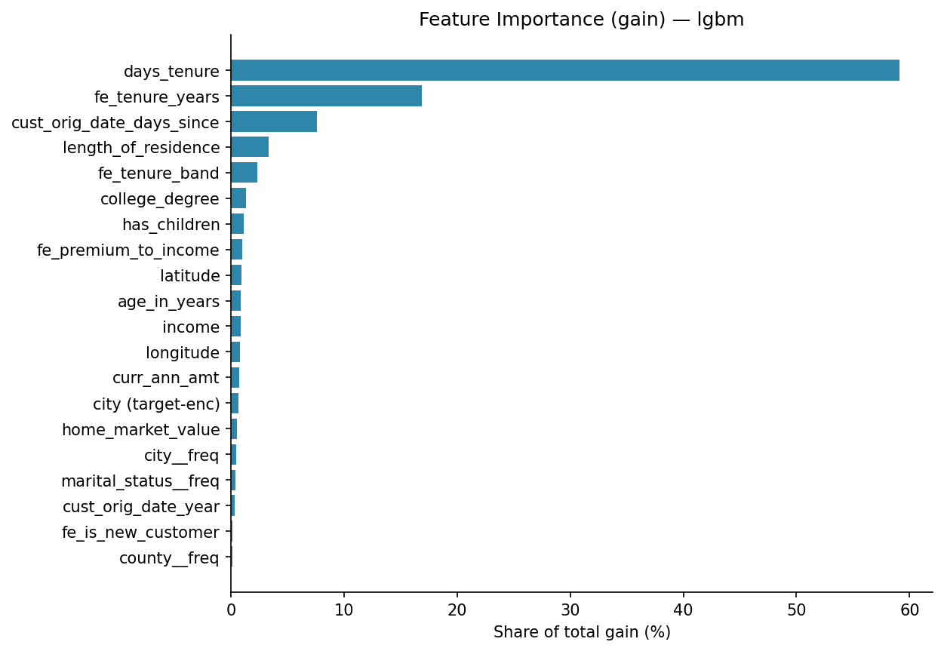
Figure G.1. Feature Importance (gain) — lgbm
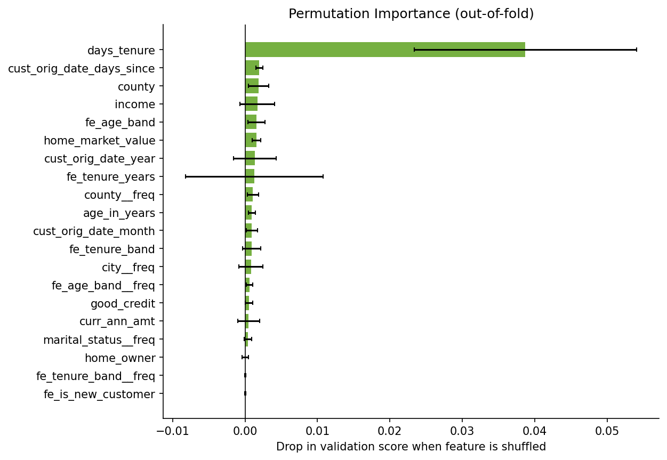
Figure G.2. Permutation Importance (out-of-fold)
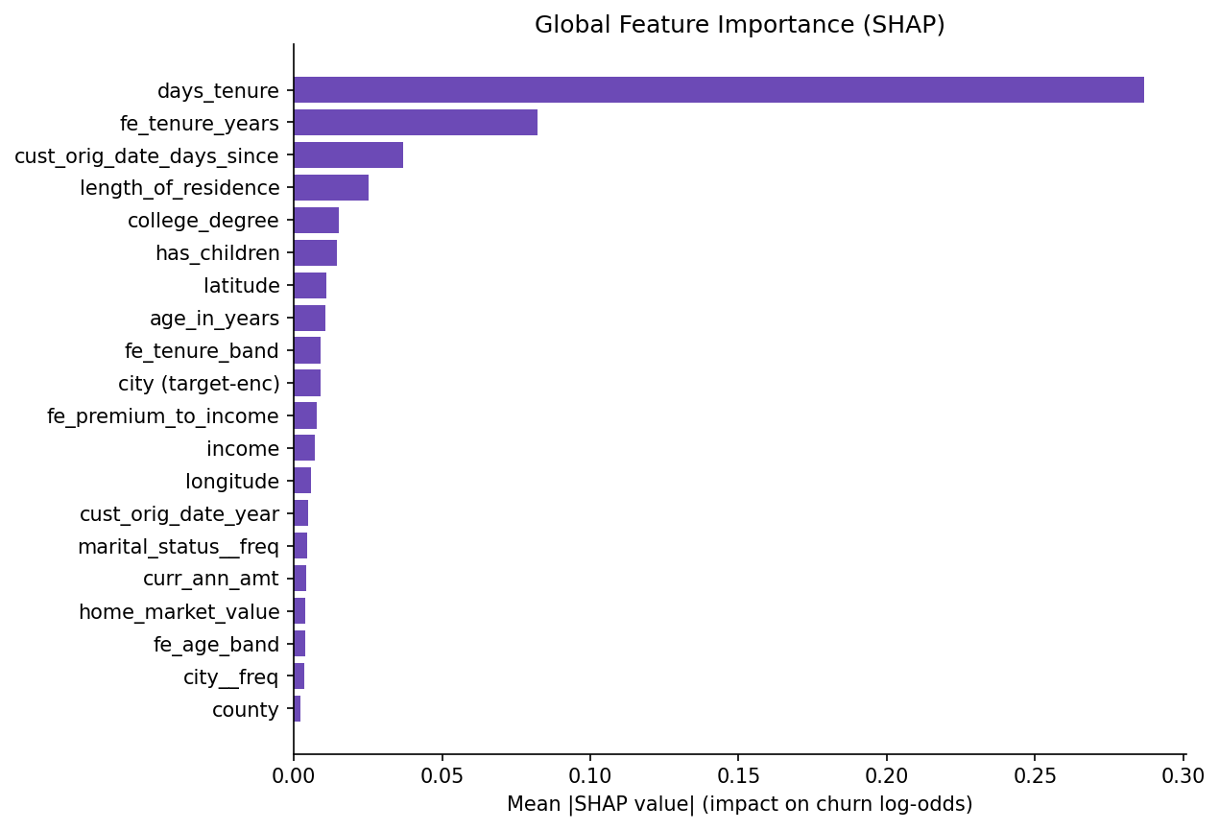
Figure G.3. Global Feature Importance (SHAP)
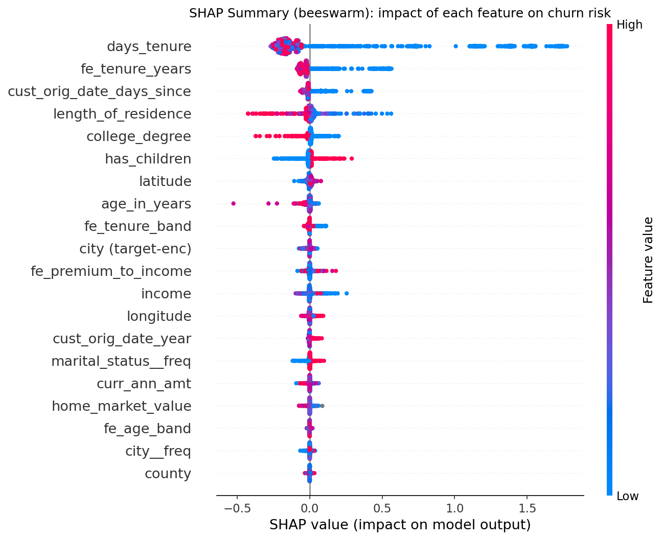
Figure G.4. SHAP summary: each dot is a customer; positive values push churn risk up (colour = feature value).
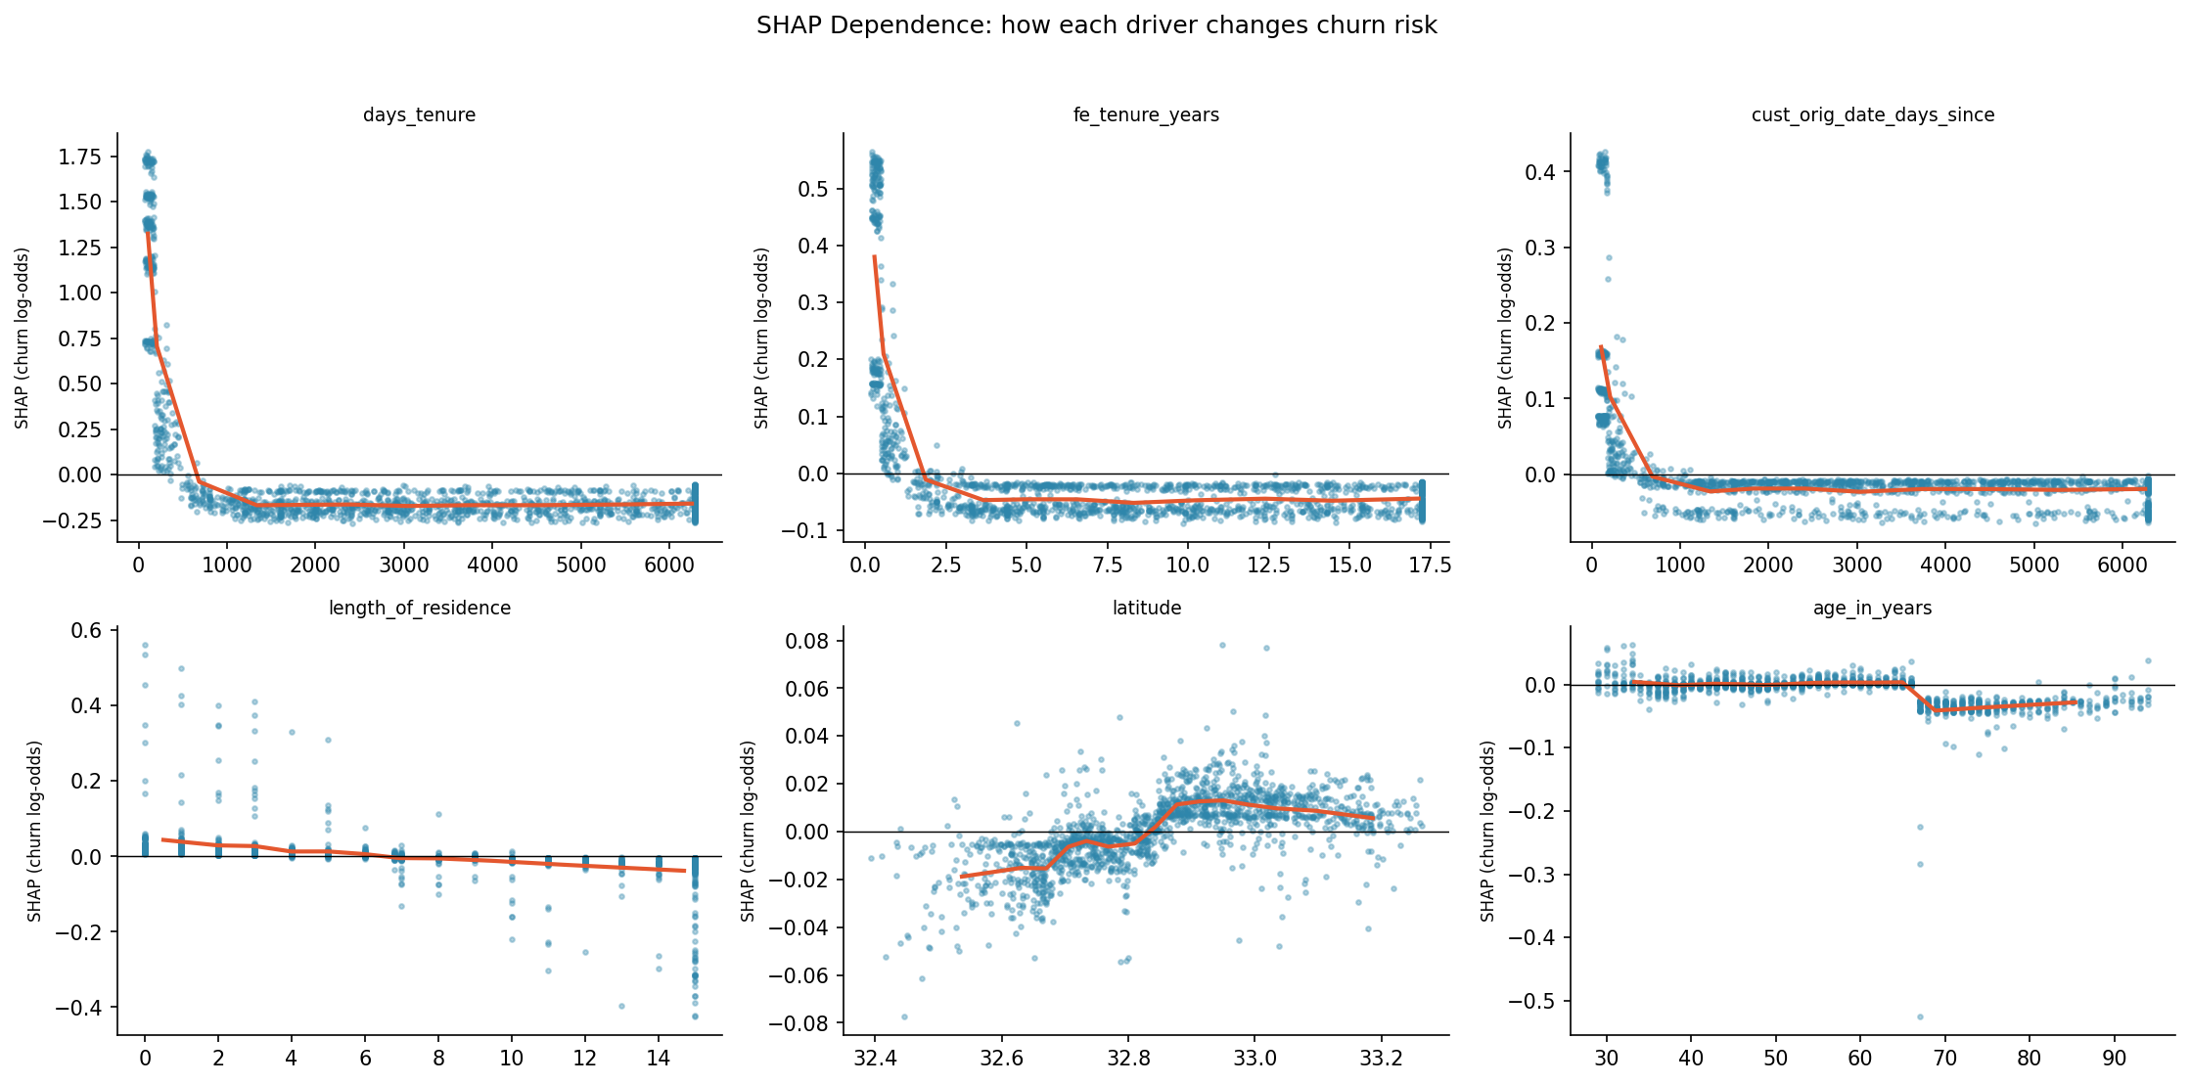
Figure G.5. SHAP Dependence: how each driver changes churn risk
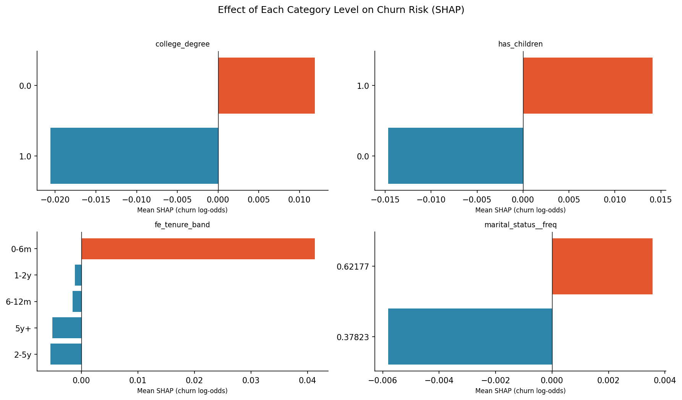
Figure G.6. Effect of Each Category Level on Churn Risk (SHAP)
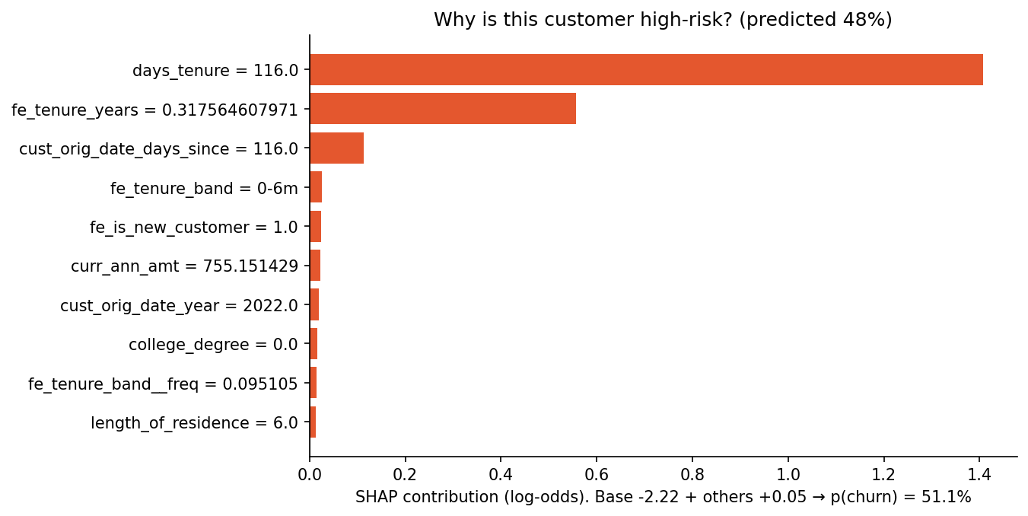
Figure G.7. Why is this customer high-risk? (predicted 48%)
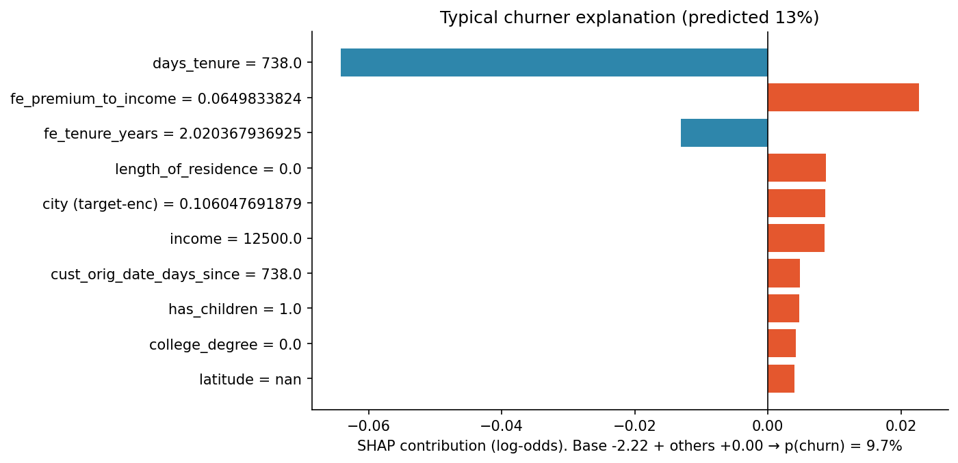
Figure G.8. Typical churner explanation (predicted 13%)
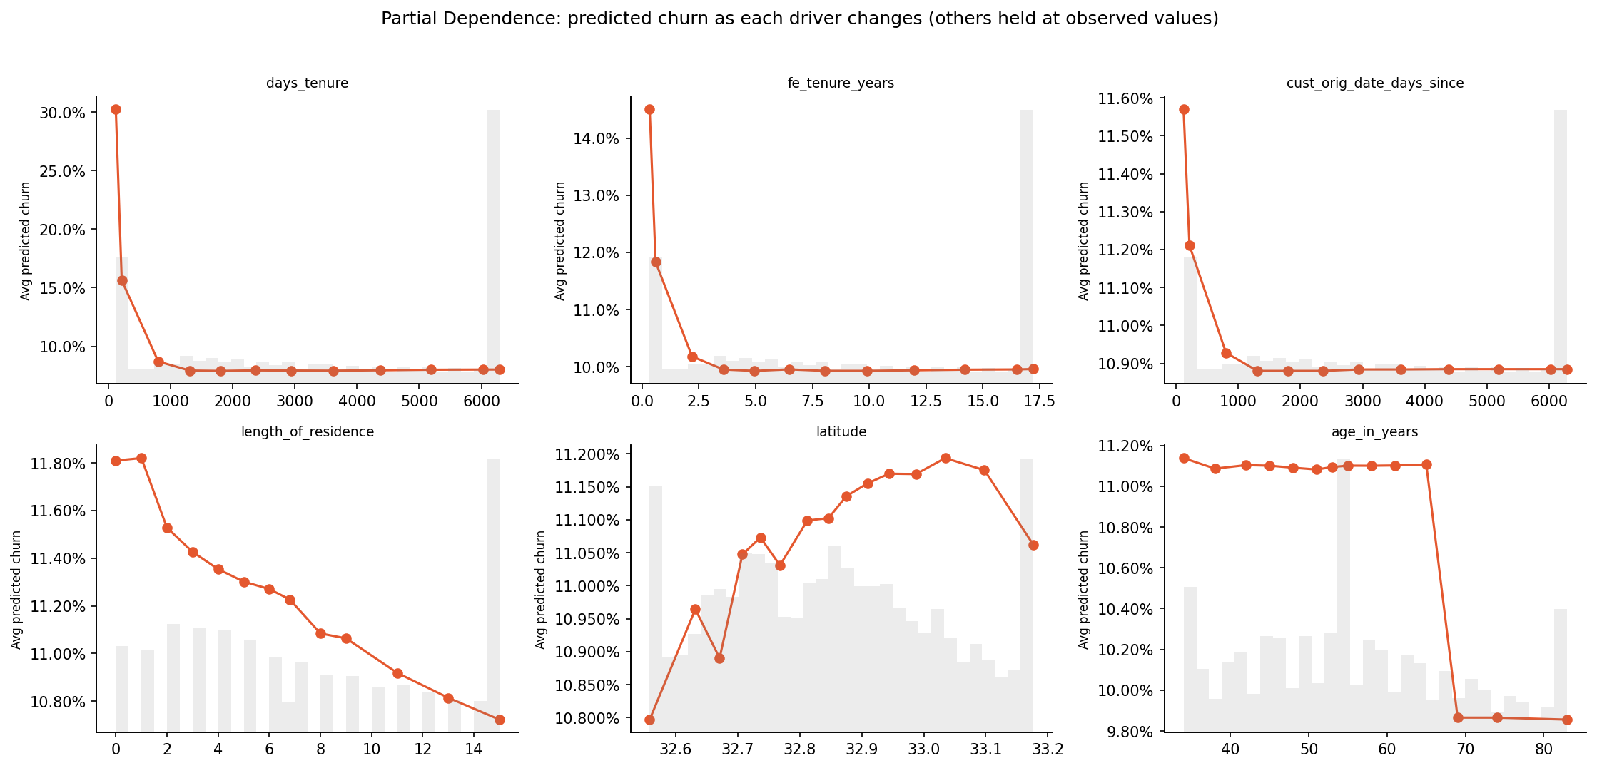
Figure G.9. Partial Dependence: predicted churn as each driver changes (others held at observed values)
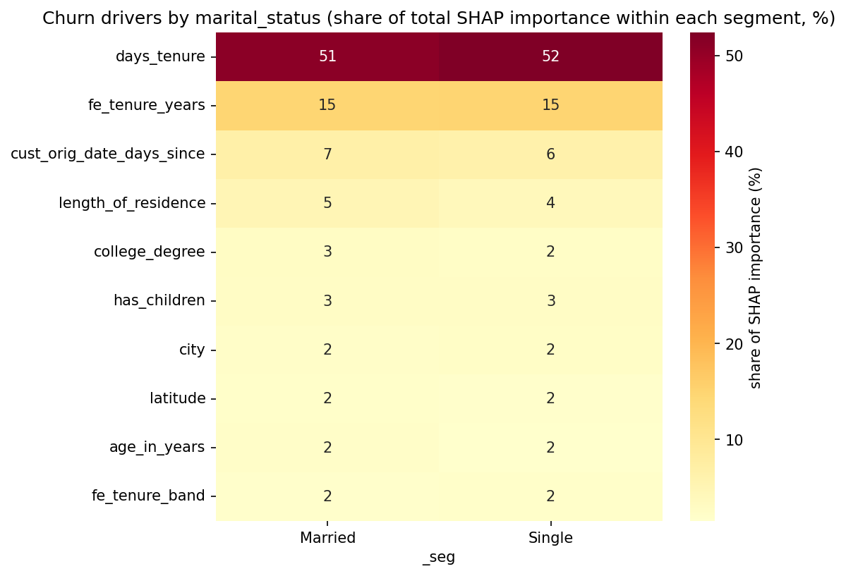
Figure G.10. Churn drivers by marital status (share of total SHAP importance within each segment, %)
Table G.1. SHAP importance and direction of effect (top 20).
Feature | Mean abs shap | Share % | Direction
days tenure | 0.287 | 51.6 | higher value → lower churn risk
tenure (years) | 0.082 | 14.8 | higher value → lower churn risk
cust orig date (days since) | 0.037 | 6.609 | higher value → lower churn risk
length of residence | 0.025 | 4.538 | higher value → lower churn risk
college degree | 0.015 | 2.696 | riskiest: '0.0' (+0.01); safest: '1.0' (-0.02)
has children | 0.014 | 2.587 | riskiest: '1.0' (+0.01); safest: '0.0' (-0.01)
latitude | 0.011 | 1.973 | higher value → higher churn risk
age in years | 0.011 | 1.929 | higher value → lower churn risk
tenure band | 0.009 | 1.626 | riskiest: '0-6m' (+0.04); safest: '2-5y' (-0.01)
city (target-enc) | 0.009 | 1.607 | higher value → higher churn risk
premium-to-income ratio | 0.008 | 1.360 | non-monotonic / mixed
income | 0.007 | 1.293 | non-monotonic / mixed
longitude | 0.006 | 1.019 | higher value → higher churn risk
cust orig date year | 0.005 | 0.864 | higher value → higher churn risk
marital_status__freq | 0.004 | 0.804 | riskiest: '0.62177' (+0.00); safest: '0.37823' (-0.01)
curr ann amt | 0.004 | 0.744 | higher value → lower churn risk
home market value | 0.004 | 0.713 | higher value → lower churn risk
age band | 0.004 | 0.695 | riskiest: '55-64' (+0.00); safest: '65+' (-0.00)
city__freq | 0.003 | 0.607 | higher value → higher churn risk
county | 0.002 | 0.415 | riskiest: 'Dallas' (+0.00); safest: 'Parker' (-0.00)

Table G.2. Consolidated driver evidence matrix (first 10 columns; full table in report_tables.xlsx).
Feature | Iv | Effect size | Q value BH | Highest risk level | Highest risk rate | Odds ratio | Hazard ratio | Shap rank | Evidence score
tenure band | 0.885 | 0.381 | 0 | 0-6m | 0.488 | 12.2 |  | 10 | 3
age band | 0.038 | 0.060 | 3.1e-120 | 25-34 | 0.146 | 0.921 | 0.484 | 16 | 3
days tenure | 0.855 | -0.391 | 0 | 20–191 | 0.473 |  |  | 1 | 2
tenure (years) | 0.855 | -0.391 | 0 | 0.0548–0.523 | 0.473 |  |  | 2 | 2
cust orig date (days since) | 0.855 | -0.391 | 0 | 20–191 | 0.473 |  |  | 3 | 2
length of residence | 0.011 | -0.061 | 1.9e-41 | 0–1 | 0.135 |  |  | 4 | 2
college degree | 0.004 | 0.021 | 5.4e-17 | 0 | 0.122 |  |  | 5 | 2
has children | 0.005 | 0.022 | 1.2e-17 | 1 | 0.123 |  |  | 6 | 2
age in years | 0.038 | -0.094 | 3.8e-96 | 23–37 | 0.143 |  |  | 9 | 2
latitude | 0.002 | 0.009 | 0.082 | Missing | 0.124 |  |  | 8 | 1
premium-to-income ratio | 0.002 | 0.017 | 1.7e-04 | 0.0182–0.0232 | 0.124 |  |  | 11 | 1
cust orig date year | 0.713 | 0.378 | 0 | 2,020–2,022 | 0.348 |  |  | 15 | 1
curr ann amt | 0.003 | 0.030 | 3.8e-11 | 1,261–2,108 | 0.126 |  |  | 17 | 1
new customer (<12 months) | 0.759 | 0.338 | 0 | 1 | 0.384 |  |  | 20 | 1
cust orig date month | 0.086 | -0.039 | 1.2e-18 | 6–7 | 0.201 | 1.011 |  | 21 | 1
number of missing fields | 0.002 | 0.011 | 1.0e-04 | ≥3 | 0.136 |  |  | 23 | 1
home owner | 0.001 | 0.012 | 3.4e-06 | 0 | 0.125 |  |  | 24 | 1
income | 4.3e-04 | -0.003 | 0.624 | 27.5K–37.5K | 0.120 |  |  | 12 | 0
marital status | 1.7e-04 | 0.004 | 0.113 | Single | 0.119 |  |  | 13 | 0
longitude | 0.002 | -0.001 | 0.772 | Missing | 0.124 |  |  | 14 | 0
home market value | 0.002 | -0.004 | 0.433 | Missing | 0.134 |  |  | 18 | 0
county | 6.3e-04 | 0.008 | 0.724 | Rockwall | 0.124 |  |  | 19 | 0
good credit | 2.6e-04 | 0.005 | 0.052 | 0 | 0.121 |  |  | 22 | 0

Appendix I. Business Analytics
Lift and gains, risk tiers, risk × value prioritisation, campaign simulation and sensitivity, churn personas.
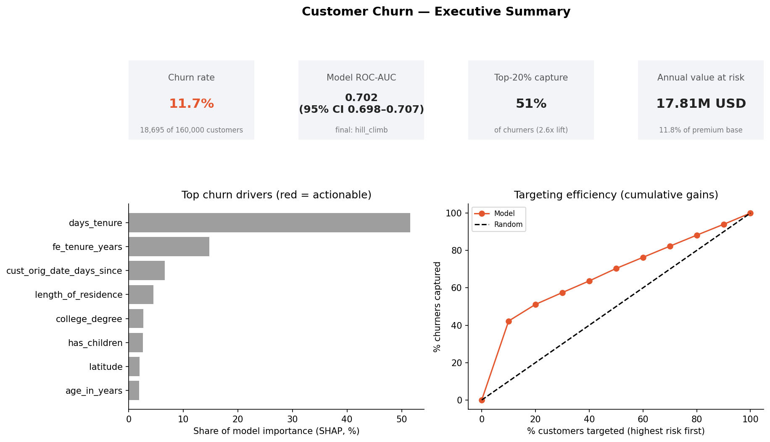
Figure I.1. Customer Churn — Executive Summary
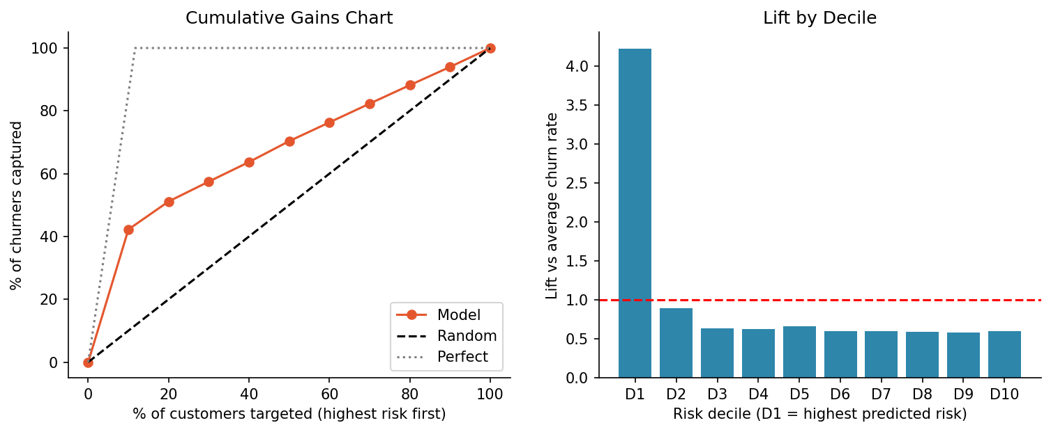
Figure I.2. Cumulative Gains Chart
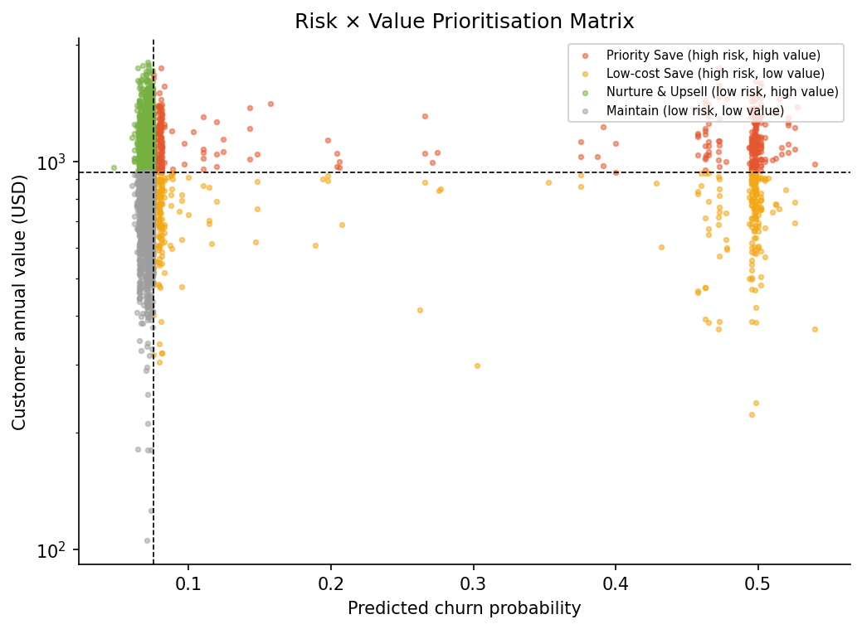
Figure I.3. Risk × Value Prioritisation Matrix
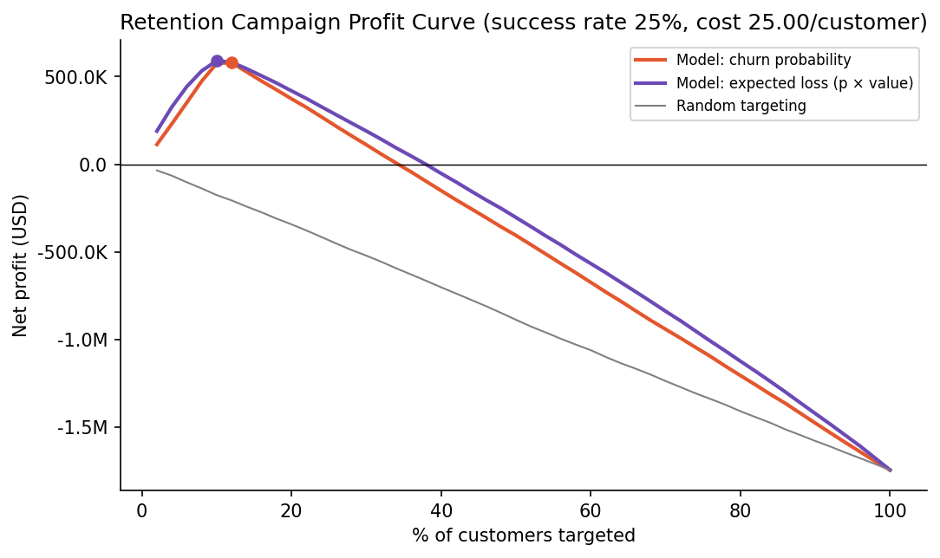
Figure I.4. Retention Campaign Profit Curve (success rate 25%, cost 25.00/customer)
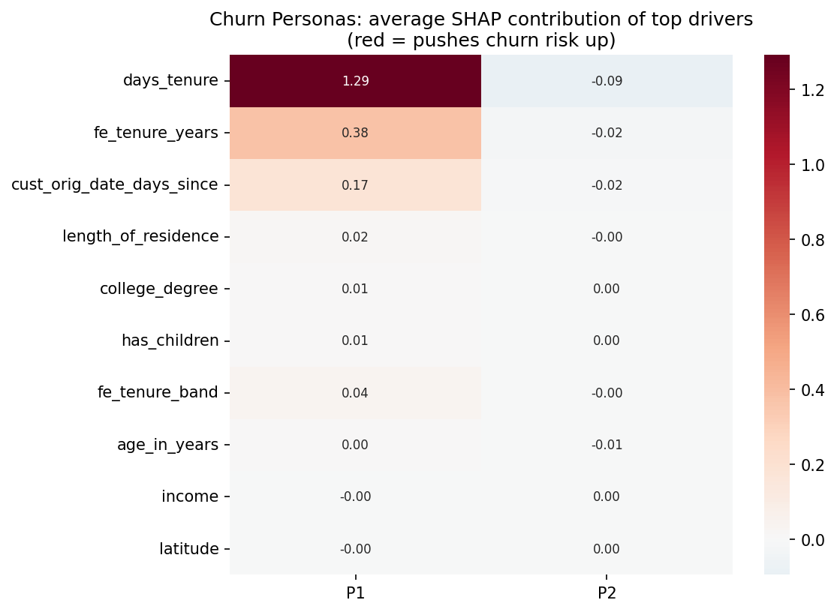
Figure I.5. Churn Personas: average SHAP contribution of top drivers
(red = pushes churn risk up)
Table I.1. Lift by risk decile.
Decile | N | Churners | Avg pred | Min pred | Churn rate | Lift | Cum customers % | Cum churners captured % | Cum lift
D1 | 16,000 | 7,896 | 0.494 | 0.458 | 0.493 | 4.224 | 10.0 | 42.2 | 4.224
D2 | 16,000 | 1,666 | 0.108 | 0.075 | 0.104 | 0.891 | 20.0 | 51.1 | 2.557
D3 | 16,000 | 1,183 | 0.075 | 0.074 | 0.074 | 0.633 | 30.0 | 57.5 | 1.916
D4 | 16,000 | 1,164 | 0.074 | 0.074 | 0.073 | 0.623 | 40.0 | 63.7 | 1.593
D5 | 16,000 | 1,245 | 0.073 | 0.072 | 0.078 | 0.666 | 50.0 | 70.4 | 1.407
D6 | 16,000 | 1,114 | 0.071 | 0.071 | 0.070 | 0.596 | 60.0 | 76.3 | 1.272
D7 | 16,000 | 1,116 | 0.071 | 0.071 | 0.070 | 0.597 | 70.0 | 82.3 | 1.176
D8 | 16,000 | 1,100 | 0.070 | 0.070 | 0.069 | 0.588 | 80.0 | 88.2 | 1.102
D9 | 16,000 | 1,085 | 0.068 | 0.066 | 0.068 | 0.580 | 90.0 | 94.0 | 1.044
D10 | 16,000 | 1,126 | 0.065 | 1.0e-04 | 0.070 | 0.602 | 100.0 | 100.0 | 1.000

Table I.2. Risk tiers.
Tier | N train | Actual churn rate | Avg predicted | Share churners % | N test
High | 35,105 | 0.280 | 0.281 | 52.6 | 6,581
Medium | 45,048 | 0.074 | 0.074 | 17.9 | 12,982
Low | 79,847 | 0.069 | 0.069 | 29.5 | 20,437

Table I.3. Risk × value quadrants.
Quadrant | N | Actual churn rate | Avg pred | Total value | Value at risk | Share value at risk %
Low-cost Save (high risk, low value) | 16,870 | 0.266 | 0.266 | 12.59M | 3.36M | 18.9
Maintain (low risk, low value) | 63,128 | 0.072 | 0.071 | 46.94M | 3.32M | 18.7
Nurture & Upsell (low risk, high value) | 61,767 | 0.070 | 0.071 | 70.21M | 4.97M | 27.9
Priority Save (high risk, high value) | 18,235 | 0.293 | 0.295 | 20.78M | 6.16M | 34.6

Table I.4. Optimal campaign size by strategy.
Strategy | Target % | N targeted | Churners reached | Benefit | Cost | Net profit | Roi
Model: churn probability | 12.0 | 19,200 | 8,597 | 1.06M | 480,000 | 578,864 | 1.206
Model: expected loss (p × value) | 10.0 | 16,000 | 7,809 | 990,809 | 400,000 | 590,809 | 1.477
Random targeting | 2.000 | 3,200 | 374.0 | 45,029 | 80,000 | -34,971 | -0.437

Table I.5. Campaign sensitivity analysis.
Success rate | Cost per contact | Optimal target % | Max net profit | Roi
0.125 | 12.5 | 10.2 | 296,717 | 1.459
0.125 | 25.0 | 6.083 | 102,486 | 0.421
0.125 | 50.0 | 2.000 | -25,579 | -0.160
0.250 | 12.5 | 14.2 | 823,789 | 2.891
0.250 | 25.0 | 10.2 | 593,435 | 1.459
0.250 | 50.0 | 6.083 | 204,971 | 0.421
0.375 | 12.5 | 63.3 | 1.55M | 1.227
0.375 | 25.0 | 10.2 | 1.09M | 2.689
0.375 | 50.0 | 10.2 | 686,827 | 0.844

Table I.6. Churn personas (first 10 columns; full table in report_tables.xlsx).
Persona | N in sample | Share of at risk % | Avg pred churn | Actual churn rate | Top drivers | Tenure band | Age band | Days tenure | Tenure (years)
P2 | 791 | 78.6 | 0.083 | 0.085 | no dominant driver (moderate, diffuse risk) | 5y+ | 45-54 | 3,674 | 10.1
P1 | 216 | 21.4 | 0.490 | 0.519 | days tenure (+1.29); tenure (years) (+0.38); cust orig date (days since) (+0.17) | 0-6m | 45-54 | 120.4 | 0.330

Appendix J. Governance, Deployment and Implementation
Fairness audit, model card, deployment loop, pilot design and implementation roadmap.
The model card follows Mitchell et al. (2019). The fairness audit compares calibration (mean predicted vs actual churn), discrimination (AUC) and selection into the High-risk tier across customer groups; differences in selection that mirror genuine differences in churn are expected, whereas calibration gaps would indicate bias. The score is restricted to retention outreach.
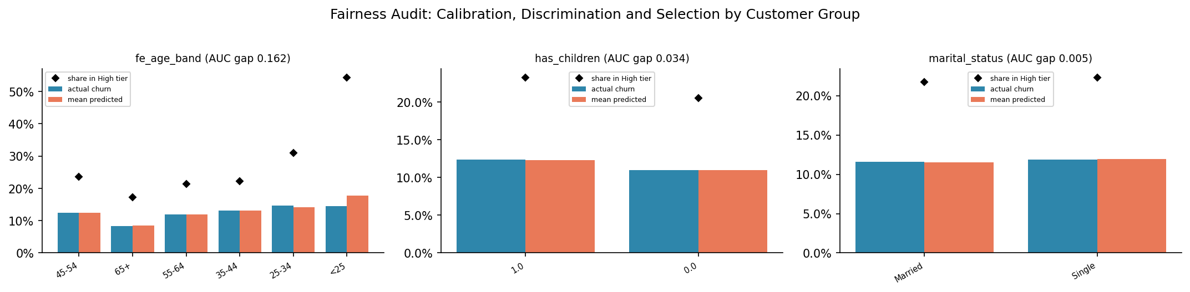
Figure J.1. Fairness Audit: Calibration, Discrimination and Selection by Customer Group
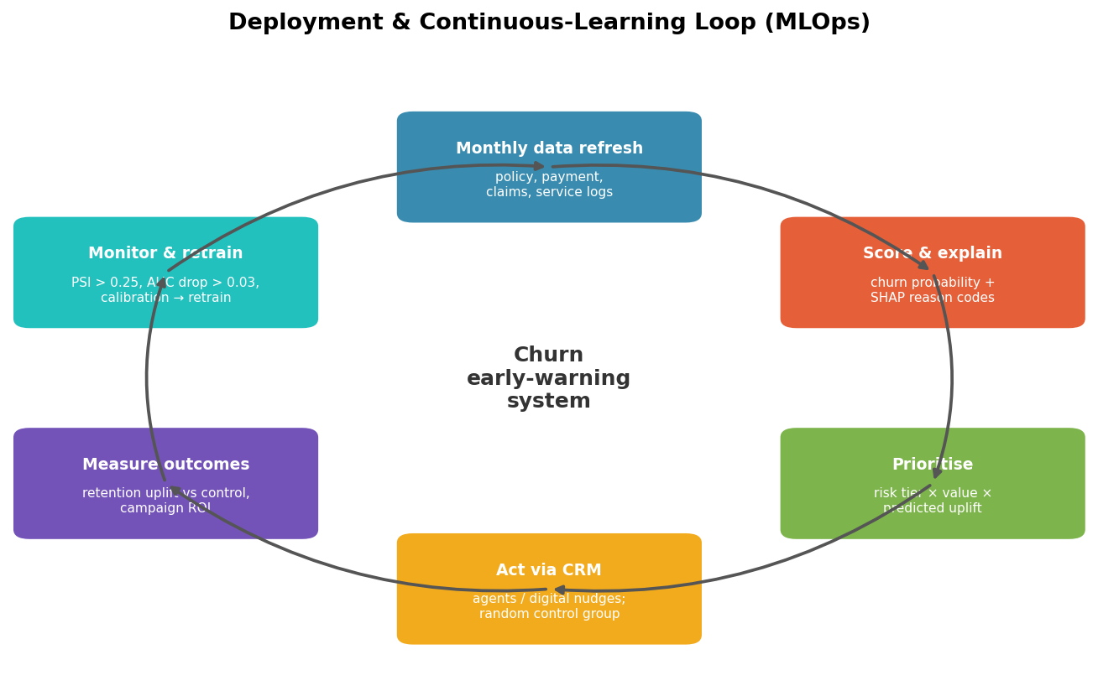
Figure J.2. Deployment & Continuous-Learning Loop (MLOps)
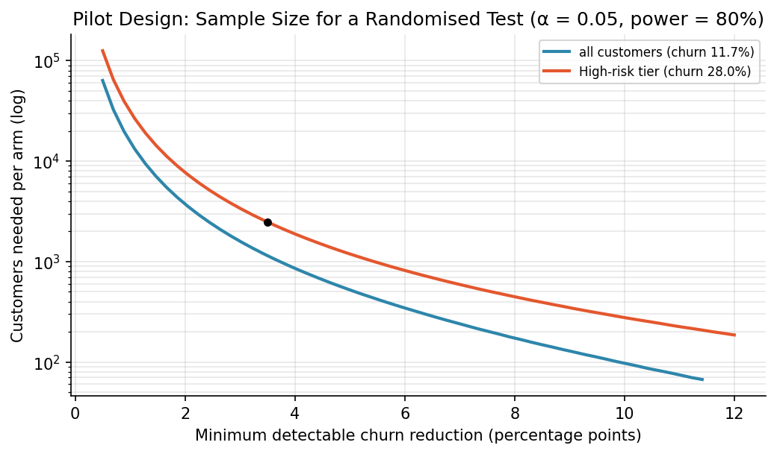
Figure J.3. Pilot Design: Sample Size for a Randomised Test (α = 0.05, power = 80%)
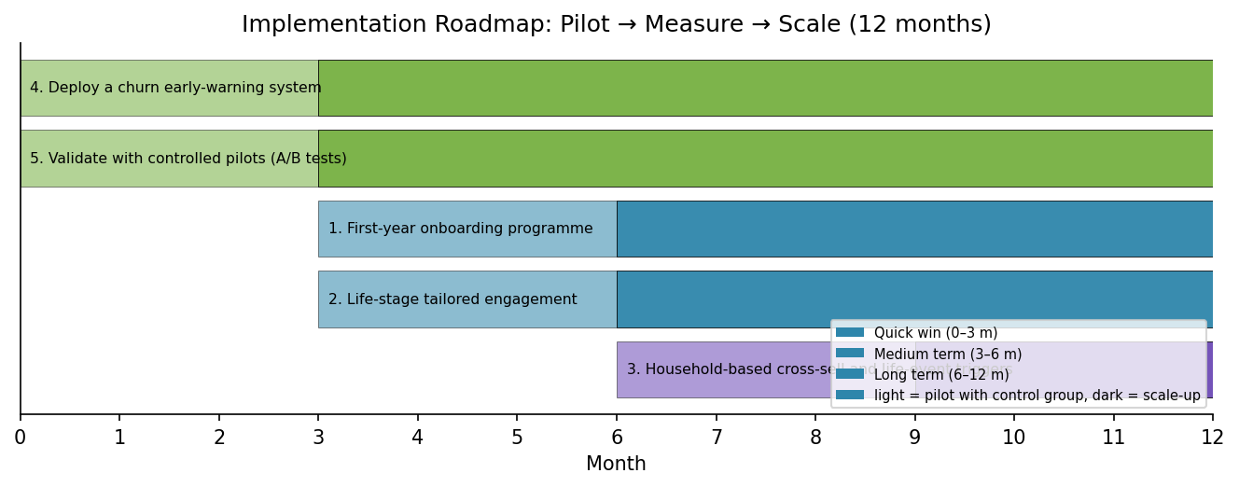
Figure J.4. Twelve-month implementation roadmap: each initiative is piloted against a control group before scale-up.
Table J.1. Model card (Mitchell et al., 2019).
Item | Description
Model | hill_climb (lgbm 0.50, lgbm_tuned 0.50)
Intended use | Rank active policyholders by 12-month churn risk to prioritise retention outreach and allocate retention budget.
Out-of-scope use | Not for premium pricing, underwriting, claims decisions or denial of service; not validated for other products/markets.
Training data | 160,000 customers, 24 input features; target 'Churn' (churn = 1); churn rate 11.7%.
Excluded variables | acct suspd date year, acct suspd date month, acct suspd date (days since), acct suspd date (post-event leakage)
Validation | Stratified 5-fold CV (out-of-fold), target encoding inside folds, shuffled-label & adversarial checks, bootstrap & DeLong CIs.
Performance | ROC-AUC 0.702 (95% CI 0.698–0.707); PR-AUC 0.329; Brier 0.087; ECE 0.002; EMPC 4.31 USD/customer.
Calibration | isotonic (selected by cross-validated log-loss).
Decision rule | Risk tiers at the 50%/80% quantiles; campaign size chosen by expected profit (see Section 4).
Explainability | Global: SHAP, permutation importance, PDP, EBM shape functions (if used). Local: SHAP waterfall per customer for agents.
Fairness | Audited on age band, has children, marital status; max AUC gap 0.162.
Monitoring | Monthly: PSI per feature (alert > 0.25), score distribution, realised churn by tier, calibration; retrain quarterly or if AUC drops > 0.03.
Limitations | Observational snapshot data; causal effects assume no unmeasured confounding; ROI depends on stated cost/acceptance assumptions.

Table J.2. Fairness summary by attribute.
Attribute | Min sel | Max sel | Min auc | Max auc | Min cal | Max cal | Selection ratio | Auc gap
age band | 0.173 | 0.543 | 0.596 | 0.758 | 0.971 | 1.225 | 0.318 | 0.162
has children | 0.205 | 0.233 | 0.683 | 0.717 | 0.996 | 1.005 | 0.881 | 0.034
marital status | 0.217 | 0.223 | 0.700 | 0.705 | 0.995 | 1.008 | 0.973 | 0.005

Table J.3. Pilot design: sample size per arm.
Intervention | Effect source | Baseline churn target segment | Expected reduction pp | N per arm | Total pilot size | Share of high tier %
Generic retention offer | assumed success rate × 50% (conservative) | 0.280 | 3.499 | 2,481 | 4,962 | 75.4

Table J.4. Implementation roadmap.
Priority | Initiative | Phase | Start month | Pilot months | Scale months | Kpi
4 | Deploy a churn early-warning system | Quick win (0–3 m) | 0 | 3 | 3 | Precision/recall of alerts; retained revenue vs control group
5 | Validate with controlled pilots (A/B tests) | Quick win (0–3 m) | 0 | 3 | 3 | Uplift in retention rate (treated − control)
1 | First-year onboarding programme | Medium term (3–6 m) | 3 | 3 | 3 | 13th-month persistency ratio; first-year churn rate
2 | Life-stage tailored engagement | Medium term (3–6 m) | 3 | 3 | 3 | Churn rate by age band; adoption of tailored offers
3 | Household-based cross-sell and life-event triggers | Long term (6–12 m) | 6 | 3 | 6 | Products per household; churn after life events

Table J.5. Full recommendation list with evidence and KPIs.
Priority | Recommendation | Action | Evidence | Estimated impact | Kpi
1 | First-year onboarding programme | Welcome call, policy walkthrough, app activation and 90-day check-in for new customers; first renewal treated as a critical moment. | '0-6m' churns at 48.8% (4.2x avg); IV 0.89; OR 12.20; SHAP rank #10 |  | 13th-month persistency ratio; first-year churn rate
2 | Life-stage tailored engagement | Tailor products, pricing communication and service channels to the highest-risk age groups (e.g. digital-first onboarding and flexible payment for younger customers; loyalty recognition for long-standing older customers). | '25-34' churns at 14.6% (1.2x avg); IV 0.04; OR 0.92; HR 0.48; SHAP rank #16 |  | Churn rate by age band; adoption of tailored offers
3 | Household-based cross-sell and life-event triggers | Use household profile and life events (moving, marriage, children) as triggers for coverage reviews and multi-policy bundles. | '0–1' churns at 13.5% (1.2x avg); IV 0.01; SHAP rank #4 |  | Products per household; churn after life events
4 | Deploy a churn early-warning system | Score all active policies monthly with this model; route High-risk/Priority-Save customers to retention teams, lower tiers to automated digital nudges; refresh the model quarterly. | Model ROC-AUC 0.702; top-20% captures 51% of churners | optimal campaign: target top 10% → net 590.81K | Precision/recall of alerts; retained revenue vs control group
5 | Validate with controlled pilots (A/B tests) | For each intervention keep a random control group (e.g. 20% of targeted customers) to measure true uplift before scaling. | What-if results are associational |  | Uplift in retention rate (treated − control)

Appendix K. Reproducibility
All results were produced by one notebook executed top-to-bottom (Restart & Run All) with random seed 42, 5-fold stratified cross-validation and the settings in Appendix B. Software: Python 3.11.9, pandas 2.3.3, scikit-learn 1.6.1, LightGBM 4.7.0, XGBoost 3.2.0, CatBoost 1.2.10, SHAP 0.51.0, statsmodels 0.15.0, lifelines 0.30.3, Optuna 4.9.0; platform Windows 10. The submission package contains the executed notebook with all outputs, every figure and table (CSV and Excel), the model card, the per-customer action list and an interactive dashboard.

References for the Appendices
Akiba, T., Sano, S., Yanase, T., Ohta, T., & Koyama, M. (2019). Optuna: A next-generation hyperparameter optimization framework. In Proceedings of the 25th ACM SIGKDD International Conference on Knowledge Discovery & Data Mining (pp. 2623–2631). https://doi.org/10.1145/3292500.3330701
Caruana, R., Niculescu-Mizil, A., Crew, G., & Ksikes, A. (2004). Ensemble selection from libraries of models. In Proceedings of the 21st International Conference on Machine Learning (p. 18). https://doi.org/10.1145/1015330.1015432
Chen, T., & Guestrin, C. (2016). XGBoost: A scalable tree boosting system. In Proceedings of the 22nd ACM SIGKDD International Conference on Knowledge Discovery and Data Mining (pp. 785–794). https://doi.org/10.1145/2939672.2939785
Guo, C., Pleiss, G., Sun, Y., & Weinberger, K. Q. (2017). On calibration of modern neural networks. In Proceedings of the 34th International Conference on Machine Learning (PMLR 70, pp. 1321–1330).
Harrell, F. E., Califf, R. M., Pryor, D. B., Lee, K. L., & Rosati, R. A. (1982). Evaluating the yield of medical tests. JAMA, 247(18), 2543–2546. https://doi.org/10.1001/jama.1982.03320430047030
Höppner, S., Stripling, E., Baesens, B., vanden Broucke, S., & Verdonck, T. (2020). Profit driven decision trees for churn prediction. European Journal of Operational Research, 284(3), 920–933. https://doi.org/10.1016/j.ejor.2018.11.072
Ke, G., Meng, Q., Finley, T., Wang, T., Chen, W., Ma, W., Ye, Q., & Liu, T.-Y. (2017). LightGBM: A highly efficient gradient boosting decision tree. In Advances in Neural Information Processing Systems 30. https://papers.nips.cc/paper_files/paper/2017/hash/6449f44a102fde848669bdd9eb6b76fa-Abstract.html
Lou, Y., Caruana, R., Gehrke, J., & Hooker, G. (2013). Accurate intelligible models with pairwise interactions. In Proceedings of the 19th ACM SIGKDD International Conference on Knowledge Discovery and Data Mining (pp. 623–631). https://doi.org/10.1145/2487575.2487579
Mitchell, M., Wu, S., Zaldivar, A., Barnes, P., Vasserman, L., Hutchinson, B., Spitzer, E., Raji, I. D., & Gebru, T. (2019). Model cards for model reporting. In Proceedings of the Conference on Fairness, Accountability, and Transparency (pp. 220–229). https://doi.org/10.1145/3287560.3287596
Prokhorenkova, L., Gusev, G., Vorobev, A., Dorogush, A. V., & Gulin, A. (2018). CatBoost: Unbiased boosting with categorical features. In Advances in Neural Information Processing Systems 31.
Royston, P., & Parmar, M. K. B. (2013). Restricted mean survival time: An alternative to the hazard ratio for the design and analysis of randomized trials with a time-to-event outcome. BMC Medical Research Methodology, 13, 152. https://doi.org/10.1186/1471-2288-13-152
Rudin, C. (2019). Stop explaining black box machine learning models for high stakes decisions and use interpretable models instead. Nature Machine Intelligence, 1(5), 206–215. https://doi.org/10.1038/s42256-019-0048-x
Schoenfeld, D. (1982). Partial residuals for the proportional hazards regression model. Biometrika, 69(1), 239–241. https://doi.org/10.1093/biomet/69.1.239
Siddiqi, N. (2006). Credit risk scorecards: Developing and implementing intelligent credit scoring. John Wiley & Sons.
Verbeke, W., Dejaeger, K., Martens, D., Hur, J., & Baesens, B. (2012). New insights into churn prediction in the telecommunication sector: A profit driven data mining approach. European Journal of Operational Research, 218(1), 211–229. https://doi.org/10.1016/j.ejor.2011.09.031
Wei, L. J. (1992). The accelerated failure time model: A useful alternative to the Cox regression model in survival analysis. Statistics in Medicine, 11(14–15), 1871–1879. https://doi.org/10.1002/sim.4780111409

